|  |
| --- |
|  |



|  |  |
| --- | --- |
| NTNU | Summary – TIØ4175 Purchasing & Logistics Management |

## Contents

Week 2 – Introduction to logistics management, customer value, logistical costs and performance 1

Logistics Management (Ch. 1) 1

Definitions 1

Competitive advantages 1

Supply chain -> value chain 2

A changing competitive environment 4

The 4 Rs – For handling the changed business environment 5

Essential logistics decision variables 5

Customer value (Ch. 2) 6

Definitions 6

Market driven supply chains 7

Defining customer service objectives 8

Setting customer service priorities 8

Setting service standards 9

Logistics cost and performance (Ch. 3) 9

Week 3 – Logistics supply strategies 11

Lecture summary 11

Matching supply and demand (Ch. 4) 11

The lead time gap 11

Push vs. pull 11

Improving demand visibility 12

Demand management and planning 12

Creating the responsive supply chain (Ch. 5) 13

The foundations of agility 14

Strategic lead-time management (Ch. 6) 15

Lead time concepts 16

Goals of logistics pipeline management 16

The synchronous supply chain (Ch. 7) 16

The role of information in the virtual supply chain 17

Quick response logistics 18

Week 4 – Global supply chains, risks, barriers to integration 18

Complexity and the supply chain (Ch. 8) 18

Cost of complexity 19

Sources of supply chain complexity 19

Mastering complexity 20

Managing the global pipeline (Ch. 9) 20

Trends in the globalization in the supply chain 21

Supply chain event management (SCEM) 22

Organizing for global logistics 22

Managing risk in the supply chain (Ch. 10) 23

Reasons for supply chain vulnerability 24

Understanding the supply chain risk profile 24

Managing supply chain risk 25

The era of network competition (Ch. 11) 26

Managing the supply chain as a network 27

Seven major business transformations and their implications for management skills 28

Overcoming the barriers to supply chain integration (Ch. 12) 28

Problems created by conventional organization 28

Characteristics of a horizontal organization 29

Benchmarking 29

Identifying logistics performance indicators 30

Week 6 – Introduction to purchasing management, evolution 30

The evolution of purchasing and supply management (Ch. 2) 30

Drivers of purchasing evolution – PEST 31

The role of the purchasing function 31

A1: Specifications 32

Week 7 – Make or buy 34

The make-buy decision: a theoretical perspective (Ch. 3) 34

The inadequacy of neoclassical economic theory 34

The transaction cost approach 34

The capability approach 36

The RBV and the make-buy decision 36

A2: A satisficing model of outsourcing 37

Week 8 – Sourcing strategies; Electronic Procurement 39

4. Sourcing strategies 39

Supply base reduction (SBR) 39

Sourcing strategies 40

Supply structure and design 42

A10: Making the Most of Supplier Relationships 44

Coping with supplier relationships 44

Economy of supplier relationships 44

The posture of supplier relationships 45

High and low involvement relationships 46

The variety of relationship postures 46

Involvement and the volume of business in the relationship 47

Managing in relationships 47

Implications 48

A11: Supplier Segmentation –”When Supplier Relationship Matter” 48

A12: A conceptual model for assessing the impact of electronic procurement 52

Dimensions if impact of EP on organizations 54

Week 9 – “To make together” The design process and specifications 56

Week 10 – Supplier Development and relationships 57

Supplier development (Ch. 6) 57

Objectives of supplier development 57

Supplier development strategies 58

The supplier development process 58

Is supplier development always a success? 59

Managing inter-firm relationship (Ch. 13) 59

Towards a management model 59

Development of a relationship management approach 60

The management of dependencies and certainties 60

Implications for managing relationships 61

A4: Developing Relationships in Business Networks 61

Structural characteristics of business relationships 62

Process characteristics of business relationships 63

Relationships and business enterprise (this is not a part of the lecture) 65

Interdependencies and connectedness in business relationships 65

Connectedness of business relationships 67

Business relationships in market networks 67

A3: Managing Interfaces with Suppliers 68

Preface 68

Introduction 68

Purpose 68

Resource interfaces 68

Conclusions 72

Managerial Implications 73

Week 11 – Food Supply Chains 73

Week 12 – Supply Networks 74

A9: A strategic review of “supply networks” 74

Abstract 74

Introduction and scope 74

The four perspectives to cover the scope of SCM research 76

A8: Supply network initiatives – a means to reorganize the supply base? 79

Hensikten med artikkelen 79

Litteraturstudie 79

Supply base management – important issues: 79

Supply network management – important issues: 80

Supply base versus supply network management 81

Methodology 81

Empirical basis 82

Analysis and discussion 83

The post-initiative stage 84

Results and implications 85

A7: A Conceptual Model for Researching the Creation and Operation of Supply Networks 85

Abstract 85

Introduksjon 85

How the model was developed 86

Initial conceptual framework 87

Exploratory survey of supply networks 88

Reflections and conclusions 89

Week 15 – Corporate Alignment; organization of purchasing 90

Logistics effectiveness & efficiency vs. organizational structure and systems 90

Supply wheel concept 90

Rationale of the supply wheel: 90

Supply wheel elements 91

The strategy concept – aligning supply with corporate strategy 92

What is strategic alignment? 92

Competency and skills 93

Competence requirements for strategic supply 94

Purchasing competency development model 94

Know-what vs. know-how 96

Organizational structure 97

Historical overview 97

The classic choices –Centralization vs. Decentralization – and the hybrid 97

A6: Developing a typology of organizational forms of cooperative purchasing 98

5 different types of purchasing groups 99

Week 16 – Strategic supplier selection, performance measurement, cost benefit analysis 103

The 4 main stages of supplier selection 103

1. Initial supplier selection 103

2. Agree on measurement criteria 103

3. Obtain relevant information 104

4. Make selection 105

Decision models 105

AHP-technique (fully compensatory) 105

A5: Outranking methods in support of supplier selection. 107

Performance measurement 111

PM as signaling devices and design of PM 111

Benefits of measurement 112

Pitfalls in performance measurement 112

Categories of performance measures 112

Developing a performance measurement system 113

Characteristics of effective performance measurement systems 114

Cost-benefit analysis 114

Price-focused approach consequence: The business cycle effect 115

Total cost of ownership 115

Week 17 – Green Purchasing and logistics CSR in a SCM context 116

Creating a sustainable SC (Ch. 13) 116

The triple bottom line 116

The SC of the future (Ch. 14) 119

Emerging mega-trends 119

Shifting centers of gravity 120

Environmental and ethical issues in supply management (Ch. 14 – Cousins) 121

Sustainability, green, and environmental soundness 122

Purchasing and supply management’s environmental contribution 122

Strategy for minimizing impacts 123

Risks for purchasing and supply managers 124

Implementation issues 124

Week 18 – Supplier involvement in product development 125

Advantages of ESI 126

Product related 126

Organization related 126

Disadvantages of ESI 126

Early supplier involvement 126

1. Selecting the right suppliers 126

2. Timing of supplier involvement 127

3. Extent of supplier involvement 127

4. Managing the involvement 127

Week 19 – Public procurement 128

Relevance 128

Public vs. private procurement 128

European Commission Directives 128

The thresholds 129

The procedures 130

Procedure description from slides (Gjønnes, 2007) 132

Critique 132

# Week 2 – Introduction to logistics management, customer value, logistical costs and performance

## Logistics Management (Ch. 1)

### Definitions

#### Logistics

…*is the process of* ***strategically managing the procurement, movement and storage of materials, parts and finished inventory*** *(and the related information flows) through the organization and its marketing channels in such a way that current and future* ***profitability are maximized through the cost-effective fulfillment of orders*.**

…is essentially a planning orientation and framework that seeks to create a single plan for the flow of products and information through a business.

Supply Chain Management (demand chain management/demand network management)

…the management of **upstream and downstream relationships** with suppliers and customers in order to **deliver superior customer value at less cost o the supply chain as a whole.**

...builds on the logistics framework and seeks to achieve linkage and co-ordination between the processes of other entities in the pipeline and the organization itself.

### Competitive advantages

Successful companies either have a cost advantage, a value advantage – or a combination of the two.

**Cost advantage drivers**

Economies of scale

The experience curve

Logistics and supply chain management

**Value advantage**

Unless the product or service offered can be distinguished in some way from its competitors the marketplace will view it as a ‘commodity’ – leaving the sale to the cheapest supplier. The development of a strategy built on added-values will normally require a more segmented approach to the market – identifying distinct value segments.

Due to an increasing convergence of technology, making it difficult to compete effectively on the basis of product differences, many companies have started to focus upon service as means of gaining a competitive advantage.

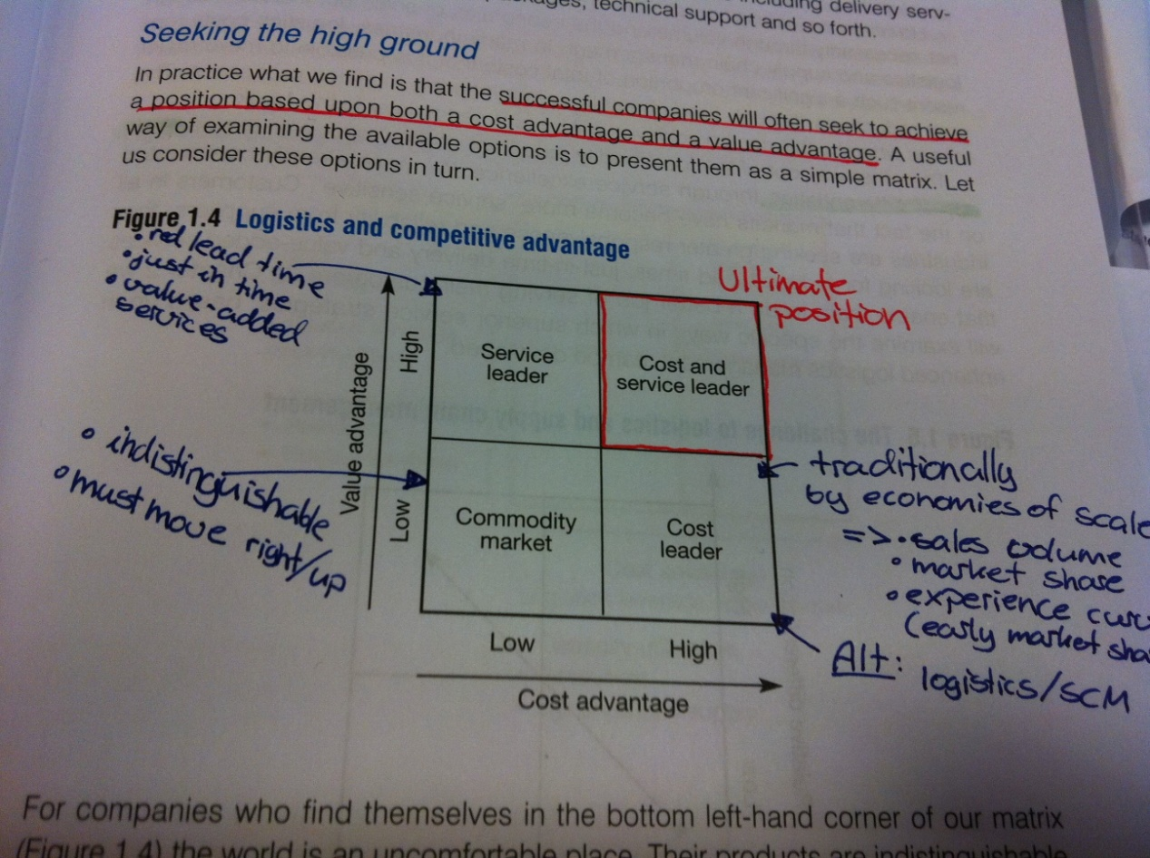

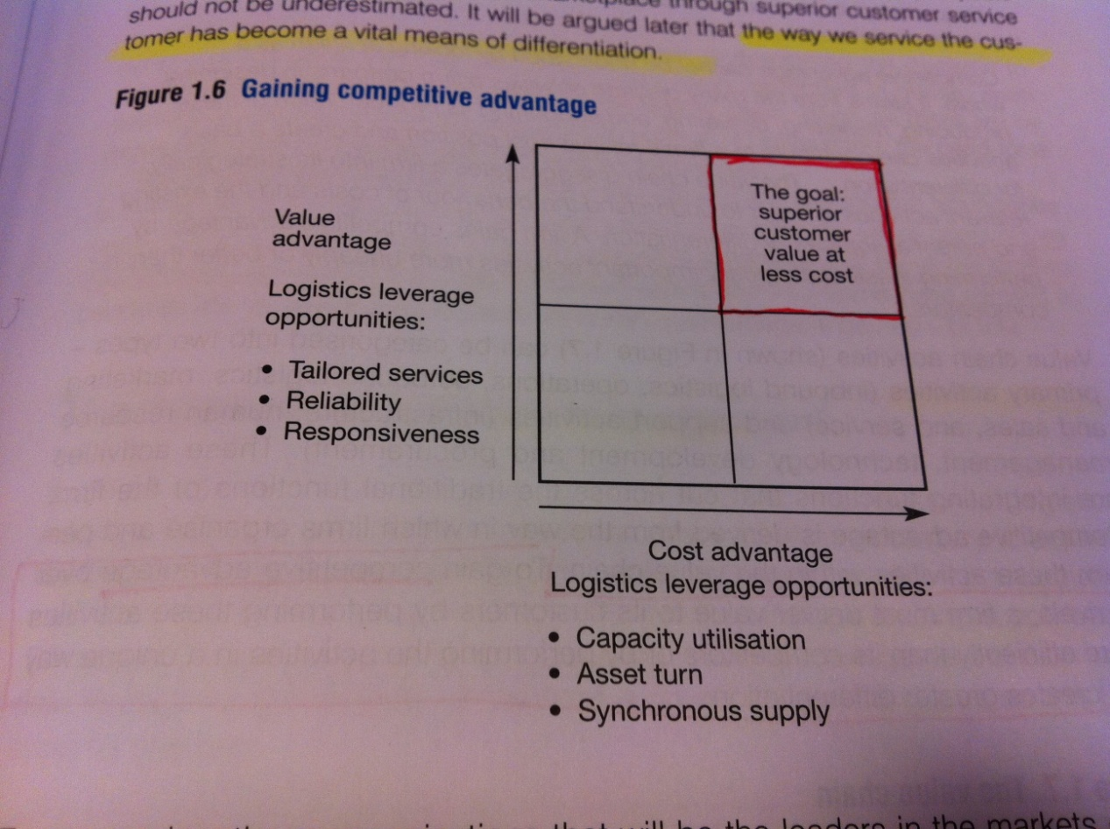Successful companies often seek to achieve a position based upon both a cost advantage and a value advantage. This corresponds to the upper-right corner of the matrix. Being situated in the commodity corner of the matrix with an undistinguished product from competitors, the only strategy is to either move towards a cost leadership, or a service leadership. The cost leadership strategy can be especially difficult to achieve in mature markets, as it is hard to gain market share needed for sufficient economies of scale. A service leadership can be driven by an increased demand for responsiveness and reliability, reduced lead times, JiT delivery and other value added services. There is no middle ground between cost leadership and service excellence – the management challenge is therefore to identify appropriate logistics and supply chain strategies to take the organization to the top right-hand corner of the matrix. *The leaders in the markets of the future will be those that have sought and achieved the twin peaks of excellence; cost leadership and service leadership.*

### Supply chain -> value chain

To gain competitive advantages over its rivals, a firm must deliver value to its customers by performing these activities more efficiently than its competitors or by performing the activities in a unique way that creates greater differentiation.

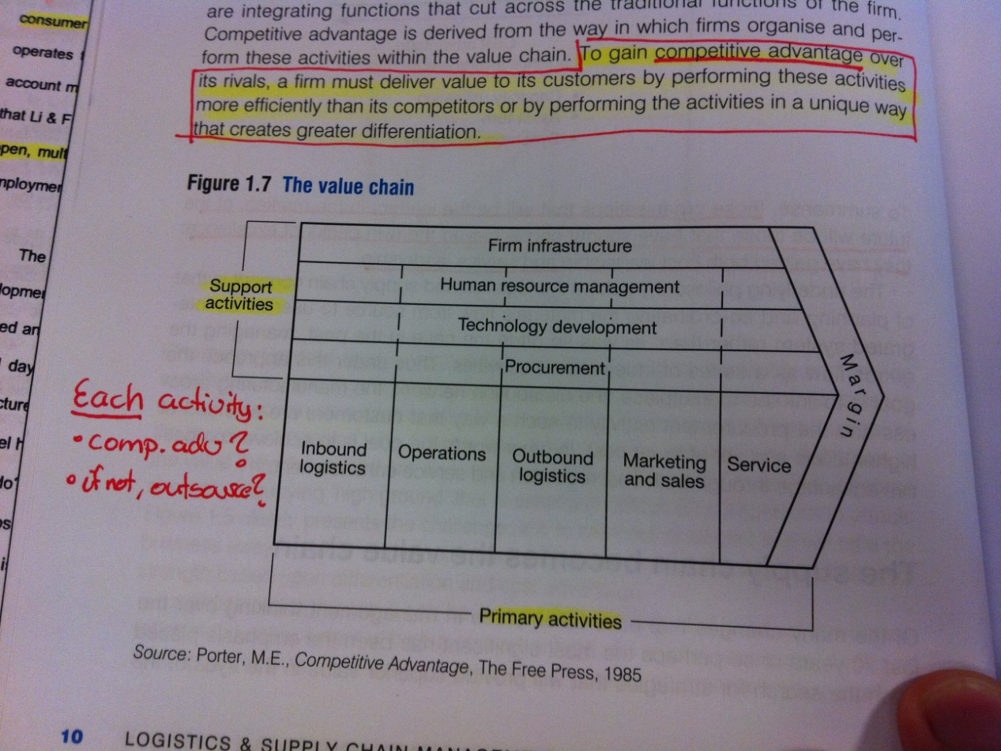

Organizations should look at each activity in their value chain and assess whether they have a real competitive advantage in the activity. If not, outsourcing should be considered while keeping in mind the added complexity to the supply chain due to the increased number of interfaces to be managed. The effect of outsourcing is to extend the value chain beyond the business boundaries, leading the supply chain to become a value chain – value (and cost) is not just created in the focal firm of the network, but by all the entities connected to each other.

#### The role of logistics

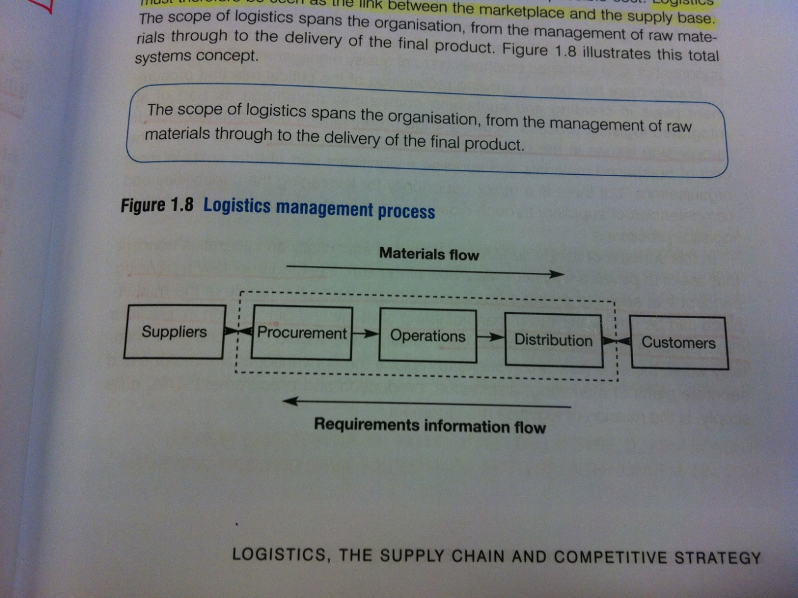In this setting logistics will be seen as the link between the marketplace and the supply base. With this view, and in todays turbulent environment, there is no longer any possibility of manufacturing and marketing acting independently of each other. The need to understand and meet customer requirements is a prerequisite for survival, and there has been a growing recognition in the role purchasing plays in creating and sustaining competitive advantage as part of an integrated logistics process. Leading-edge organizations therefore routinely include supply-side issues in the development of their strategic plans. Logistics is in this view a planning concept that seeks to create a framework through with the needs of the marketplace can be translated into a manufacturing strategy and plan, which in turn links into a strategy and plan for procurement.

#### The role of supply chain management

Traditionally most organizations viewed themselves as independent entities that needed to compete to survive. The supply chain on the other hand, is a network of organizations that are involved (upstream and downstream activities) in the different processes and activities that produce value in forms of products/services for the ultimate customer. However, supply chain management is different from vertical integration – organizations are increasingly focusing on their ‘core business’, outsourcing everything else. Supply chain management must therefore address the challenge of integrating and coordinating material flow from a multitude of suppliers, and similarly manage the distribution of products by way of multiple intermediaries.

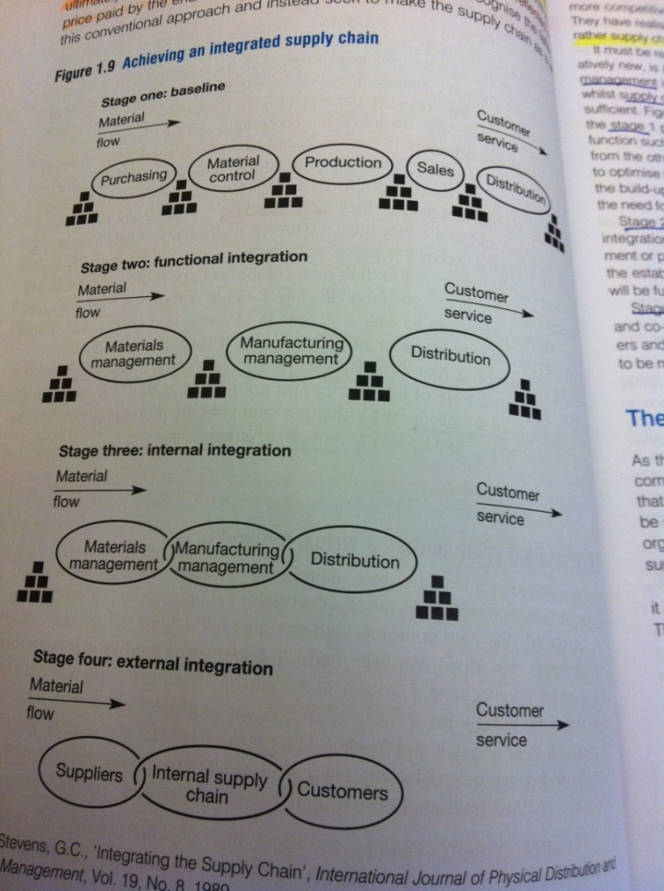

Simply transferring costs upstream or downstream does not make companies any more competitive, as all costs will ultimately make their way to the final marketplace to be reflected in the price paid by the user. The real competition is therefore not company against company, but rather supply chain against supply chain. Supply chain management is actually no more than an extension of the logic of logistics concerns with optimizing within the organization, as SCM recognize that internal integration is not sufficient by itself (see figure).

### A changing competitive environment

|  |  |  |
| --- | --- | --- |
| **Pressure** | **Characteristics** | **Consequences** |
| **New rules of competition** | - Organization no longer an isolated, independent entity  - Competition through capabilities and competences rather than brands backed up by marketing budgets and aggressive selling.  - Trend towards commoditization on many markets  - Order-winning criteria likely to be service-based rather than product based.  - Demand concentration  - Supplier base reduction  - Shorter product life cycles | - Need to create value delivery systems  - Need to manage core processes better than competitors  - Less brand loyalty, more decisions taken at place of purchase  - More powerful and demanding customers  - Close-relationship strategies with key accounts  - Situations arising where life cycle is shorter than the strategic lead time |
| **Globalization of industry** | - Materials and components sourced worldwide and products may be manufactured offshore and sold in many different countries, perhaps with local customization. | - Longer supply chains due to increasing outsourcing and long-distance sourcing  - Increased end-to-end pipeline times |
| **Downward pressure on price** | - Global competitors supported by low-cost manufacturing bases  - Removal of trade barriers, deregulation of markets  - Price deflation – comparison easier with the internet  - More value conscious customers | - Need to bring down costs to match fall in price  - Need to reduce inventory levels at the most expensive locations in the chain (close to customer (25% of product value/year) |
| **Customers taking control** | - More demanding, not just of product quality, but also of service | - Service excellence can only be achieved through a closely integrated logistics strategy |

Table 1 – Competitive pressures and consequences

### The 4 Rs – For handling the changed business environment

**Responsiveness** – Ability to respond to customers’ requirements in short-time frames is increasingly important. Agility – the ability to move quickly and meet customer demand sooner, is a key word in the changed environment. Organizations must be more demand-driven than forecast driven, and responsiveness also implies that the organization is somewhat close to the customer.

**Reliability** – Ability to meet delivery promise or quality of materials/components. Rather than do quality control through inspections, a process control focus should be adapted. One of the keys for improving SC reliability is through reducing process variability.

**Resilience** – Ability to cope with unexpected disturbances. Resilient SCs may not be the lowest-cost, bit they are more capable of coping with an uncertain business environment. An important characteristic of such SCs is a business-wide recognition of where the SC is at its most vulnerable. Another is their recognition of the importance of strategic inventory and selective use of spare capacity to cope with ‘surge’ effects.

**Relationships** – Increasingly companies discover the advantages that can be gained by seeking mutually beneficent, long-term relationships with suppliers. Supplier base reduction and partnership sourcing can lead to improved quality, innovation sharing, reduced costs and integrated scheduling of production and deliveries. Relationships can also prove to be formidable barriers to entry for competitors – more linked processes implies a stronger mutual dependence and an increasing difficulty in competitor entrance. Successful SCs are governed by a constant search for win-win solutions based on mutuality and trust.

### Essential logistics decision variables

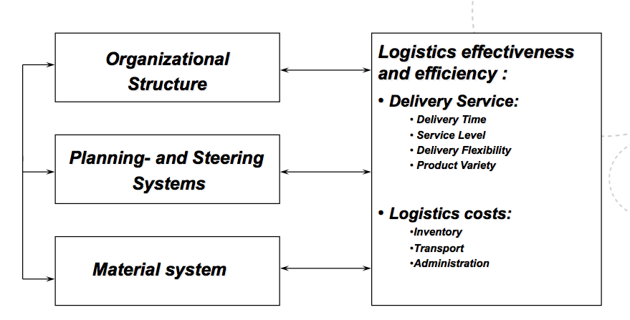

## Customer value (Ch. 2)

Ultimately the purpose of any logistics system is to satisfy customers, everyone in the organization has a stake in customer service. The objective should therefore be to establish a chain of customers that links people at all levels in the organization directly or indirectly to the market place (internal customers). Instead of designing supply chains from the ‘factory outwards’ the challenge is to design them from the ‘customer backwards’.

In more and more markets the power of the brand has declined and customers are more willing to accept substitutes. As it harder to maintain a competitive edge on the product itself, customer service can provide the distinctive difference between one company’s offer and that of its competitors.

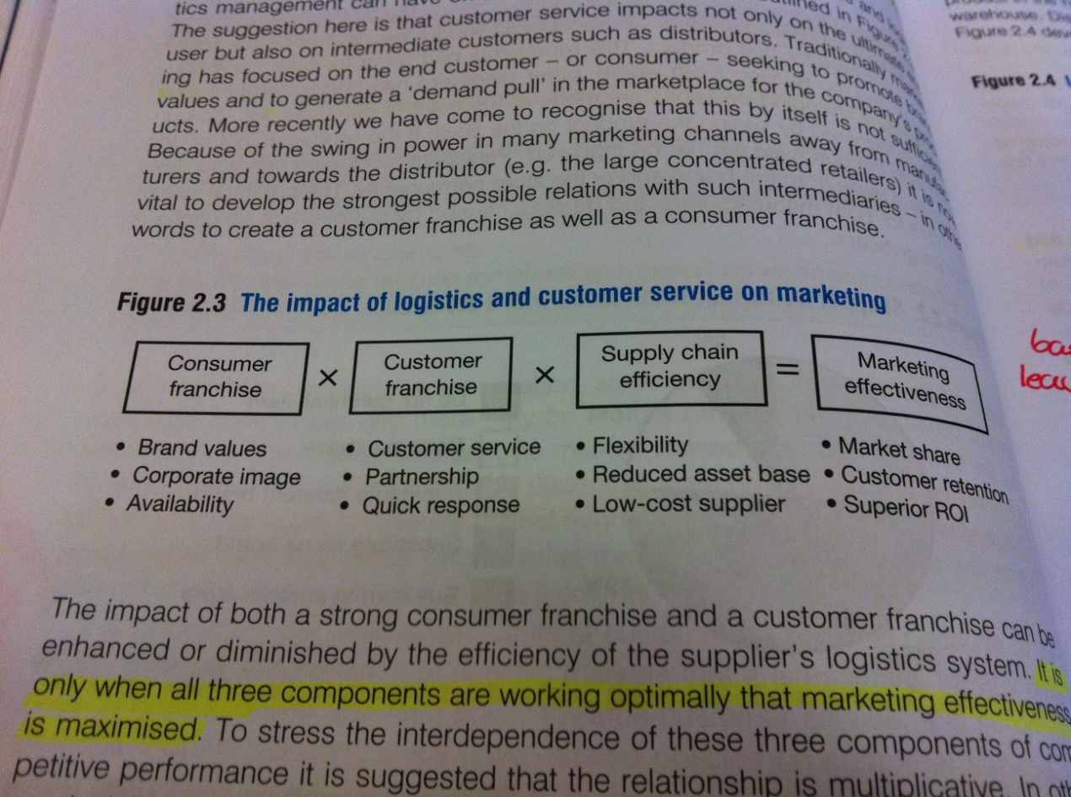

### Definitions

#### Customer value

$$Customer value=\frac{Perception of benefits}{Total cost of ownership}$$

The total cost of ownership will be greater than the initial purchase price, and in the same way the benefits perceived from the purchase or relationship are often greater than the tangible products features or functionality. The successful companies will generally deliver more customer value than the competitors. Logistics management can impact both the numerator and denominator, something that is easily viewable by expanding the fraction:

$$Customer value=\frac{Quality x Service}{Cost x Time}$$

Quality – Functionality, performance, technical specification

Service – Availability, support, commitment provided to customer

Cost – Transaction costs including price and life cycle costs

Time – Time taken to respond to customer requirements

**Lifetime value of a customer:**

$Lifetime value=Average transaction value x yearly purhase frequency x customer 'life expectancy'$ Higher customer retention rates correlates strongly with profitability, hence a prime objective of any customer service strategy should be to enhance customer retention.

#### Customer service

1. **Pre-transaction elements** – elements related to corporate policies or programs
   1. Customer service policy, accessibility, organization structure, system flexibility
2. **Transaction elements** – variables directly involved in performing the physical distribution function
   1. Order cycle time, inventory, order fill rate, order status information
3. **Post-transaction elements** – generally supportive of the product while in use
   1. Availability of spares, call-out-time, product tracing/warranty, customer complaints/claims

Customer service must be understood in terms of differing requirements for different market segments – No universal approach exists.

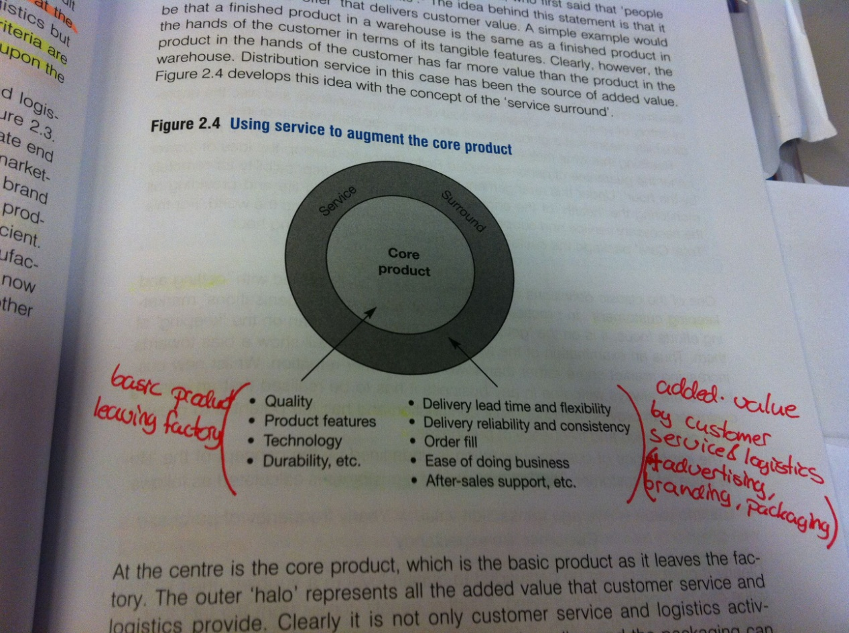

### Market driven supply chains

1. **Identify value segments** - *What do our customers value?*
   1. **Identify key components of customer service**
      1. Common failing to assume knowledge of customer wishes
      2. Identify key sources of influence upon purchase decision
      3. Which elements of total marketing offering will have what effect upon the purchase decision?
   2. **Establish the relative importance of the components**
      1. Ranking from a subset of customers
      2. Trade-off technique – asking customers to rank feasible combinations, a computer calculate the implicit importance
   3. **Identify customer service segments**
      1. Look after preference similarities
2. **Define the value proposition** – *How to translate requirements into an offer?*
3. **Identify the market winners** – *What does it take to succeed in market?*
4. **Develop the supply chain strategy** – *How to deliver against proposition?*

### Defining customer service objectives

The perfect order is achieved only when each of the service needs is met to the customer’s satisfaction. The measure of service is therefore defined as the percentage of occasions on which the customer requirements are met in full.

The Pareto Law states that an 80/20 rule can be applied in many situations. Here it implies that 80 percent of the profits of the business come from 20 percent of the customers, while 80 percent of the total cost to serve will be generated from 20 percent of the customers. **The challenge to customer service management is therefore to:**

1: Identify the real profitability of customers

2: Develop strategies for service that improves the profitability of all customers

As there are costs as well as benefits in providing customer service, an appropriate level and mix of service will vary by customer type. In this aspect it is also important to keep in mind the exponential form of the service cost curve – as the desired service level rises, it takes a disproportionate investment in inventory to achieve small incremental improvements in availability.

### Setting customer service priorities

Since not all customers and/or products are equally profitable, the highest service should be given to key customers and key products. Profit should be used to make the priorities, not sales revenue or volume as they might disguise considerable variations in cost. The Pareto law (80/20 rule) can also be applied in this case, dividing the products in to three categories:

|  |  |  |
| --- | --- | --- |
| Product category | Characteristics (profitability) | Required stock availability[1] |
| A | Top 20 percent of products and customers | 99% |
| B | Next 50 percent of products and customers | 97% |
| C | Final 30 % of products and customers | 90% |

Table 2 – A,B,C categorization of customers and products

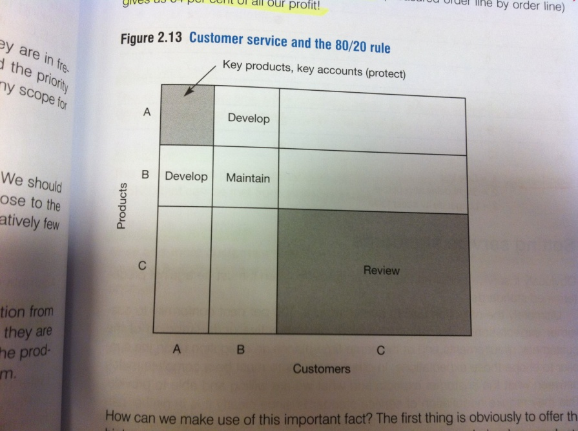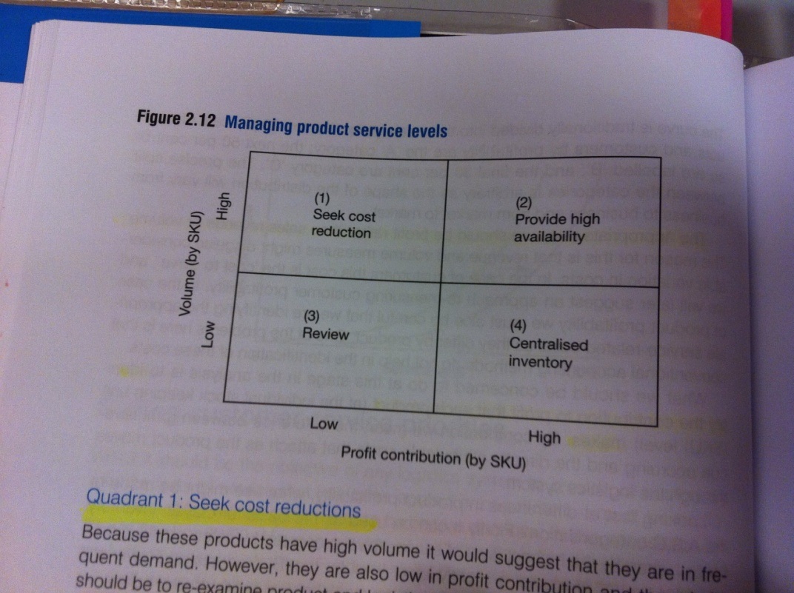

This can be taken further by using the matrix to the left in the choice of product strategies. A similar matrix is shown to the right related to customer service strategies, where an application of the 80/20 rules shows that 20% of the customers buy 20% of the products (4% of all transactions) providing 65% of the total profit (80% of 80% of total profit)

### Setting service standards

If service performance is to be controlled, it must be against predetermined standards. To be effective the customers themselves must define these standards. However, there are **some key areas where standards are essential:** Order cycle time, stock availability, order-size constraints, ordering convenience, delivery frequency, delivery reliability, documentation quality, claims procedure, order completeness, technical support, and order status information.

**From the customers perspective there are only two levels of standards – either 100 % or 0 %.**

## Logistics cost and performance (Ch. 3)

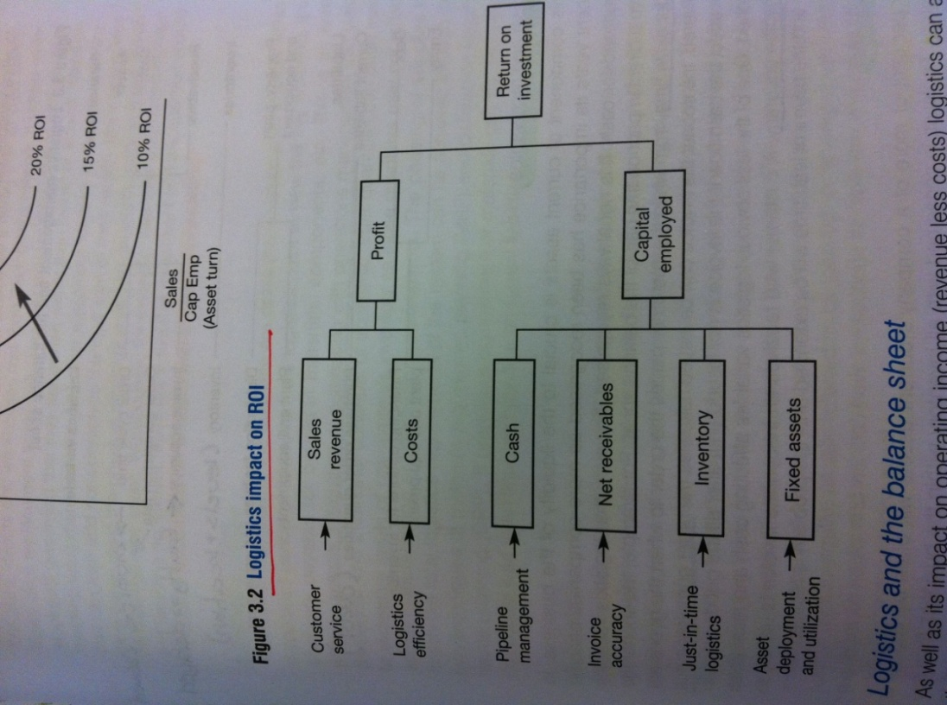Logistics activity does not only generate costs, but also benefits through provision of availability – it is therefore important to understand the profit impact of logistics and supply chain decisions. Into this profit impact it is important to include both product costs and customer costs. The ways in which logistics management can impact on ROI are many and varied, the following figure highlights the major elements:

**Drivers of shareholder value:**

* Revenue growth
  + Sales volume, customer retention
* Operating cost reduction
  + Total pipeline view of costs, time compression in SC
* Fixed capital efficiency
  + Logistics fixed asset intensive by nature => third-party logistics, lease rather than buy
* Working capital efficiency
  + Time compression in SC => reduced order-to-cash cycle time
* Tax minimization

Because logistics management is a flow-oriented concept with the objective of integrating resources across a pipeline, it is desirable to have a means whereby costs and performance of that pipeline flow can be assessed. Conventional accounting systems group costs into broad, aggregated categories without permitting the detailed analysis necessary to identify the true cost of servicing customers buying particular product mixes**. A logistics costing system should:**

* **Mirror the materials flow**
  + i.e. be capable of identifying the costs resulting from providing customer service in the marketplace
* **Enable separate cost and revenue analyses for smaller entities**
  + Thus enabling separate cost and revenue analyses to be made by customer type, by market segment or distribution channel.

This approach requires that the activity centers associated with a particular distribution mission to be identified (e.g. transport, warehousing, inventory), and that the incremental cost for each activity center incurred as a result of undertaking a particular mission is isolated. An approach to overcome these problems is ‘activity based costing’ – where the key is to seek out the ‘cost drivers’ along the logistics pipeline that cause costs because they consume resources. The advantage of activity-based costing is that it enables each customer’s unique characteristics to be separately accounted for.

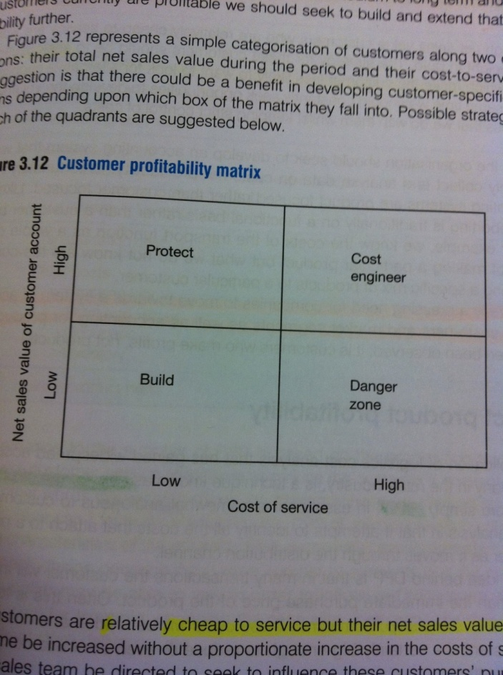**Such an approach will allow a customer profitability analysis**. The best measure of customer profitability is to ask the question: “What cost would I avoid and what revenues would I lose if I lost this customer?” The following matrix can be used to decide on which action to take based on the outcome of the customer profitability analysis:

**Build:** Cheap to service, but low net sales. Possible to raise volumes or influence purchases towards a more profitable product mix?

**Danger zone:** Medium/long-term prospect of improving net sales or reduce cost of service? A strategic reason for keeping them (volume)?

**Cost engineer:** Could be more profitable if cost of service is reduced (decrease variability, consolidated deliveries, internet sales?

**Protect:** High net sales, cheap to service. Seek relationships to make the customer less likely to want to look for alternative suppliers.

**Problems with the current cost measurement systems:**

* General ignorance of the true cost of servicing different customer types/channels/market segments
* Cost are captured at too high levels of aggregation
* Full cost allocation
* Conventional accounting systems are the functionally oriented, rather than output oriented
* Companies understand product costs, but not customer costs

# Week 3 – Logistics supply strategies

## Lecture summary

* Lean is often no longer enough
* Volume and product variety require variety
* Lead time compression, process redesign and real time information systems are crucial in making the transfer
* Not only within the focal firm, but also across chains
* All these strategies correspond to (unique) combinations of essential variables (systems design, planning & steering and organizational structures) – preferably hard to copy.

### Push vs. pull

* **Push**
  + Activities primarily driven by forecasts
  + Stock based
  + Emphasis on planning (MRP) and economic order quantities
* **Pull**
  + Activities primarily driven by actual needs of next step
  + Emphasis on frequent (continuous) replenishment
  + Emphasis on small orders (kanbans) and Just in Time.

## Matching supply and demand (Ch. 4)

### The lead time gap

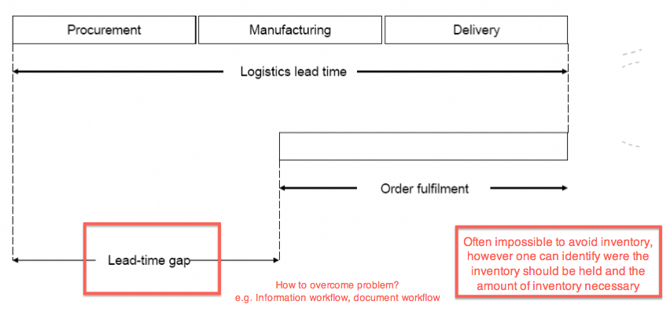

In basic essence, the goal of supply chain management is to match supply and demand under the presence of uncertainty and challenging volatility, turbulence and error prone forecasts. The conventional way of bridging the lead-time gap is by seeking to forecast market requirements and build inventory ahead of demand. A perfect match between logistics lead-time and the customer’s required order cycle would imply no need of forecasts and inventory.

### Improving demand visibility

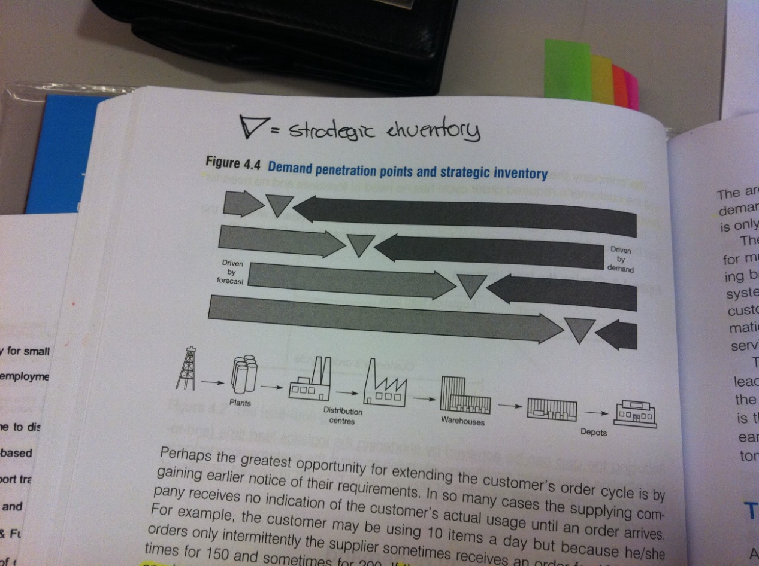

**The *demand penetration point (decoupling point)* is frequently found to be too far down the pipeline, and the real demand is often hidden from view** – replaced by orders of other supply chain partners. A key concern of logistics management should be to identify ways to push the demand penetration point as far downstream as possible – the goal being to improve the suppliers’ ability to anticipate the customer’s requirement and better schedule his own logistics activities. Whilst the customer will still require ever swifter delivery, an ongoing feed-forward of information on demand will be likely to enhance the customer service level and reduce the supplier costs. The lead-time gap will never be completely closed, but empirical data suggest that **substantial improvements can be made in both responsiveness and the capture of early information – resulting in better customer service at lower costs.**

**Velocity and visibility drive responsiveness:**

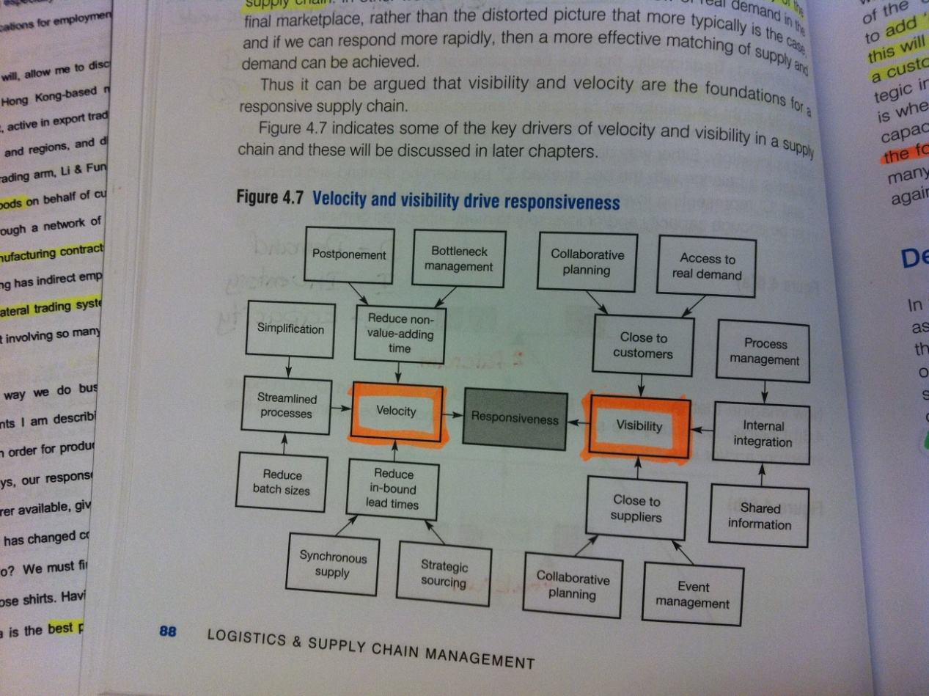

### Demand management and planning

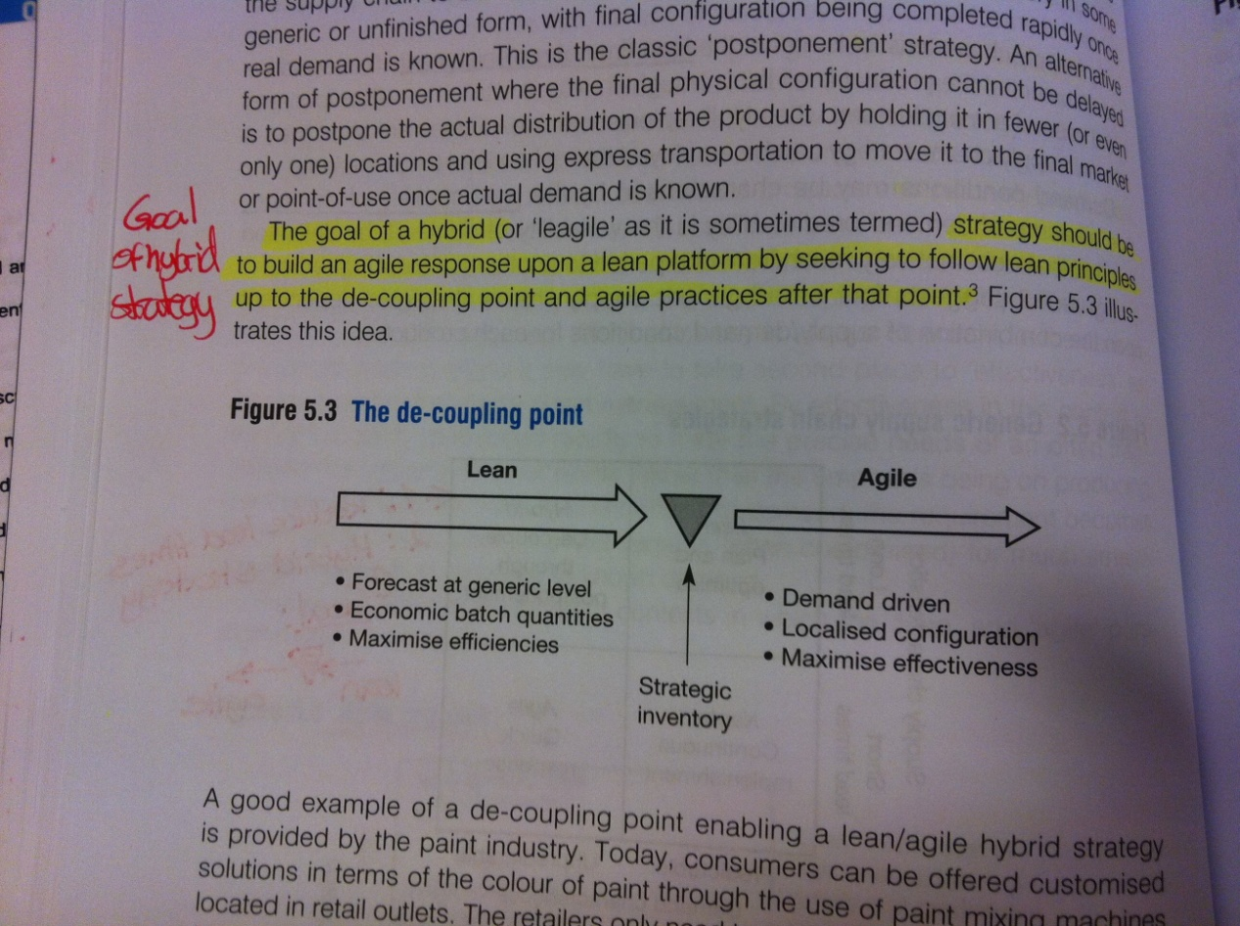In today’s volatile business environment it is much harder to achieve high levels of forecast accuracy for individual items. The focus has to be on how the company can **move from a forecast-driven to a demand driven mentality.** While forecasts will always be required, the forecasting should be done at an aggregate volume (not individual item level) to enable the company to plan for the capacity and resources that will be required to produce that volume. A way to achieve a decoupling point as close to the customer as possible is to add ‘generic’ inventory (strategic inventory) at a late point in the supply chain that will facilitate late configuration or even manufacture of the product against a customer’s specific requirements (e.g. Zara’s un-dyed fabric and forecasting on resources and materials rather than final garments).

#### The sales and operations planning process

1. **Generate aggregate demand forecast**
   1. Easier to forecast at aggregate levels (product family)
   2. Use of past data
2. **Modify forecast with demand intelligence**
   1. Specific intelligence on current market conditions and events
   2. Involving key customers or accounts
3. **Create a consensus forecast**
   1. Marketing and sales meet at regular intervals with operations and supply chain; the former presenting modified sales forecasts and the latter detail constraints that might curtail achievement of the forecast.
4. **Create a ‘rough cut’ capacity plan**
   1. To ensure that enough capacity and resources are available
5. **Execute at SKU levels against demand**
   1. Ideally nothing is finally assembled, configured or packaged until there is knowledge about the customer’s order specifies. This require high levels of agility and visibility of real demand through information sharing in the SC.
6. **Measure performance**
   1. Percentage of perfect order achievement compared to the number of days of inventory and the amount of capacity needed to achieve that level.
   2. Lead time gap at individual item level – aim of reducing this gap by focusing on time compression and improved visibility.

CPFR (Collaborative planning, forecasting and replenishment) or VMI can help in overcoming the lead-time gap. The VMI by reducing the need for carrying safety stock as a result of ‘substituting information for inventory’. A key element of CPFR is the generation of a joint forecast, which is agreed and signed off by both supplier and the customer.

## Creating the responsive supply chain (Ch. 5)

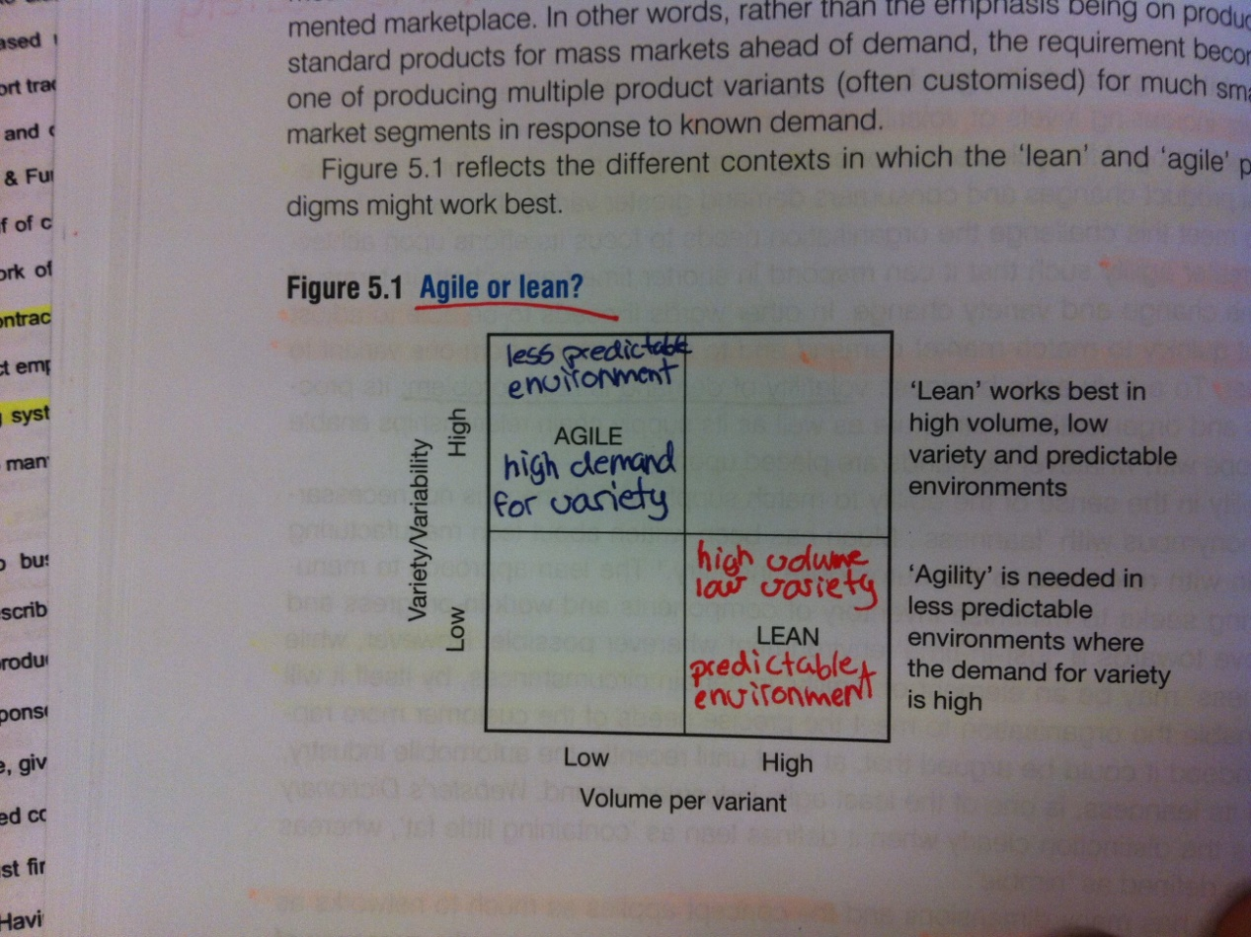To meet the challenge of ever increasing levels of demand volatility, the organization needs to focus its efforts upon achieving greater agility – being able to adjust output quickly to match market demand and to switch rapidly from one variant to another. To a truly agile process volatility of demand is not a problem. While lean might be an element of agility (e.g. the JiT concept), it will not by itself enable the organization to meet the precise needs of the customer more rapidly.

In reality, within the same business it is likely that there will exist the need for both lean and agile supply chain solutions since some products have predictable demand whilst the demand is more volatile for others. One way to identify the right supply chain strategy for different circumstances is to position products in the following matrix according to their supply and demand characteristics (lead time of replenishment vs. predictability of demand).

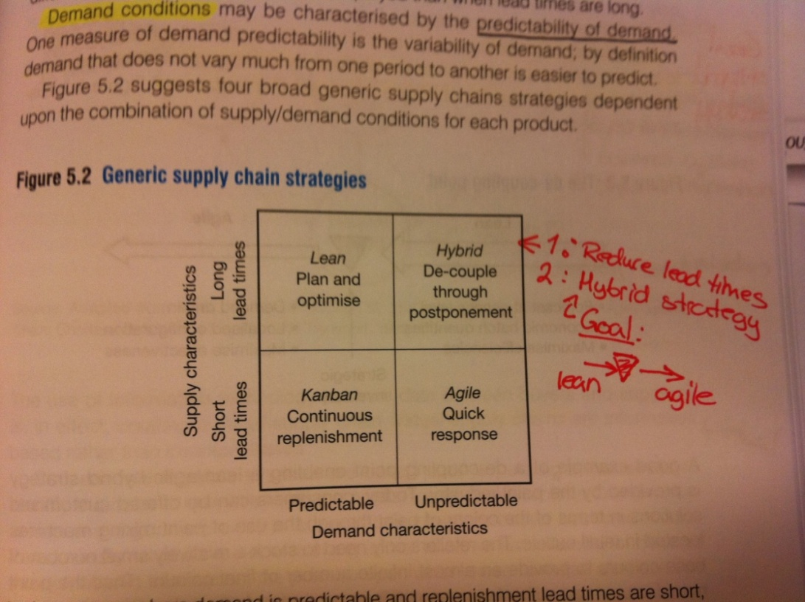

**A truly agile supply chain possesses the following distinguishing characteristics:**

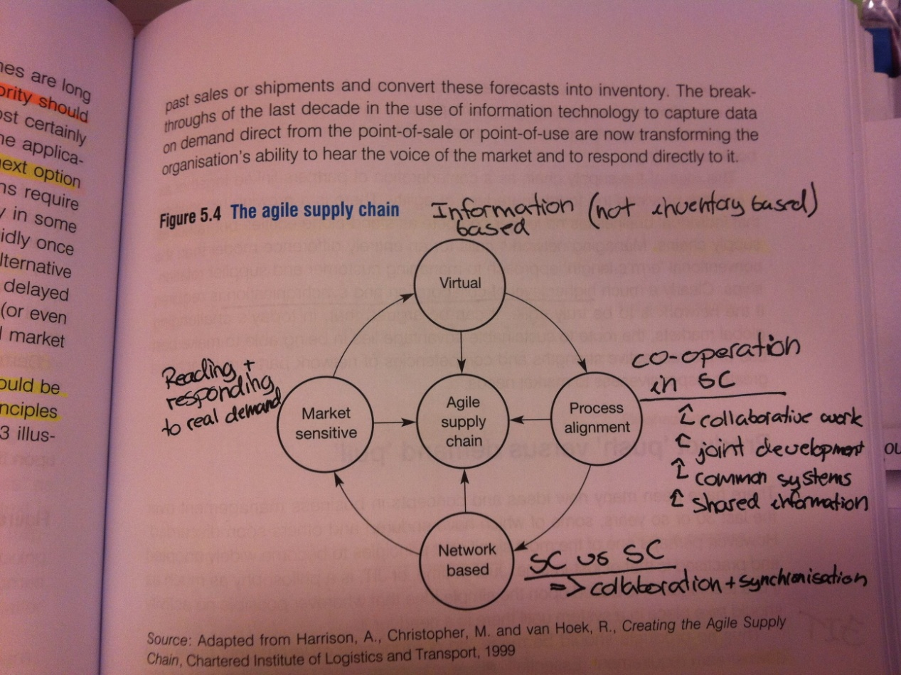

### The foundations of agility

1. **Synchronize activities through shared information**
   1. Shared information & process alignment
      1. POS data, production plans, schedules
2. **Work smarter, not harder**
   1. Supply chain mapping
      1. Reduce non-value-added time, time spent in inventory
      2. Remove parallel activities, practices performed for historical reasons
3. **Partner with suppliers to reduce in-bound lead times**
   1. Joint supplier/customer teams to explore opportunities for re-aligning and re-engineering processes.
   2. Knowledge transfer and best practice from supplier operations to customer – and vice versa
4. **Seek to reduce complexity**
   1. Multiple product variants, greatly different bill of materials within product families, frequent product changes
   2. Level of variety greater than required by customer?
   3. Seek commonality of components or sub-assemblies across product families
5. **Postpone the final configuration/assembly/distribution of products**
6. **Manage processes, not functions**
   1. Processes are horizontal, market-facing sequences of activities that create value for customers.
      1. Cross-functional by nature, best handled by interdisciplinary teams
   2. Process alignment between entities in chain is clearly facilitated if organizational structures are horizontal rather than vertical.
7. **Utilize appropriate performance metrics**

**A roadmap to responsiveness:**

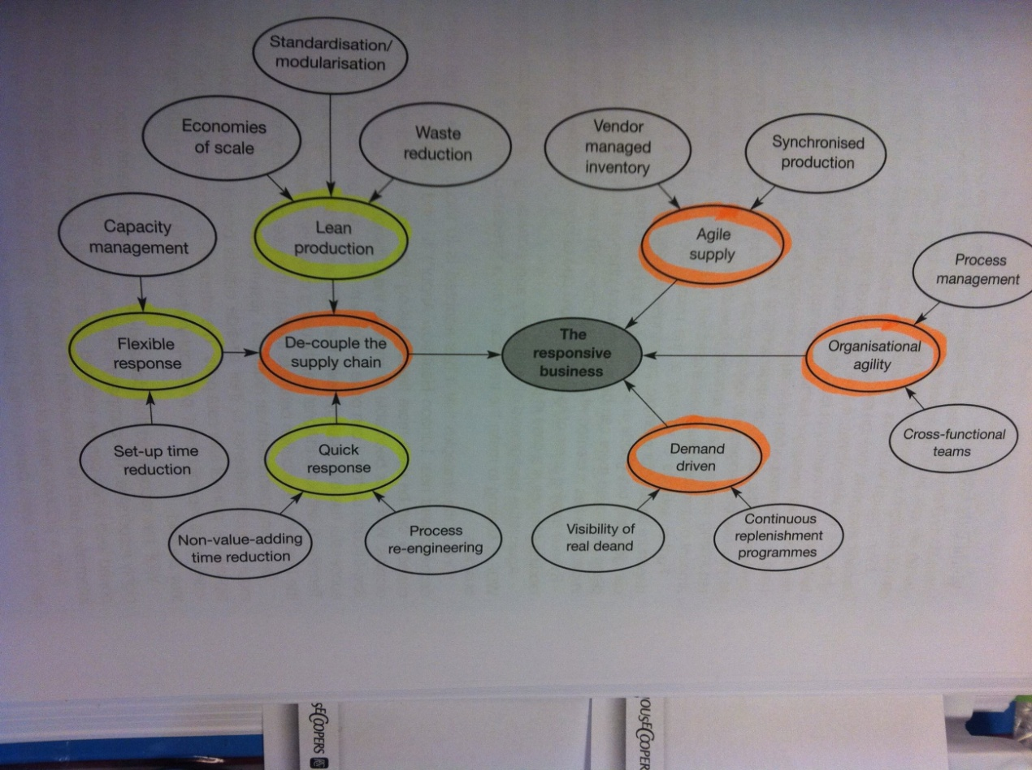

## Strategic lead-time management (Ch. 6)

Customers in all markets (industrial & consumer) **are increasingly time-sensitive**. Time therefore not only represent costs to the logistics manager (e.g. inventory holding costs), but extended lead times also imply a service penalty for the customer. Whilst price is still important, a major determinant of choice of supplier brand is the ‘cost of time’.

A longer pipeline from source to final user implies less responsiveness to demand changes and an obscured visibility of end-demand. This increases the need for safety stocks ($SS≈\sqrt{Pipeline}_length$)

|  |  |
| --- | --- |
| **Pressure** | **Characteristics** |
| **Shortening life cycles** | - Time available to develop new products, launch them and meet marketplace demand is greatly reduced.  - Timing becomes crucial and once the product is on the market the lead time to re-supply a market becomes crucial. |
| **Customer’s drive for reduced inventories** | - Almost universal move from companies to reduce inventories  - Timeliness of delivery becomes the order-winning criterion; imperative that suppliers can deliver JiT  - While many companies think they will have to carry the inventory instead of the customer, they should rather substitute responsiveness for inventory wherever possible. |
| **Volatile markets making reliance of forecasts dangerous** | - Forecast errors increasing as lead time increases  - Increasing demand volatility  - While the conventional response is increased safety stock, it is surely preferable to reduce lead times to reduce forecast error and the need for inventory. |

Table 3 – Pressures leading to the growth of time-sensitive markets

### Lead time concepts

**Customer lead-time:** order-to-delivery

**Supplier lead-time:** cash-to-cash

### Goals of logistics pipeline management

* **Lower costs**
  + - Value-adding time vs. non-value-adding time
      * Most value added early in the process and the product is therefore more expensive to hold as inventory
* **Higher quality**
* **More flexibility**
  + - Much flexibility lost as the product is configured
* **Faster response times**

## The synchronous supply chain (Ch. 7)

A tendency is for separate functions to seek to optimize own performance resulting in inventory buffers and time lags in the interfaces between organizations and functions within the organization. To overcome this problem, the supply chain needs to act as a synchronized network – requiring a higher level of process alignment, again demanding a higher level of collaborative working.

Under the synchronization philosophy the requirement is for small shipments to be made more frequently and to meet the precise time requirements of the customer. Through seeking economies of scale, supply chain partners might seek to ship by container or truck-load, discourage from ordering smaller quantities by price penalties and base delivery schedules on optimizing the efficiency of routes and the consolidation of deliveries. Thus a challenge to logistics management is to find ways in which these changed requirements can be achieved without uneconomic escalation of costs. This can be solved by:

* Early identification of shipping and replenishment requirements
* Highest level of planning discipline
* Combine orders from multiple suppliers into a single delivery
  + Often through the use of third-party logistics
    - Cross-docking

Today’s nature of business enterprise is changing towards an idea of an extended enterprise – eroded internal function barriers in favor of horizontal process management and gradual lessening of the separation between vendors, distributors, customers and the firm. Underpinning this concept of the extended enterprise is a common information ‘highway’ – the use of shared information enables cross-functional, horizontal management to become a reality.

### The role of information in the virtual supply chain

The extension of the information system beyond the classical dimensions of simple planning and control enables a direct link between the customer and supplier, and for the supplier to act (sometimes in real time) to changes in the market. The internet has transformed the way in which SC partners can connect, and provides a perfect vehicle for the establishment of the virtual supply chain enabling information sharing in a highly cost-effective way. Increasingly, successful companies seem to use their information and information technology to improve customer responsiveness. There is an emergence of integrated logistics systems – linking business operations with supplier operations and customer operations. The use of these systems has the potential to convert supply chains into demand chains in the sense that the system can now respond to known demand rather than having to anticipate demand through forecasts.

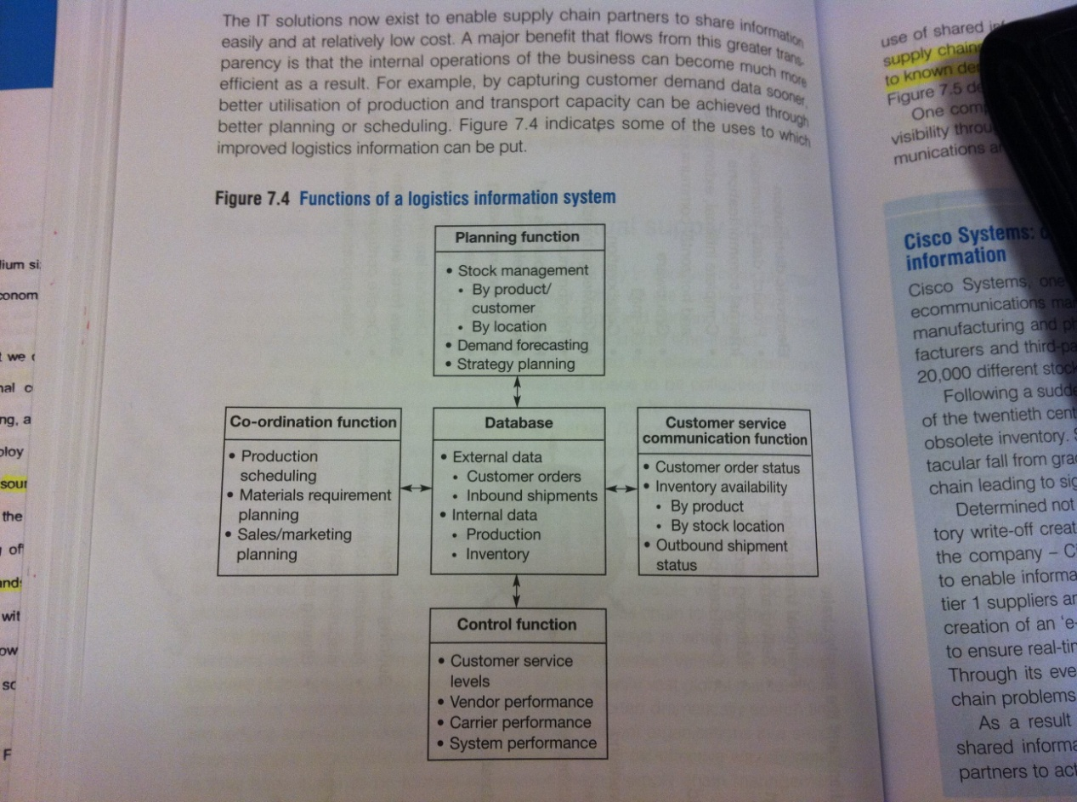

### Quick response logistics

In order to reap the advantages of time-based competition it is necessary to develop systems that are responsive and fast. QR is essentially an umbrella term for the information systems and logistics systems that combine to provide ‘the right product in the right place at the right time’. **The logic behind QR is that demand is captured as close to real-time as possible and as close to the final customer as possible.** The logistics response is then made directly as a result of that information.

In order for the QR logistics to work, the **production has to be flexible.** Whilst zero lead-times are not achievably, the new focus on flexible manufacturing systems has highlighted the possibilities of substantial progress in that direction. This indicates a fundamental shift; from economies of scale to economies of scope. The main barrier to flexibility is the ‘set-up times’ – if they can be driven as close to zero as possible, then flexible response to customer requirements is no problem.

**In essence QR can be summarized as this (from the slides):**

* Flexibility is key-word
  + Volume
  + Product features
* How?
  + Flexible manufacturing systems
  + Process simplification/redesign
  + Smart design (postponement)
  + Close network of key suppliers
  + …

# Week 4 – Global supply chains, risks, barriers to integration

## Complexity and the supply chain (Ch. 8)

Supply chains convey an idea of a series of one-to-one relationships. As the focal firm is at the center of a complex web of interconnected and interrelated yet independent entities, **one should rather talk of supply networks.** Due to trends of outsourcing and offshoring, the interdependency across the network has increased. This complex interdependency implies that unpredictable events in one part of the network can have unforeseen impacts somewhere else in the network. The growing volatility in the business environment increases the unpredictability of the events. To summarize, the increased complexity in the supply chain is a source of uncertainty and with the uncertainty comes an increased likelihood of forecast error. **The challenge for organizations is therefore to reduce their dependence on forecast and become more demand- and event-driven.**

### Cost of complexity

An increasing proportion of total end-to-end costs in the supply chain are driven by complexity in one form or another (often hidden in general overheads or cost of carrying inventory). In addition, most companies performing an 80:20 analysis will identify a ‘long-tail’ of customers who, whilst significant in numbers, actually contribute very little to overall profitability. The same analysis on a product level often shows a little amount of products generating a large amount of overall profit. There may be strategic reasons for maintaining a high level of variety, or possibilities to use other strategies to profit on slow movers (e.g. internet ‘long-tail’ principle). However, for most companies it is likely that a selective rationalization of slow-moving lines will have a positive impact on overall profitability.

### Sources of supply chain complexity

* **Network complexity**
  + Number of nodes and links in network (e.g. due to outsourcing)
  + Increased potential for unexpected disruptions
* **Process complexity**
  + Internal and external
    - Not producing the same set of products each day
  + Lengthy processes with many different activities creates extended lead times and are more prone to performance variability
  + Need for constant review of process structure and if necessary process re-engineering to keep complexity at a minimum
* **Range complexity**
  + Rang of products and/or services has a tendency to grow
  + As more variants are added the demand per variant is reduced, leading to a decreased forecast accuracy (=> inventory build-up)
* **Product complexity**
  + Choice of material and components (design)
    - Number of components, little commonality, replenishment lead time, time-to-market/volume, SC vulnerability, after sales support, late-stage customization
* **Customer complexity**
  + Non-standard service options or customized solutions
  + Usually a limited understanding of the true cost of serving individual customers – prepared to pay for complexity?
* **Supplier complexity**
  + Size of supplier base; number and types of suppliers
* **Organizational complexity**
  + Vertical vs. horizontal arrangements
  + Organic growth => increasing complexity
* **Information complexity**
  + Volume, accuracy of data flows
  + Visibility of actual demand
  + Directly/indirectly influenced by the preceding complexity sources

### Mastering complexity

1. Understand the sources of complexity
2. Undertake Pareto 80:20 analysis
3. Focus on the ‘long tail’
4. Which elements of complexity add value, and which do not?
5. Seek to eliminate non-value adding complexity

**From class; “successful companies have:”**

* Built in a lower degree of complexity in supply systems
  + Lower variety in finished goods
  + Lower number of subassemblies
  + Lower number of parts
* Lower number of suppliers per purchasing volume
* Splintered supply chains
  + Choosing production locations depending on variety in demand and volume

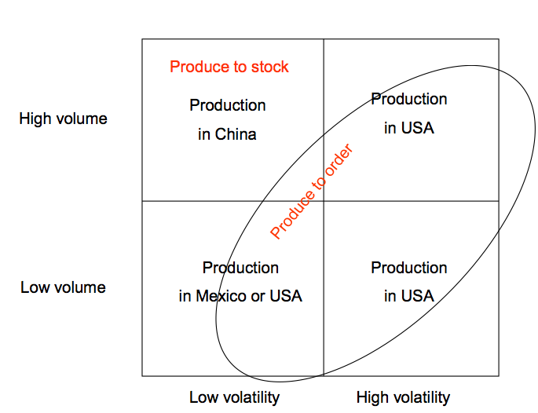

**Challenges:**

* Keep it simple, but not too simple
  + Danger of cutting away too much of the plant
    - Unique capabilities, competitive power
* How to cut away unwanted complexity while keeping desired?
* Difficult to pin-point core competences

## Managing the global pipeline (Ch. 9)

Global brands and companies dominate most markets, typically sourcing on a worldwide basis for global production and distribution with the goal of extending their markets whilst at the same time seeking cost reduction through scale economies and through focused manufacturing and/or assembly operations. While the logic behind this is strong, it presents certain challenges as the world markets are not homogeneous and the coordination of complex logistics of managing global supply chains may result in increased cost-levels and lead-times. In reality it is a total cost trade-off where the cost of linger supply chains may outweigh the production cost saving. **There is a danger that companies might run the risk of sacrificing service on the altar of cost reduction through a failure to fully understand the service needs of individual markets.** Whilst the brand may be global the product may need certain customization to meet specific country needs; **the paradox of global synergies vs. local responsiveness (strategipensum).**

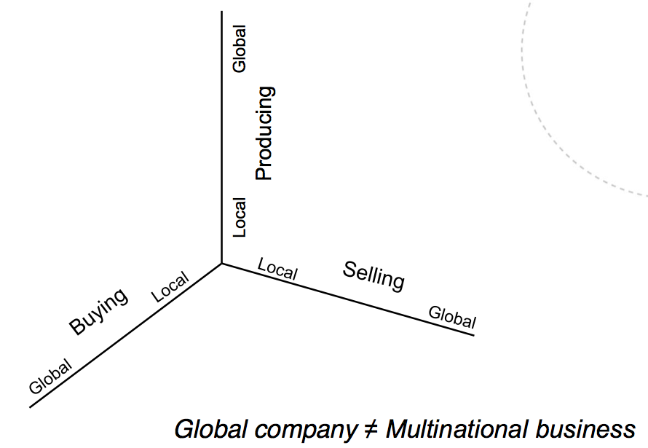**A multinational company is not a global company!**

**Dimensions of globalization:**

* Spatial dimension
  + Worldwide scope
* Variance dimension
  + Worldwide similarity
* Linkages dimension
  + Worldwide integration

**Sources of global synergies:**

* **Leveraging resources**
  + Resource reallocation
  + Resource replication
* **Integrating activities**
  + Scale advantages
  + Location advantages
* **Aligning positions**
  + Cross-border customers
  + Cross-border competition

### Trends in the globalization in the supply chain

1. **Focused factories**
   1. Economies of scale through limiting product range and mix manufactured in a single location
   2. Crucial trade-offs:
      1. Transport costs and delivery lead time
      2. Need for local packaging
      3. Product variety in one order
      4. Impact on production flexibility
   3. Typically less than 10& of a high-tech company’s costs are direct labor, hence an offshore decision to save on labor costs makes little sense if penalties are occurred elsewhere in the value chain
2. **Centralized inventory control**
   1. Consolidating inventory in fewer locations to reduce total inventory requirements
   2. May be even greater gains by locating the inventory strategically near the customer or production point, but managing and controlling it centrally
      1. Providing local variety
      2. Managing more complex chains
      3. Exploiting cost advantages
   3. Requires an information system that can provide complete visibility of demand from one end of the pipeline to the other in as close to real time as possible.
3. **Postponement and localization**
   1. There are still significant local differences in customer and consumer requirements.
   2. Designing products using common platforms, components and modules – but allowing the final assembly or customization to take place as the final market destination and/or customer requirement is known.
      1. Generic inventory level => easier forecasting
      2. Greater flexibility
      3. Higher variety level offered at lower total cost

**Rooted networks vs. footloose networks:**

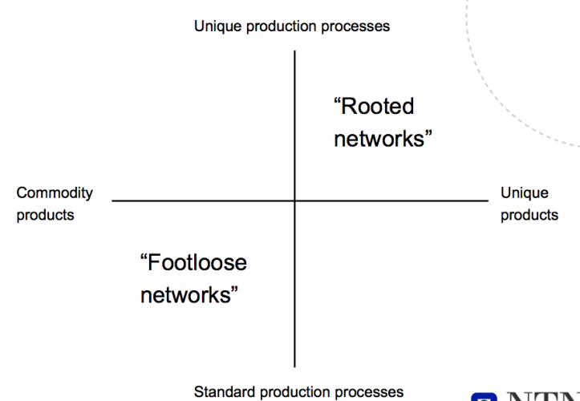

### Supply chain event management (SCEM)

There is often a higher level of uncertainty about the status of a shipment in transit in global pipelines, and local managers tend to compensate for this by over-ordering and by building inventory-buffers. SCEM is the process of monitoring the planned sequence of activities along a SC and the subsequent reporting of any divergence from that plan. This enables organizations to gain visibility upstream and downstream of their operations and to assume an active approach to supply risk. The complexity of most supply networks is such that event management in reality needs to be restricted to the critical parts of the network.

### Organizing for global logistics

1. **Centralized structure and control**
   1. Strategic structuring and overall control of logistics flows must be centralized to achieve worldwide cost optimization
2. **Localized customer service management**
   1. Control and management must be localized against the requirements of specific markets to ensure competitive advantage is gained and maintained.
3. **Outsourcing and partnerships**
   1. AS the rends towards outsourcing everything except core competencies increases, so does the need for global co-ordination
4. **Logistics information**
   1. A global logistics information system is a prerequisite for enabling the achievement of local service needs whilst seeking global cost optimization.

**Plant strategies:**

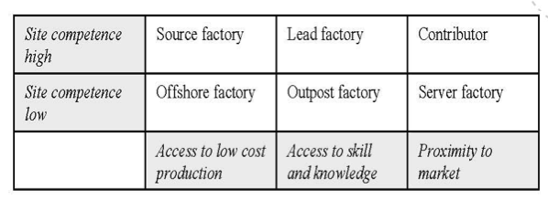

**Global co-ordination and local management:**

|  |  |
| --- | --- |
| **Global** | **Local** |
| Network structuring for production and transportation optimization | Customer service management |
| Information systems development and control | Gathering market intelligence |
| Inventory positioning | Warehouse management and local delivery |
| Sourcing decisions | Customer profitability analyses |
| International transport mode and sourcing decisions | Liaison with local sales and marketing management |
| Trade-off analyses and supply chain cost control | Human resource management |

**True cost of global sourcing:**

* Transportation costs
* Exchange rate fluctuations
* Inventory needs and lead time
* Risk of obsolescence
* Quality problems
* Loss of intellectual property
* Carbon footprints

## Managing risk in the supply chain (Ch. 10)

An increasing demand volatility in almost very industry sector coupled with shortened technology and product life cycles makes today’s marketplace turbulent and uncertain. This happens at the same time as the industries are adopting ‘lean’ practices, moves towards outsourcing and tends to reduce the size of the supplier base – all making the supply chains more vulnerable to disturbance or disruption. As a result of this heightened risk, organizations need to develop appropriate programs to mitigate and manage the risk. The alternative could be that unplanned or unforeseen events have severe financial effects over the network as a whole, ultimately impacting the share-price as the problem becomes public knowledge. Whilst most organizations recognize the need to regularly assess their risk profile, the assessment tends to be focused on broader regulatory financial risks –rather than the supply chain vulnerability with its internal and external risks (whist external risk cannot be influenced by managerial actions, internal risk can).

### Reasons for supply chain vulnerability

1. **A focus on efficiency rather than effectiveness**
   1. Cutting costs by focusing on inventory reduction (JiT)
      1. Of merit in stable market conditions, but may become less viable as demand volatility increases
   2. => Challenge of best combining ‘lean’ and ‘agile’ practices
2. **The globalization of supply chains**
   1. While the motivation of offshore sourcing and manufacturing is cost reduction, total supply chain costs are rarely considered. A result is often higher risk levels due to extended lead times, greater buffer stocks and potentially higher obsolescence levels.
3. **Focused factories and centralized distribution**
   1. Reduction of trade barriers
   2. Economies of scale y manufacturing greater volumes at fewer sites
   3. Tendency to centralize distribution
4. **The trend to outsourcing** 
   1. Strong logic behind focusing on activities in which companies have a competitive advantage. However, outsourcing also brings with it a number of risks, not least being the potential loss of control.
5. **Reduction of the supplier base**
   1. Several cases where major supply chain disruptions have been caused because of a failure at a single source. Even though there are benefits to the reduction, it has to be recognized that it brings with it increased risk.

### Understanding the supply chain risk profile

$$Supply chain risk=Probability of disruption x Impact$$

A weakness of this risk definition is that it may lead to a failure to recognize that supply chains may be at their most vulnerable where the probability of occurrence is small, but the potential impact could be catastrophic.

To help identify the risk profile of a business it is helpful to make an audit of the **main sources of risk across the network (included in slides).** It is important for senior management to understand that the risk profile is directly and indirectly impacted by the strategic decisions that they take. Business decisions should therefore be examined in terms of how it may affect vulnerability from the five risk sources described below.

|  |  |
| --- | --- |
| **Risk source** | **Description and determinants** |
| **Supply risk** | Vulnerability to supply disruptions?  May be higher due to global sourcing, reliance on key suppliers, poor supply management |
| **Demand risk** | How volatile is demand?  Bullwhip effect causing demand amplification? Parallel interactions where another product’s demand affects the demand for ours? |
| **Process risk** | How resilient are our processes?  Understanding of sources of process variability? Bottlenecks? How much available additional capacity is available if required? |
| **Control risk** | How likely are disturbances and distortions to be caused by own internal control systems?  Order quantities, batch sizes and safety stock policies can distort real demand. |
| **Environmental risk** | Where across the supply chain as a whole are there vulnerabilities for external forces? Type and timings of extreme external events might be difficult to forecast, but the impact needs to be assessed. |

### Managing supply chain risk

1. **Understand the supply chain**
   1. A general lack of awareness of what lies upstream from first tier suppliers
   2. For complex supply chains it would be appropriate only to look in detail at the ‘critical paths’
2. **Improve the supply chain** 
   1. Simplification, improving process reliability, reducing process variability, reducing complexity (e.g. by six sigma methodology)
   2. Supply chains tend to develop organically – not be designed in a holistic way
3. **Identify the critical paths**
   1. The vulnerability of the supply network is determined by the risk of failure of these nodes and links
   2. Critical paths tend to have a number of characteristics:
      1. Long lead time
      2. Single source of supply, no short-term alternative
      3. Specific infrastructure dependence
      4. High concentration amongst suppliers and customers
      5. Bottlenecks or ‘pinch points’
      6. High levels of identifiable risk (the 5 risk sources)
   3. FMEA – Failure Mode and Effect Analysis
      1. 1
         1. What could go wrong?
         2. What effect would this failure have?
         3. What are the key causes to this failure?
      2. 2
         1. What is the severity of the effect of failure?
         2. How likely is his failure to occur?
         3. How likely is the failure to be detected?
4. **Manage the critical paths**
   1. Mitigation or removal of risk
   2. Contingency plans or re-engineering of supply chain
   3. Cause and effect analysis can be used here
5. **Improve network visibility**
   1. It can take weeks or months before problems become visible, by which time it may be too late to take effective action
   2. The challenge is not technological, but the need to engender a greater willingness of SC entities to share information with each other, even if that information is not always good news.
6. **Establish a supply chain continuity team**
   1. Should be extended in scope from the largely IT/IS focused continuity teams to take account of the fact that the biggest risk to business continuity lies in the wider SC.
   2. Cross-functional, access to all skills necessary to undertake a detailed analysis and implementation.
7. **Work with suppliers and customers**
   1. If each entity in the network took responsibility for implementing risk management procedures with their immediate first tier suppliers and customers, then a far more resilient supply chain would emerge.
   2. 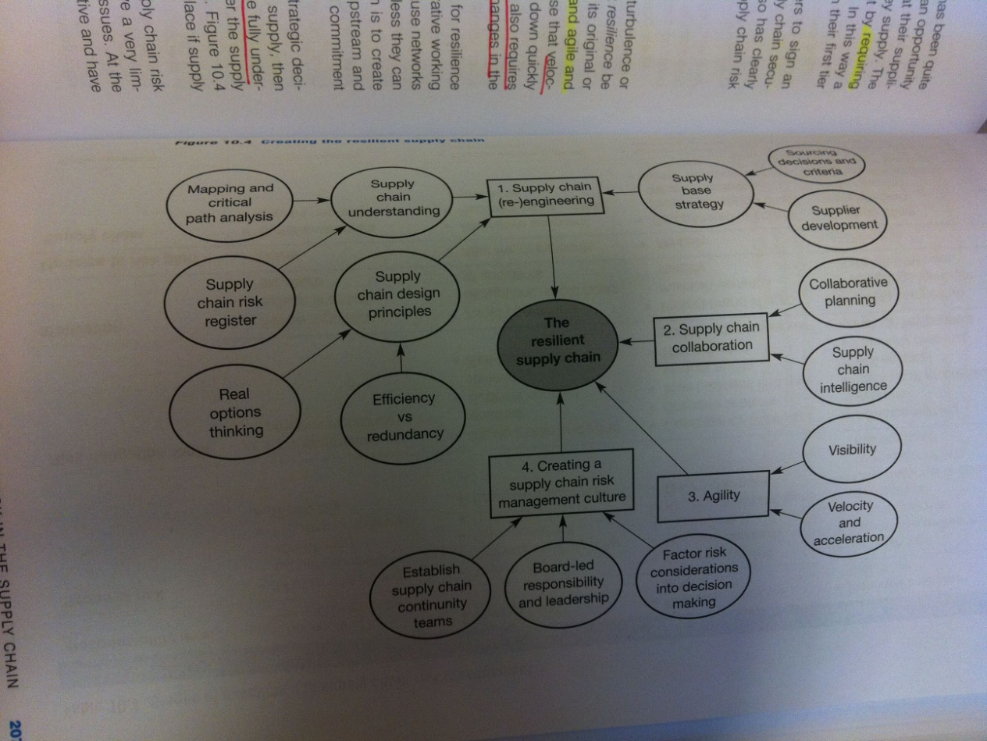

## The era of network competition (Ch. 11)

Based on an analysis of leading companies, a survey have identified six consistent characteristics exhibited by those companies:

* **Outside-in focus**
  + Designed from the customer backwards and demand driven
* **Embedded innovation**
  + Close integration of product design, manufacturing and logistics
* **Extended supply chain**
  + Close management of relationships from end-to-end
* **Balanced metrics**
* **Attitude**
  + Recognition of the need for internal silos to be removed and that external partnerships must be managed in a spirit of partnership
* **Supply chain talent**
  + Enabling success in the previous five elements

Individual businesses do no longer compete as stand-alone entities, but rather as supply chains. Making networks more effective in satisfying end-user requirements demands a high level of cooperation between organizations, along with the recognition of the need to make inter-form relationships mutually beneficial. The key to success in this new competitive framework is the way in which this network of alliances and suppliers are welded together in partnership to achieve mutually beneficial goals. The closer the relationship between buyer and supplier, the more likely it is that the expertise of both parties can be applied to mutual benefit. The book here introduces the philosophy of co-makership; the supplier should be considered an extension of the customer’s operations with the emphasis on continuity and a ‘seamless’ end-to-end pipeline. This philosophy can be extended to both ends of the pipeline.

### Managing the supply chain as a network

1. Collective strategy development
   1. Network members must collectively agree strategic goals for the network and the means of attaining them.
2. Win-win thinking
   1. At a minimum all partners should benefit and be better of as a result of cooperation (need not mean 50/50).
3. Open communication
   1. Visibility and transparency of relevant information throughout the supply chain is essential

### Seven major business transformations and their implications for management skills

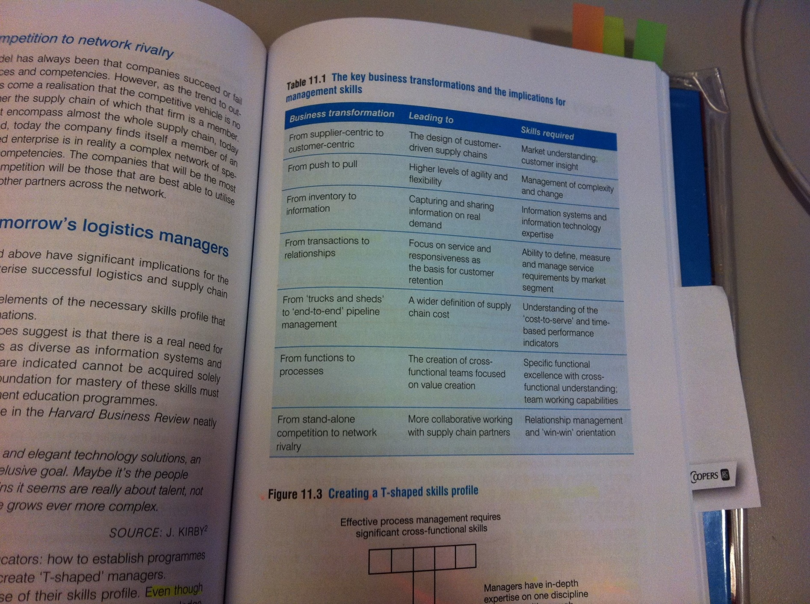

## Overcoming the barriers to supply chain integration (Ch. 12)

Traditional organizations have grown heavy with layer upon layer of management and bureaucracy, with little chance of remaining competitive in the new market place. It is not sufficient to rely on removing layers of management, unless it is accompanied by equivalent change to the networks and systems that deliver service to the customer.

Companies have found significant benefits in defining a logistic vision statement for the firm, giving a clear indication of the basis on which the business intends to build a position of advantage through closer customer relationships. The major barrier to implementation of the logistics concept is organizational – the entrenched and rigid organizational structures that most established companies are burdened with.

### Problems created by conventional organization

1. **Inventory builds up at functional boundaries**
   1. Individual functions are encouraged to optimize their own costs
   2. Obscured visibility of real demand
2. **Pipeline costs are not transparent**
   1. Difficult to measure costs relating to flow of materials across functional areas
   2. The costing systems are designed to monitor functional or input costs rather than flow or output costs
3. **Functional boundaries impede process management**
   1. Organic growth tend to add to existing processes in a patchwork manner rather than taking a ‘clean piece of paper’ approach
4. **Conventional organizations present many faces to the customer**
   1. No one person or department is empowered to manage a customer from enquiry through to order delivery.

### Characteristics of a horizontal organization

* Organized around processes
* Flat and de-layered
* Built upon multi-functional teams
* Guided by performance metrics that are market based

**Typical core processes:**

* Innovation
* Consumer development
* Customer management
* Supplier development
* Supply chain management

### Benchmarking

Measures only have meaning when they are compared against a relevant ‘metric’ or benchmark. In this it is important to remember that:

1. The ultimate measuring rod is the customer
2. It is not sufficient just to compare performance to that if immediate competitors
3. Not just outputs should be measured and compared, but also the processes that produce that output

The objective of creating competitive advantage involves outperforming rather than matching the efforts of competitors. The benchmarking is therefore expanded from a focus solely in competitors to a wider, but selective, focus on the processes of top performing companies regardless of their industry sector.

**Benefits derived from benchmarking:**

* Enables best practices from any industry to be creatively incorporated into the processes of the benchmarked function
* It can provide stimulation and motivation to the professionals shoes creativity is required to perform and implement benchmark findings
* Benchmarking breaks down ingrained reluctance of operations to change
* Benchmarking may identify a technological break-through that would not else have been recognized, and thus not applied, in one’s own industry for some time to come.

**KPI:** Whilst there are many performance measures that can be deployed in an organization, there are a relatively small number of critical dimensions that contribute more than proportionately to the success or failure in the marketplace.

**Balanced scorecard:** There are a number of KPIs – most of them probably non-financial measures – that will provide management with a better means of meetings strategic goals than the more traditional financially oriented measures.

### Identifying logistics performance indicators

1. Articulate logistics and supply chain strategy
2. What are the measurable outcomes of success?
3. What are the processes that affect these outcomes?
4. What are the drivers of performance within these processes?
   1. 4 common key outcomes: Better, Faster, Cheaper, Closer

What gets measured gets managed – it is therefore important to ensure that the logistics scorecard is designed to encourage the actions and behavior that will lead to the fulfillment of the logistics vision. Organizational change should begin reviewing the performance measures already in use!

# Week 6 – Introduction to purchasing management, evolution

## The evolution of purchasing and supply management (Ch. 2)

**The author’s definition of strategy:**

*“An integrated set of choices positioning a firm in an industry to earn superior financial returns over the long run”*

In the 1990’s we started to look upon purchasing as an important and strategic process. Part of this redefinition has been to differentiate between purchasing operations, purchasing strategy and purchasing as a strategic function.

*Purchasing operations* deal with the day-to-day buying activities of the firm, while *purchasing strategy* refers to the specific actions of the function to achieve its goals. Only when the activities and strategies of the purchasing function are aligned with the overall strategies of the firm *can purchasing be a strategic function*.

As a strategic function, purchasing can contribute to shaping firm strategy and firm boundaries. For example, a supply manager might be tasked with assessing strategic options in outsourcing elements of the firm’s activities. This might include examining the best way to organize the supply structure.

Further, once the organization accurately identifies what is core to their business, supply strategy could the focus on these non-core areas. The firm’s strategic vision, for example, may not include assembly, but identify design as a core to its business. The firm’s supply strategy would therefore be to outsource assembly to other organizations. Supply management must translate the firm’s corporate strategy into an appropriate supply strategy which is then manifested in the supply base activities of the firm.

Supply management is concerned not only with the input but also the transition and management process of goods and services through the enterprise. Its aim is to make the enterprise more competitive, involving not only purchasing goods and services at competitive prices but also focusing on cost reduction techniques, improving cycle times, reducing time-to-market, and constantly seeking to exploit actual and potential innovations from within the supply market.

### Drivers of purchasing evolution – PEST

The prime reason for purchasing assuming a more strategic focus stems from the many pressures placed upon it from the competitive environment. A simple PEST model illustrates this point.

**Political pressures**

Factors:

* Export/import
* Privatization
* Funding
* CSR
* Constraints of regulation
* Focus on reduction in public expenditure and overhead
* protectionism

**Economic pressures**

Factors:

* Inflation
* Recession/depression
* Emerging low-cost manufacturing and global competition
* Industrial alliances
* Corporate mergers

**Social pressures**

Factors:

* Need for well-qualified personnel
* Customer awareness of social issues
* Ethical sourcing
* Labor rates
* Quality of working life
* Changing role of managers
* Job losses from outsourcing
* Environmental and ethical issues

**Technological issues**

Factors:

* Advancement in IT
* Electronic catalogues, online auctions and internet portals
* Shorter innovation cycles
* Reduction in time-to-market
* Increased global connectedness

### The role of the purchasing function

It is critical to understand that there is a difference between purchasing strategy and purchasing performing as a strategic function. When purchasing is viewed as a strategic function, it is included as as key decision maker and participant in the firm’s strategic planning process. Three distinct types of “purchasing strategy” are proposed:

* Purchasing function *implements competitive strategy*
* Purchasing function *supports strategy* of other functions and those of the firm as a whole
* Purchasing function *drives* strategy of the firm

#### Judging purchasing contribution to strategy

One of the earliest typologies of purchasing function development was a four-stage model developed by Reck and Long, which evaluates the competitive role and contribution of purchasing to any type of company. It begins with a contribution in Stage 1 which is largely passive, through to purchasing becoming a competitive weapon of the organization is Stage 4.

The stages help managers assess their current position and identify the type of changes in attitudes, practices, and procedures needed to shift purchasing from a clerically oriented function to a strategic contributor.

#### The scope of strategic supply management

From dyadic relationships 🡪 triad relationships 🡪 network relationships

## A1: Specifications

*Nellore et al*

People engaged in development work communicate requirements with the help of specifications. Unfortunately, suppliers do not always satisfy these specifications.

Problems regarding specs are often due to suppliers interpreting the term “specification” in different ways. Kamath and Liker (1994) have classified suppliers into four types, which are as follows:

* *Partners*: Are able to develop entire subsystems and work with different concepts through independent engineering capacity.
* *Adult*: Need only rough specifications as a base for starting the development work.
* *Child*: Need complete and detailed specifications to commence work
* *Commodity*: Make standard parts that can be ordered from a catalogue.

The authors researched this, and found out that there were 8 different parameters that were central in which a supplier looked upon a specification.

* **Communication**A specification is a document that is used in building a product. Because changes are a part of the development process, specs must reflect the changes. Making all changes incorporated into the specification would lead to improved communications and a quality product, because all-important details regarding the product and its interfaces would be documented and not overlooked.

To strengthen communication and avoid confusion-related errors, redundant statements need to be minimized. Specs need to be discussed further to avoid misunderstandings. Face-to-face communication is best for solving problems.

* **Product requirements**The product requirements can be separated into a general description of the product and a technical description to allow satisfactory performance in use. Specifications need to mention not only the end product but also the ways and means of obtaining it. The specs should contain quantitative measurement indicators demonstrating that the requirements and benefits have been met to the extent needed by the customer.
* **Functionality**

Functionality refers to the practical use of the product rather than the technical details. A spec may contain a list of functionalities and requirements needed to meet them.

* **Process requirements**

A spec can include the process requirements that will be used for manufacturing the product. The process requirements should be mentioned in the specifications to validate that the product can be produced in the manner the customer requires.

* **Standards**

Specs can cover standards that are to be followed in manufacturing a product. E.g. standards for:

* Components
* Legal issues
* Performance
* Country

Knowing and understanding all the different standards can help prevent late changes. Standards are an important part of specifications and can be used in the dialogue with suppliers.

* **Drawings**

Because many features in a specification need pictorial explanations, the spec may contain drawings. It is important to remember that drawings are the outcomes of specs, and not vice versa. Drawings can provide details that cannot be put into writing.

* **Customer requirements**

Customer requirements give the necessary impetus (drivkraft) to create the product requirements, which in turn lead to the process requirements. Thus, specs need to cover all three sets. It is important that the product and process requirements be created in parallel with identifying the customer requirements.

* **Level of technology**

Technological sophistication influences the interfaces between the different components and systems within a product. Statements on the proposed functionality of a product must consider the level of technology involved. Specifications can consider whether the technology is static (remains the same compared to previous components) or dynamic (contains innovation).

*Smith and Reinertsen define a spec as “a written description of a product to guide the development process.” We argue that such guidance can be improved if the specifications satisfy the eight integrated parameters discussed.*

# Week 7 – Make or buy

## The make-buy decision: a theoretical perspective (Ch. 3)

The link between the make-buy decision, corporate strategy and supply strategy is clear: the decision determines the areas where the firm will compete and those it will leave to others

The aggregation of make-buy decisions defines the boundaries of the firm. The boundaries of the firm are the combined activities that an organization performs in-house rather than using external suppliers. Boundaries are therefore concerned with both *the scale of production* (how many widgets are we going to produce?) and the *scope of production* (what widgets are we going to produce?)

The firm could choose to make at all stages in the SC, a situation known as vertical integration. A good example of this is the oil and gas industry, where companies like Shell and BP control the entire SC.

### The inadequacy of neoclassical economic theory

* The neoclassical view of the firm is one of a production set, transforming input to output
* The neoclassical manager enjoys complete rationality and full information to maximize the owners profits
* The profit maximizing level of output determines production levels
* The firm will continue to increase production until marginal revenue equals marginal cost, thus maximizing profit.
* The reason for the firm to exist is to make profit,
* Firms are homogenous entities because of perfect information

Given that contracts are less costly than hierarchies and that the objective of firms is to maximize profits, Barney and Ouchi argue that all transactions should be conducted in the marketplace.

Neoclassical theory tells us little about the make-buy decision. We need prescriptive theory that examines the characteristics of a given situation and helps to derive a well-informed and rational choice.

**We got two approaches:**

* Transaction cost economics
* The resource based view

### The transaction cost approach

Ronal Coase asserted that firms exist due to what he termed transaction costs, or the price of using the open market price mechanism.

The application of TCE to the make-buy decision can be seen with reference to the figure below

**Transaction characteristics**

**Behavoural characteristics**

**Level of transaction costs**

**Make or buy?**

We can define transaction costs as the costs of planning, adapting, coordinating and safeguarding exchange. The higher level of these transaction costs, the more likely the firm is to “make” rather than “buy”. The benefit of TCE is that it provides a clear and structured framework to assist in the decision-making process.

The level of transaction costs depend upon behavioral and transaction characteristics;

**Behavioral characteristics include two key-assumptions:**

* Opportunism: “self interest seeking with guile
* Bounded rationality

**Transaction characteristics:**

* **Asset specificity**: considers how specialized a particular asset is to relationship. Specialized assets are risky in that the full production value of the asset cannot be transferred if a contract or relationship is prematurely terminated
* **Uncertainty**: environmental costs, behavioral costs

#### TCE and the make-buy decision

The basic understanding of TCE is that firms must make investments to transact with each other. These investments are relationship specific; their value in another relationship is appreciably lower (perhaps even lower).

(Where the transaction demands investment in relationship-specific assets parties may be liable to opportunistic behavior. Not all actors will behave opportunistically but due to the effects of bounded rationality and uncertainty it is not possible ex ante to distinguish whose who will cooperate from those who will be opportunistic.)

The make-buy decision is one of efficiency: the optimal choice is the one that minimizes the transaction costs of the exchange.

#### TCE criticism

**TCE does not address the limitation of firms.**

TCE assumes that the capabilities required for production pre-exist or can be developed equally in all firms. However, capabilities have been shown to be both heterogeneous and path dependent

**TCE is a theory of cost minimization, not of value maximization**

Zajac and Olsen suggest that the value created in a transaction may be greatest under circumstances that may, from a TCE perspective, appear inefficient. Firms do not exist simply because of market failure, but have positive, value creating attributes not found in markets.

### The capability approach

The capability approach is associated primarily with the resource-based view of the firm founded by Penrose. Penrose argues for the firm as a bundle of productive resources under the direct control of the administrative unit.

A basic assumption in the RBV is that resources are heterogeneous and endowed with differential levels of efficiency.

The conditions under which competitive advantage can be sustained are of particular interest. Three criteria are identified; imperfect limitability, imperfect substitutability and imperfect mobility.

### The RBV and the make-buy decision

The RBV is an attempt to advance a reason for the existence and boundaries of the firm independent of the effects of opportunism.

Firms are positive entities that exist because the combination of specific resources garners advantage that is not available in market forms of transactions

#### The resource-based approach to the make-buy decision

Have we got the capabilities required to make this product?

Can we develop the required capabilities to make this product?

Can we acquire the required capabilities to make this product?

**Make**

**Make**

**Buy**

**Make (M&A)**

YES

YES

YES

NO

NO

NO

The choice between these various options is predicated on the costs of developing and acquiring capabilities. There are several reasons whit it may be costly to develop resources internally:

* Historical context
* Path dependence
* Social complexity
* Causal ambiguity

Where the costs of developing the required resources are prohibitively high, managers must look outside the boundaries of the firm. Resources can either be acquired from another firm, through either a merger or an acquisition, or the y may simply choose to source from an external supplier.

## A2: A satisficing model of outsourcing

*de Boer et al.*

*There appear to be discrepancies (avvik) between many of the prescriptive outsourcing models in the literature and the processes observed in practice The satisficing concept provides a useful explanation of these discrepancies and useful design principles for developing more realistic prescriptive outsourcing decision models.*

* The authors suggest that many managers find it difficult to transfer general frameworks for outsourcing into practical decision making action.
* Boyson et al. (1999) suggest that strategic outsourcing of integrated activities along the SC – using third part logistic (3PL) service providers – will be more effective than “piecemeal” outsourcing of separate activities.
* The purchasing of comprehensive logistics services is increasingly becoming more complex. Factors contributing to the complexity:
* The difficulty to specify the logistical needs
* The sometimes limited number of capable suppliers
* *“Satisficing” model of outsourcing*: The satisficing model implies a process of constrained but intelligent search for – and development of – a reasonable sourcing solution rather than an effortless process of finding the best solution form a complete and give set of solutions.
* Arlbjørn et al. (2004) point out that *outsourcing* implies going through a process which includes determining what should be outsourced, selecting a supplier, project completion and supplier management.

**Empirical accounts**

From the literature we conclude that:

* Firms outsource distinct sets of subsystems of their overall logistics system.
* Increasingly, firms outsource bundles of such subsystems to a single 3PL provider.
* It is difficult to specify such bundles, which in turn complicates writing clear RFP’s and comparing provider proposals. Usually after starting to work with an external provider the details of the specification emerge.
* Often, firms perceive (oppfatter) that there are few if any capable providers and that development of a provider is the only option
* The outsourcing process contains various loops back to earlier stages.

**Analysis of the cases researched**

* The decision which logistics activity should be outsourced does not appear to result from a systematic and pro-active process. Instead, considering a logistics activity as a candidate for outsourcing is triggered by a problem and/or an opportunity.
* Outsourcing is often triggered by a problem and/or an opportunity
* The logistics activity to be outsourced is specified without a systematic analysis of the supplier market. Knowing a particular service provider may influence the decision which activity to consider for outsourcing.
* Top management usually selects the logistics activity – in a broad sense – but the selection of the provider is often assigned to the more operational level. What is expected from this level is the recommendation of a provider. The existence of two decision groups at different hierarchical levels, sometimes separated geographically, inhibits interaction and feedback. The outsourcing process is broken in two phases – what to outsource and to whom – leading to a forced selection of a provider.
* Logistics activities are typically considered on an individual basis rather than in relation to each other, leading to separate searches for providers.

Conclusion from the cases: Both cases studied exhibit a decision-making process that is essentially reactive, lacks systematic and comprehensive evaluation of outsourcing options, considers only a few supplies and that takes place in different hierarchical levels.

**Explaining the practice of logistics outsourcing: a satisficing view**

* The general idea of ***bounded rationality*** is that the decision maker’s capacity to discover alternatives and gather and process information is limited.
* As a consequence of bounded rationality, decision makers cannot maximize on a global level but instead satisfice, meaning that search for a solution terminates as soon as a satisfactory solution has been found.

Let us now project the features of the satisficing concept onto the prescriptive outsourcing models:

* Bounded rationality rules out that in an outsourcing process all in-house activities and all combinations of such activities are explicitly identified let alone evaluated. *A firm can only identify in detail some activities at a time and compare estimates of internal costs with expected costs of outsourcing to some providers*. This is also typically what appears from the empirical accounts of outsourcing.
* Neither the activities that are the candidates for outsourcing nor the potential providers are necessarily ready to “be discovered”. The empirical accounts of outsourcing clearly provide examples of modifications of the activities to be outsourced as well as upgrading of suppliers. *A firm should not expect to find a large number of capable providers for each possible activity it considers for outsourcing*. It therefore seems reasonable to explore the possibilities of developing external or internal providers in case there are none or very few readily available and to vary the scope of the activity considered for outsourcing.
* It is clear that in the outsourcing practice both cognitive and experiential search and evaluation are used. Cognitive search is a off-line, cognitive process based on a simplified representation of reality.

**A satisficing model of outsourcing logistics activities**

The previous section provided us with three design principles for developing prescriptive outsourcing models.

Principle 1: Accept and work form the premise that any outsourcing study must be incomplete and selective.

Principle 2: Neither the system boundary of the activity under consideration nor the capabilities of potential service providers must be taken for granted.

Principle 3: Search for and evaluation of outsourcing alternatives can both be cognitive and experimental.

How the model then could be designed:

* The starting point is that one or more logistics activities draw the attention of a decision maker as a result of internal and/or external stimuli. The sensing of such stimuli could perhaps be improved by monitoring systems, diagnostic checklists and so on.
* Next step is to sketch or imagine a limited set of sourcing options. Alternative sourcing options are generated by varying the system boundaries of the activity and varying the capabilities of the provider.
* The next step is to assess to what extent the firm can reasonably evaluate and compare the sourcing options.
* Next, a tentative solution is determined by evaluating the sourcing options with regard to relevant criteria such as “integral costs”, “contribution to competitive advantage” and the relative risk surrounding each option.

# Week 8 – Sourcing strategies; Electronic Procurement

## 4. Sourcing strategies

### Supply base reduction (SBR)

The move towards increased supplier integration in the 90’s spawned a strategy called supply base reduction. This means working more closely with fewer suppliers. By reducing the number of suppliers that a firm has to manage it can focus its resources. This strategy may realize short-term cost saving and is supported by manufacturing systems such as lean manufacturing. But SBR is not without problems. By reducing the supply base firms change the market and power dynamic of their inter-firm relationships. When a supply base is reduced the nature of the inter-firm relationships changes from being relatively independent to becoming relatively dependant. Problems may occur, as; over-reliance on suppliers that are not capable of working in a more collaborative manner.

We look at three main types of costs that’s affected by SBR:

* **Operational costs**
  + Costs of running day-to-day relationship, e.g. cost of producing the purchase order, invoicing and so on
  + Objective
  + Easy to measure
* **Managerial costs**
  + Costs of managing the relationship, e.g. problem solving, travelling to visit the supplier, quality workshops, supplier conferences etc.
  + More subjective/less objective
  + Harder to measure
* **Strategic costs**
  + Strategic risk. i.e. the ability for a supplier to act opportunistically.
  + Subjective
  + Hard to measure

The more subjective the cost, the harder it is to measure, and therefore the less likely they are to be considered by the firm. If we consider the impact of these costs, we see that operational costs have relatively low impact on the business; however, as the costs increase in subjectivity and sophistication they have a much larger impact on the business.

## 

### Sourcing strategies

The choice of sourcing strategy depends upon many factors, the most important being importance of a goods or service, competitiveness of the marketplace, and technical complexity.

To help buyers formulate sourcing and competitive strategies, Kraljic develop a simple positioning matrix based on these factors. Kraljic identified four key purchasing strategies. He suggested that selecting the best supply strategy is a function of the level of supply exposure, technical risk, and the strategic nature of the product or service.

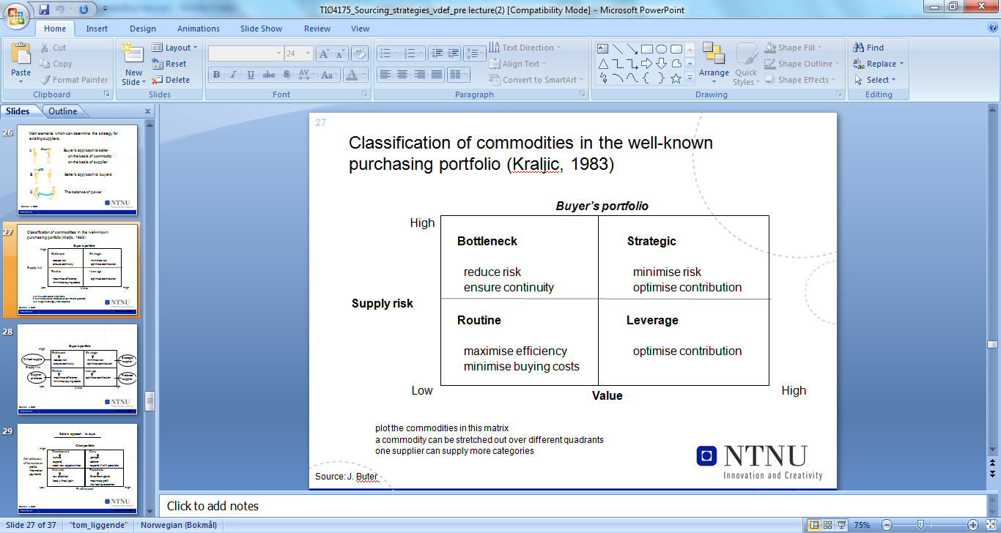

The Kraljic matrix proposes a strategy based on characteristics of the product that is to be sourced. It is possible to have up to several strategies against the same supplier.

#### Supply market complexity

The horizontal axis is concerned with the supply-side risk that occurs to external supply market issues and the complexity of the market. Porter’s five forces model gives a goods indication of the factors causing rivalry (or competition in an industry)

#### Impact on business

The vertical axis of the matrix is fundamentally concerned with the impact on profit or the value obtained from the sourcing group. The impact on business factors can be thought of as “internal” to the firm.

The cost approach to product and service positioning tends to use Pareto analysis. A-items account for 80 % of cost and 20 % of volume and so on…pay attention to A-items.

In practice, the firm generally positions based on the ABC-analysis. It would then go back through these items and decide what level of (internal) risk they might represent.

#### Strategic decisions for managing category spends

The matrix itself forces firms to consider categories of spend based on their level of supply market exposure and internal risk and cost. It is worth emphasizing that the matrix does not allow for the positioning of companies, but rather spend categories. These categories may well be spread across a range of suppliers. The model offers buyer firms four distinct strategies that they can follow:

**Strategy 1: Routine**

* Strategy based on efficiency
* Sourcing from the most efficient suppliers
* The objective is to pay the most competitive price for the product, while maintaining delivery and quality standards.
* As switching costs are low and the market is highly competitive, buyers would negotiate on price

**Strategy 2: Bottleneck**

* The strategy is to maintain supply continuity by, for example, establishing long-term contracts containing liquidated damages clauses. The buyer will tend to focus on total cost rather than simply on purchase price

**Strategy 3: Leverage**

* Obtain the best deal possible
* The buyer can obtain the best deal by leveraging strategies where the buyer power is high and the supplier power is low. Leveraging involves pulling together a range of similar products – sometimes the same product bought at different locations throughout the firm – to increase contract size and therefore buyer bargaining power.

**Strategy 4: Critical**

* These suppliers fall into the top end of the Pareto curve discussed earlier; that is, the top 20 per cent of suppliers account for 80 % of the cost. These are firm’s strategic suppliers.
* Switching costs are generally very high, with mutual dependencies

### Supply structure and design

Each quadrant of the Kraljic matrix suggests a sourcing strategy which in turn dictates a related sourcing or supply structure. It is important to choose the structure that is suitable for the strategy and the sourcing category. There are four primary sourcing structures that can be used; single, multiple, delegated and parallel. Note that the most dependent relationship is found in the simplest structure.

#### Single sourcing

* Only one source s supply
* This sourcing strategy is likely to be prevalent in either the critical or bottleneck quadrants of the model
* Easy to exchange ideas, have a clear understanding of cost structures and look for ways to redesign or enhance the product and processes.
* Long term focus
* Disadvantage: dependency, restriction of buyers’ flexibility to acquire new technologies or innovations that exist within the wider network
* (shorter horizon? Less aware of others? Rooted?)

#### Multiple sourcing

* Competition based on price
* The structure is often used to maintain competition in a given supply market
* Less risk through more suppliers
* This structure will tend to appear in the “routine” quadrant of the strategic positioning matrix and applies to the low-level type of purchase.
* This approach maintains continuity of supply in the short term, whilst enabling the buyer to achieve price reductions

#### Delegated sourcing strategy

* This involves making one supplier responsible for the delivery of an entire sub-assembly as opposed to an individual part. The customer delegates authority to a key supplier who becomes known as a first-tier supplier
* Focusing on one supplier makes the buyer to work closely with that one supply source to reduce day-to-day transaction costs.
* The increased dependency on one supplier results in the buyer and supplier exchanging more detailed information, particularly around cost issues.
* The buyer tends to transfer capabilities and technologies that enable that supplier to produce the required sub-assembly
* Very dependent upon the one supplier
* Tends to create “mega” suppliers that may evolve in to a potential threat
* This strategy is often found in the leverage quadrant of the matrix, moving to critical quadrant in the medium term due to the high dependency and switching costs.
* This strategy tends also to be followed by firms that are trying to optimize and/or reduce their supplier base.
* Delegated sourcing allows a firm to reduce the number of “direct” supplier without necessarily reducing the total amount of supply

#### Parallel sourcing

* It is argued that this structure provides the buyer with the advantages of sole and multiple sourcing, whilst excluding disadvantages of these strategies.
* Parallel sourcing allows the buying firm to work on a single or sole-sources basis with each component supplier within a product group while maintaining a multiple-sourced relationship across product groups. This allows the firm to maintain price competition, reduce complacency, and protect against capacity constraints issues while at the same time working more closely with suppliers within the model groups. This may involve sharing of information and design specifications and embarking on process improvement initiatives

Sourcing structures provide the means of implementing supply strategy. As such, they must be aligned to the requirements of the organization.

## A10: Making the Most of Supplier Relationships

**Gadde and Snehota**

Developing partnerships with suppliers is resource-intensive and can be justified only when the costs of extended involvement are exceeded by relationship benefits. The article examines the economic consequences following from different degrees of involvement with suppliers. Our conclusion is that a company can be highly involved with only a limited number of suppliers and needs a variety of relationships – each providing its different benefits.

Outsourcing is inevitable as increasing technical complexity and diversity make it more and more difficult for a company to stay at the cutting edge in several different areas of technology at the same time.

There has been a tendency to portray close relationships to suppliers as the superior solution for making the most of supplier relationships. The authors believe that such a view is often based on blurry assumptions, oversimplifies the issues involve and may be bad for practice. *The most critical element of supply strategy is a company’s capacity to handle various types of supplier relationships.*

### Coping with supplier relationships

Making good use of suppliers is a complex task for at least two reasons

* The economic consequences are difficult to assess.
* Companies can exercise only limited control over a vendor.

Companies make use of supplier relationships, depending on the nature of their business, the kind of technology used and the context in which they operate. A purchasing strategy can change over time.

* Companies modify the *scope of suppliers*. They rely on external suppliers to varying extents.
* Buying firms change the *configuration of the supplier base.*
* Companies develop different *postures of supplier relationships*, i.e. ways of handling and dealing with individual suppliers.¨

On the whole, it appears to be justified to have different types of supplier relationships coexisting within one and the same company.

### Economy of supplier relationships

*The actual supplier relationship represents one of the most important assets the company can make use of*. As with all other assets, the value is not absolute but context dependent.

The impact of a specific supplier relationship depends on how it fits into the operations and the strategy of the buying company and how other supplier and customer relationships are affected. This means that the role and value of a particular relationship cannot be assessed from its product/service context only.

Various technical, commercial, and organizational solutions in a supplier relationship, and any change in the actual arrangement, ultimately affect costs and benefits of both companies.

In order to develop effective supply strategy, companies need to understand the multiple economic consequences of changes in relationships.

**Relationship costs**

* Direct procurement costs
  + Easy to identify and measure.
* Direct transaction costs
  + May be difficult to measure, but can be traced.
* Relationship handling costs
  + Depend on the extent of involvement with individual supplier. Some relationships require lots of continous interaction – and thus costs – for maintaining the relationship and sometimes for investments in terms of adaptations among the counterparts.
* Supply handling costs
  + Structural and common costs for the purchasing organization as a whole, including communication and administrative systems, warehousing operations etc.

**Relationship benefits**

* Cost benefits
  + Savings in various costs of operations that can be related to collaboration with suppliers
    - Efficiency improvements through e.g. integrated logistics
  + Tricky to measure
* Revenue benefits
  + The economic consequence of supplier relationships that are related to the income side of the financial statement.
  + Difficult to assess

The economic consequences cannot be evaluated only from the content of the relationship. The value of a supplier relationship stems to large extent from how it fits into the operations of the customer and is other relationships.

### The posture of supplier relationships

The extent of integration between customer and supplier, expressed in terms of the specific investment made by either partner, has a clear impact on the performance of the relationship.

Focusing on integration is an important step toward a better understanding of the critical dimensions of supplier relationships. It requires consideration of the actual behavior in relationships.

It is useful to distinguish three dimensions of involvement that affect outcomes in supplier relationships:

* Coordination of activities – *activity links.*
* Adaption of resources – *resource ties.*
* Interaction among individuals – *actor bonds.*

We refer to the degree of involvement in the three dimensions as activity links, resource ties and actor bonds. Examples of tight activity coordination are integrated delivery systems developed to reduce the costs of capital equipment investments and of the material flow. Some supplier relationships score high on all three of the relationship dimensions and other only one or two.

### High and low involvement relationships

The existence of strong links, ties and bonds describes the degree of involvement of the companies in a relationship. We refer to relationships characterized by extensive activity links, resource ties or actor bonds as high-involvement, and those that score low on all three as low-involvement.

High involvement relationships are costly because coordination, adaption and interaction entail costs. Increasing involvement usually means a substantial increase in relationship and supply handling costs, but may under certain circumstances, lead to lower direct procurement and transaction costs. However, the main rationale for high involvement is either to achieve cost benefits in terms of reduced costs in production and materials flow, improved flexibility and service levels, or revenue benefits, for instance.

Low-involvement relationships can be handled with limited coordination, adaption and interaction costs. Generally, this is the case when the context is stable and the content of the relationship can be standardized. The low involvement relationships are potentially cost effective and require lower relationship handling cost. But there may be hidden costs in these relationships. Low involvement relationships may lead to higher direct procurement costs and transaction costs.

### The variety of relationship postures

*Companies need high and low involvement relationships, in part because different degrees of involvement lead to different costs and benefits, in part because the resources that can be dedicated to management of supplier relationships are limited.* There is thus an increasing awareness of the need to differentiate the approach to supplier relationships, which is in contrast with generalized recommendations to pursue the partnership posture.

Following the line proposed by Kraljic, various criteria have been suggested to establish segments and relationship portfolios. These criteria tend to link differentiation to market or product variables rather than to relationship features. Therefore, they provide only limited guidance for increasing or decreasing the level of involvement on a specific supplier relationship.

In order to settle the issue of the degree to which involvement is appropriate, we have to turn the attention to relationship specific features in the actual context of the buying company. There are three relationship characteristics that are considered relevant in deciding whether and when high-involvement in a supplier relationship is appropriate:

1. The monetary volume of business in the relationship
2. The continuity of the relationship over time
3. Whether or not the supplier in the relationship is used as a single source.

### Involvement and the volume of business in the relationship

A buying company can only handle a limited number of high involvement relationships because they are resource intensive.

For decisions regarding the degree of involvement, the current volume of business is an insufficient criterion. The balance of interests and economic consequences owing to changes in involvement has to be explored and assessed. Such assessment may indicate both low-involvement relationships to major suppliers (potential gains from further involvement is limited, standardized items) and high-involvement relationships to minor suppliers (the supplier has particular skills and capabilities that are crucial for the buying company).

Many high involvement relationships are of long term nature. This is mainly because it takes time to develop strong resource ties, activity links and actor bonds and once they have been established they represent investments of major value which makes it worthwhile to continue the relationship. However, not all long-term relationships do require high involvement and in some short-term supplier relationships high involvement may be an effective approach.

High involvement is commonly associated with single sourcing policy and low involvement with multiple or parallel sourcing. However a buying firm may develop high-involvement relationships with two or more suppliers of the same product or service because its customers prescribe which suppliers to use. Low involvement and single sourcing may be preferred when direct procurement costs accounts for most of total costs.

### Managing in relationships

* The core of our argument is that the economic consequences of supplier relationships depend on the postures developed and on the degree of involvement in each specific relationship.
* There is no such thing as a generally best type of relationship. Both high and low involvement approaches have their pros and cons.
* The prevailing degree of involvement characterizing a relationship must never be considered a permanent solution. Modifying the posture in the light of changing conditions is the critical issue in supply management. If this is not done properly, buyer firm may end up in either over or under designed relationships.
* Over-designed relationships evolve when more resources than necessary are put into a relationship. Over-designed relationships are not only costly, but also tend to be risky because of the specific investments.
* Interest and resources of both parties must be considered.
* The higher level of involvement between companies the greater the interdependence and the more pronounced becomes the potential for conflicting interests.

### Implications

High involvement with a supplier is not always feasible or desirable. First, it takes two to effectively integrate operations and the supplier may lack the necessary motivation and interest. Second, in some situations potential relationships benefits are exceeded by the investment costs that are incurred. Third, there is always limits to the investments a company can afford.

**Three paradoxes in business networks that the authors fin effective when managing supplier relations:**

**First paradox:**

Well-developed, high involvement supplier relationships are at the heart of a company’s survival and the basis of its growth and development. But the high-involvement relationships also tie the company into its current ways of operating and restrict its capacity to change. Supplier relationships are, for a company, both the impulse to development and the cage that imprisons it

**Second paradox:**

The supplier relationships of a company are the outcome of its strategy and its actions. But at the same time, the company is itself the outcome of the relationships and what has happened in them. It is therefore necessary to consider the position of the buying company from the premise that it forms its supplier relationships but also that it is itself formed by these. Both premises are equally valid.

**Third paradox:**

Both the supplier and the customer try to control and manage the relationship so as to achieve their own aims. This ambition is one of the key forces in development of the relationship and of the entire network. But the more that one of the companies is successful in its ambition to achieve control, the less effective and innovative will be the specific relationship and the whole supplier network over time.

**Managing relationships is about coping with interdependencies. ..**

## A11: Supplier Segmentation –”When Supplier Relationship Matter”

**Persson and Håkansson**

As a significant part of operations and development is carried out by suppliers or in collaboration with suppliers, exchange processes between SC participants are changing and becoming more differentiated. A major challenge in this situation is supplier segmentation, e.g. how to segment suppliers and how to differentiate the approach toward different types of suppliers.

Parallel to the development, there has also been a theoretical development

* First, the view of purchasing efficiency has shifted from a focus on single transactions to performance improvements in series of transactions
* From being considered a clerical/administrative function purchasing is now repositioned as a strategic function for the company.
* When purchasing becomes more significant and the view of efficiency is modified, then the perception of the role of suppliers is affected as well

**Segmentation models**

In practice the segmentation of suppliers or materials can be and have been based on different criteria such as the economic importance of the material in question, the risk of shortages, the technological importance or potential of the components or subsystems, the criticality of the goods and the impact of the supplier on the performance towards customers.

**Questioning the assumptions behind the segmentation models**

Several researchers have questioned some of the assumptions underlying the segmentation models. Here are some questioned issues:

* The models focus on a single relationship, ignoring or downplaying the task of allocating resources between relationships
* Interdependencies between supplier relationships is only treated as a resource allocation issue where the aim is to optimize the resources spent on managing the relationship
* The models suggest that it is a static relationship between, on one hand, the purchasing situation in terms of the categories defined (for instance leverage, non-critical, bottleneck, and strategic products), and, on the other hand, the features of the relationship between the buyer and supplier
* There is some ideal relationship related to the different categories and situations. In other words, resources should be allocated given a purchase situation that is believed to be stable, which in turn determines the degree of involvement and the type of the relationship

**Segmentation and collaboration**

Following the logic of the portfolio models, the buyer should choose different purchasing strategies for the various segments and similar strategies within each segment.

We here use the Kraljic matrix as an example.

The notion that the type of relationship is determined by the purchasing situation, given by the supply risk and the importance of the purchase, can be questioned. And so can the assumption that only the segment strategic suppliers are targets for collaboration. Collaboration may, as we will argie, actually be a strong and viable strategy in all segments.

*Ex:*

In the *non-critical segment*, a major cost driver is the administrative cost related to each transaction. Reducing the number of transactions or reducing the transaction cost or solutions involving for instance distributors or wholesalers taking over the supply responsibility of these products, can often be an effective approach in this segment. Such an approach involves collaboration.

Thus, although the non-critical items represent the trivial many, they also represent a significant share of the transaction cost. Concentrating the purchase to few suppliers, with which one collaborates to reduce costs, is often the most effective strategy for this segment. Thus, it is suggested that a competitive advantage in this segment imply collaboration, it involves exploiting interdependence not independence.

The authors have more examples of this kind, regarding all segments. In all of these examples, collaboration offered better solutions than the market. The authors suggest that this is always the case due to the possibilities existing in a dynamic development of relationships and they also suggest that the type of relationship should not be determined as in the portfolio models. The type of relationship is rather determined by the type of collaboration and the economies involved in the collaborative effort. Efficiency gains can be created in all segments though collaboration. Collaboration is not relevant just for one of the segments.

Developing a dynamic portfolio model based on the Kraljics four segments, on might suggest that there are always possibilities of creating and advantage together and in collaboration with others. Different types of collaboration, seeking to achieve different types of gains, can be related to the different segments.

**For the segment of non-critical products**

* Distributors can function as intermediaries between buyer and supplier thereby achieving economies of scale, better coordination and lower transaction costs

**In the bottleneck segment**

* Alliances with the purpose of avoiding or reducing risk can represent a competitive advantage for the parties in question.

**Leverage products**

* An alliance can reduce variation in availability and price fluctuations and collaboration can also help the buyer become better informed on technological issues and development

**Strategic products**

* Sharing knowledge and development resources in collaborative arrangements can often create the difference in this group

**Creating and advantage**

New segmentation models based on a more dynamic logic should be developed. A major characteristic of such models is that the purchasing situation is not given, but can be influenced by the individual company. There are at least three factors to consider:

* First, there are dynamic opportunities in the interplay between the two involved companies – the suppliers also have choices! The question is not only if and how a supplier becomes attractive for the buyer but also how a buyer can become more attractive for the supplier. One key question is always how much each side is prepared to get involved and how prepared they are to change.
* Second, significant efficiency gains are often related to initiating and exploiting dynamic changes in the wider activity structures. Both the design and the operation of activity structure involving a number of companies are important determinants of efficiency.
* Third, gains in effectiveness can be achieved through changes in utilization of resource combinations. When a large part of the resources needed to develop innovative solutions are external, innovation and development will be based and dependent on the mobilization of external resources and how they can be related to the internal one. Again collaboration is a mean as it is a question of successive changes both inside and outside the company.

**Moral:**

* Exploiting interdependencies is the important goal, rather than trying to be independent.
* Relationships will then be the key to competitive advantage.
* All suppliers used, are or should be important, but for different reasons, and the question becomes which interdependencies to exploit in which relationships.

**Interdependencies and relationships**

We can classify different interdependencies:

***Pooled interdependence*** between two activities means that they both are related to a third activity, or are sharing a common resource and they are therefore indirectly dependent. By exploiting pooled interdependencies in the form of shared resources, the efficient use of resources can lead to economies of scale or economies of scope.

***Serial interdependencies*** are related to a situation where the output of one activity is the input ot another. By adjusting and coordinating the activities across the SC one can reduce costs and increase services in relation to specific counterparts

***Reciprocal interdependency*** means that there is a mutual exchange of inputs between two parties. Development projects involving several companies are often characterized by reciprocal interdependencies and they require mutual learning and continuous exchange of information.

**Conclusion**

The practical use of the dynamic model involves a change in sourcing strategies for most strategies- in essence this change means a concentration of suppliers to fewer suppliers, as well as an extensive use of delegated sourcing, where the chosen supplier takes over much of the supply responsibility.

The supply risk is reduced through becoming an attractive buyer.

It is through collaboration that new and more efficient activity structures can be sought and exploited. And it is through collaboration in business relationships that new resource combinations can be exploited and influenced in a direction that assures development.

Without a developed business relationship – there is no advantage.

In a given purchase situation, different types of economies are present or can be created. The creation and exploitation of these economies require different types of collaborative efforts.

## A12: A conceptual model for assessing the impact of electronic procurement

**de Boer et al**

Internet technology provides ways of drastically reducing different categories of transaction and communication costs. In that respect, the potential merit of various electronic procurement (EP) forms seems largely undisputed.

EP can be defined as using internet technology in the purchasing process. This definition is narrow in the sense that it excludes old applications as ordering through fax or phone, but at the same time wide as it includes the use of intranet and extranet applications.

We consider each form of EP as part of a process. The internet technology that is needed in these processes can be offered to the employees in several ways via:

* ***Electronic (public) market places.*** 
  + These are specific websites on the internet that aim to bring buyers and suppliers together in order to facilitate the application of various forms of EP and more general e-commerce.
* ***Intranets***
  + These are a collection of websites with information and applications that support one or more EP forms. An intranet can only be accessed by employees of the firm.
* ***Extranets***
  + These are a collection of website with information and applications that support on or more EP forms. An extranet can only be accessed by employees of a specified set of organizations.

Here, we distinguish between the following forms of EP

* e-MRO (maintenance, repair and operating)
* web-based ERP
* e-sourcing
* e-tendering
* e-reverse auctioning
* e-informing

**E-MRO and web-based ERP**

These forms refer to the process of creating and approving purchasing requisitions, placing purchase orders and receiving goods and services by using a software system based on internet technology.

* For e-MRO, the cost of items and services not directly used in primary operations can usually be lowered.
* E-MRO only generates savings on highly “clickable” commodities (a purchase can be executed by just a few simple mouse clicks)
* Reducing costs from executing operational purchasing activities (ordering, administration etc) with e-MRO is most effective when the number of purchase orders is high as well as the number of the internal customers.
* The costs of executing tactical purchasing activities (setting specifications, selecting suppliers etc.) will increase as more time will be necessary for discussing the conditions with respect to e-MRO with MRO suppliers.
* Web-based ERP solutions only reduce costs from executing operational purchasing activities, assuming an ERP system is already available
* Cost savings in costs from executing operational purchasing activities can be made in case of many internal customers ordering goods and services for the firm’s primary operations using inconvenient procedures.

**E-sourcing**

E-sourcing refers to the process of identifying new suppliers for a specific category of purchasing requirements using internet technology.

* As to e-sourcing, a direct impact is only expected with regard to costs of executing tactical purchasing activities. E-sourcing can be a very useful tool for locating possible new suppliers, getting information and contacting them

**E-tendering**

E-tendering concerns the process of sending requests for information and prices to suppliers and receiving the responses of suppliers. Sometimes, e-tendering also includes the analysis and comparisons of responses.

* Introducing e-tendering is expected to reduce costs of executing tactical purchasing activities, especially when current tender procedures are highly bureaucratic, involving a lot of paperwork.

**E-reverse auctioning**

This enables a purchaser to buy goods and services needed from a number of known or unknown suppliers. E-reverse auctioning is the internet technology based equivalent of reverse auction.

* For e-reversed auctioning, a company needs to work with a high number of possible suppliers as the idea of an auction is to obtain lower prices by using the market mechanism. Therefore, the impact of introducing this process will be higher when the leverage – or even routine – purchasing volume is high.

**E-informing**

E-informing is the process of gathering and distributing purchasing information both from and to internal and external parties using internet technology.

* E-informing is directed at obtaining better and more efficient access to strategic purchasing and information – and that is more reliable also – and in that way lowering the costs of executing strategic purchasing activities (e.g. developing purchasing policies)
* For the usage of e-informing, IT support will be needed, as the actual implementation involves linking different information systems. This will raise the costs.

## Dimensions if impact of EP on organizations

In general, the organizational impact of implementing ICT (information and communication technology) may be considered from a number of perspectives:

1. The impact on a firm’s primary and supportive processes
2. The impact on the organizational structures used to co-ordinate these processes
3. The impact on and compatibility with existing systems
4. Contribution to the goals of various stakeholders of the firm

The impact on a firm’s processes and the organizational structure are very closely linked to each other. By implementing a form of EP, strategic, tactical and administrative (operational) purchasing processes may all change. As a consequence, the organizational structure might change too, not necessarily only involving the purchasing department.

By implementing a form of EP, a specific application based on internet technology usually has to be introduced in the organization and has to fit in with other networks and systems.

An effective implementation of new technology into the organization requires an appropriately differentiated “internal market approach” targeted at the various stakeholders, such as management, workforce, customers and suppliers. Commitment from top management is an imperative.

The organization has to create a clear picture of

* The integral purchasing-related cost-structure that will emerge after the implementation of a specific form of EP
* The investments that have to be made in order to reach that new stable situation

**Conclusion**

As the direct cost of selecting suppliers drops, it seems to make sense to consider a higher frequency of tendering. The firm would benefit from better deals. However, changing suppliers more often will create additional costs in terms of investing in and managing more suppliers, and possibly losing certain existing cost and/or revenue benefits.

There is a danger of treating EP as one “solution”. Trying to assess the direct impact of the various forms is hardly straightforward, let alone the possible indirect impacts. Opposing effects may occur within one and the same category of purchasing costs, when introducing an EP form.

In addition, the dramatic reduction in search and communication costs makes it worthwhile to consider drastically different frequency and/or choices-sets in the purchasing process, e.g. supplier selection. Doing so may have a range of indirect effects.

# Week 9 – “To make together” The design process and specifications

# Week 10 – Supplier Development and relationships

## Supplier development (Ch. 6)

* Supplier development is attractive to both parties
* To compete, buying firms are increasingly focusing on the performance, capabilities and responsiveness of their supply base
* Supplier development;

***Any effort of a buying firm with a supplier to increase its performance and/or capabilities and meet the buying firm’s short and/or long-term supply needs”***

One of the advantages of a supplier development program is that buyer pressure can act as a catalyst for process change within suppliers. Buyer involvement can provide a fresh perspective, challenging the underlying assumptions of the supplier, but also act as an external pressure point which legitimizes the need for change, helping to overcome organizational inertia

## Objectives of supplier development

Two main goals;

* **Direct improvement activities (Results-oriented) – “Gi mannen en fisk”**
  + Workflow simplification, layout changes and set-up time reduction. E.g. 5S, value stream mapping
  + Focus on operational metrics
  + Disadvantage:
    - narrow understanding of the underlying problem
    - unable to sustain the good initial improvement rates
* **Developing supplier capability (Process-oriented) – “Gi mannen en fiskestang”**
  + The buyer tries to transfer its own in house capability to the supplier
  + Building commitment to change, reduces resistance and facilitates the transfer of knowledge
  + Takes time
  + Follow up support needed
  + Large commitments of time and resources required
  + More sustainable – gives better payoff in the long run



There are several barriers to achieve successful supplier development, which include buyer specific, supplier specific and buyer-supplier specific.

## Supplier development strategies

Different strategies to improve the supplier’s performance and develop capabilities:

* **Competitive pressure**
  + Adopting multiple sourcing strategies
* **Evaluation and certification systems**
  + Formal evaluation systems and supplier certification programs communicate expectations as well as motivate suppliers to improve performance
* **Incentives**
  + Increased volume of current business, priority for future business, sharing of cost
* **Direct involvement**
  + Capital and equipment investments
  + Investment of human and organizational resources

## The supplier development process

**Step 1: Identify critical commodities**

* Kraljic matrix

**Step 2: Identity critical suppliers**

* Amount of expenditure
* Suppliers of strategically important components
* Likely length of relationship
* Improving weakest suppliers
* The type of manufacturing/administrative processes used by suppliers

**Step 3: Form a cross-functional team**

**Step 4: Meet with supplier top management**

* Top management can push aside political barriers, assign resources and provide the drive to make change happen

**Step 5: Identify key projects**  
**Step 6: Define details of agreement**  
**Step 7: Monitor and modify strategies**

### Is supplier development always a success?

“It appears that customers may believe that they are implementing a strategy for supplier development while not actually doing so…. The benefits of these systems (supplier development systems) appear, in general, to favour the customer rather than the supplier…”

## Managing inter-firm relationship (Ch. 13)

*“Relationship is not a ‘thing’, an ‘entity’ of some description.” (Cousins et al, 2008, p. 172)*

*“A relationship is mutually oriented interaction between two reciprocally committed parties…A relationship develops over time as a chain of interaction episodes – a sequence of acts and counteracts. It has a history and a future.” (Håkansson and Snehota, 1995, p. 25)*

Relationship management can be viewed from a variety of perspectives: from the level of the firm, from the level of a particular project or grout within and between firms, and at the level of the individual.

We define relationships as *processes*, much the same as culture and communication.

Relationships should have an outcome focus, for example price or cost reduction, technology sharing and development, risk sharing and so on.

Processes need to be viewed as both efficient (how quickly they are conducted) and effective (how well they meet the strategic focus of the firm)

Effectiveness means delivery of the strategic objectives of the firm, which in essence means making sure that the relationships are business focused on a series of outcomes that are expected by both parties within the relationship.

*Inter firm relationships are a set of complex business processes that require resource allocation from the buyer and supplier to achieve a set of complex outputs. These outputs and inputs may be asymmetrical depending on the desired outcomes for the buyer and supplier. In addition, these relationships will be influenced by their respective external environments and constrained by the parties’ strategies, goals and power mechanisms.*

## Towards a management model

The management of relationships will vary according to both the strategy of the organization and the product sourced. Is the organization cost focused or do they have a focus on differentiation. See figure 13.4 on page 177. The model is called the Strategic Focused Outcomes Model and indicates which strategies should be followed dependent upon the strategic approach taken by the firm.

Relationship development outcomes will also deliver improved integration of business processes, with a view to improving efficiency and overall levels of effectiveness of these processes.

### Development of a relationship management approach

Relationships need to focus on business deliverables; they need to deliver something if they are deemed to be successful.

In order to deliver business outcomes, relationship processes need to focus at the level of the product or service. Some products need simple relationships processes, i.e. negotiation over price. Other relationships need more complex processes, i.e. for innovation exchange and so on.

There will probably be a portfolio of relationships with any particular supplier depending on what business outcomes are required from the various products and services procured from that supplier.

### The management of dependencies and certainties

Check out figure 13.5 for the strategic relationship positioning model. The model considers two key variables for the management of relationships; dependency and certainty. There are **four key dependencies;**

* Historic
* Economic
* Technological
* Political

These dependencies can be identified by both the buyer and supplier firms as drivers for the development and manipulation of the relationship.

Dependant on dependency and certainty, there are developed **four generic strategies**;

* **Adversarial** 
  + Arm’s-length contractual relationships
* **Opportunism**
  + When either the buyer pr the supplier is dependent on the other party. This allows the dominant partner to take advantage of this situation.
* **Tactical collaboration**
* **Strategic collaboration**
  + Require a large amount of investment, with large returns for both parties involved.

**The key point to remember here** is that either the buyer or the supplier should choose the most appropriate strategy for them to follow, i.e. the strategy that will achieve the most value.

*Se i boka for illustrasjon av følgende modeller*

**The partnership life cycle effect**

* Partnerships can be described as conforming to a life cycle
* The model shows conceptually how relationships operate
* Relationships have a finite life – which affects behavior

**The partnership expectations effect**

* A more detailed framework that may more accurately describe the building of partnership relationships is the partnership achievement and growth model, which illustrates the expectations effect of relationship development.

**The partnership desert effect**

* Shows how in the short, medium and long term the parties receive the benefits from entering into relationships

### Implications for managing relationships

* Relationship management should not begin with changing the way a firm manages its suppliers. It should start with how the buyer interact with itself
* There must be a business benefit from refocusing relationship approaches. Firms need to think through clearly what these benefits are, and also if the cost of getting them outweigh the actual benefits
* Relationship strategies are dynamic, they need to be thought through and managed over time. At different stages they may require different people/skills to manage them

## A4: Developing Relationships in Business Networks

**Håkan Håkansson and Ivan Snehota**

In the lecture, this article is referred to under the heading ***characteristics of a business relationship***.

A literature review conducted by the authors generally point to a few features of business relationships what they call ‘**structural**’, that is, how the relationships are in terms of importance to companies, age and so on. They also provide some interesting indications about what might be called ‘**process**’ features of relationships, that is, about the nature of the interaction processes within the relationships, how they develop and decay, and what effects they have on the parties involved.

**Important:**

|  |  |
| --- | --- |
| **Structural characteristics** | **Process characteristics** |
| Continuity | Adaptations |
| Complexity | Cooperation and conflict |
| Symmetry | Social interaction |
| Informality | Routinization |

### Structural characteristics of business relationships

Structural characteristics of business relationships are readily evident for outside observers. **Business relationships, in particular the customer-supplier relationship, have been found to be often characterized by:**

* Continuity
* Complexity
* Symmetry
* Informality

(With regards to the slides, Ms. Pedersen has included stuff not mentioned in the article under each of these… Well, you do not teach your father how to f**k.)

#### Continuity

* Not only do business transactions often stretch over a long time period, but also business is often contracted repeatedly between two companies for years in a row.
* A relationship lasts on average 10-20 years.
* The major customer or supplier relationships in a company are generally built up successively and gradually.
* There are some indications that the age of the relationship is a prerequisite for a more extensive use of the relationship by the parties involved and its continuity being a precondition (forutsetning) for change and development.
* A relation = an investment
  + since revenues and cost are occurring in different time periods
* Different types of costs:
  + Contact/information costs and adaptation costs
* Different types of revenues:
  + Rationalisation or technical development

#### Complexity

* Complexity in coordinating within a relationship
  + Number of people involved on each side
  + Coordinating technical, administrative, logistical or economical issues
  + One person can be responsible for coordinating all contact regarding one specific supplier relationship
* Complexity in coordinating between relationships
  + There are numerous ways of connecting relationships
  + Coordinating technical, administrative, logistical or economical issues between different relationships

#### Symmetry

* The parties in a business relationship tend to have resources and capabilities that are more balanced than is the situation on many consumer markets.
* Typical relationships appear symmetrical in terms of resources controlled, and thus the possibilities to exercise influence, and initiative of the parts involved.
* Relationships are important from an *economical point of view* for both parties:

1. Are seldom symmetrical
   * imbalance in one dimension may be set off against the equivalent but opposite imbalance in another dimension
2. The balance usually varies with the general state of the economy
   * short-term versus long-term

* Dependence cannot be avoided, it must be handled

#### Informality –Uformell karakter

* All business deals contain uncertainty
* Informal mechanisms are often more effective for the development of relationships than formal contractual arrangements.
* It is pointless to formulate agreements to cover all conceivable situations
  + too many aspects to cover
  + unexpected events
* Thus, business relationships often show a low degree of formalization:
  + Trust develops over time
  + Development of reciprocal learning processes
  + Important with different types of social situations

The ‘structural’ features of intercompany relationships paint a picture of relative stability of business relationships. Companies appear to be tied together by apparently long-lasting, broad, relatively balanced and informal relationships. This “conclusion” can only be drawn on the basis of what happens on the outside, i.e. the ‘structure’. One therefore has to consider what is going on within the relationships; the ‘process’ features.

### Process characteristics of business relationships

The interaction processes within business relationships have been found to be often characterized by, these are less evident for the outside observer:

* Adaptations
* Cooperation and conflict
* Social interaction
* Routinization

#### Adaptations

* Adaptation means that a certain supplier is handled in a unique way
* It has been found that mutual adaptations of some kind are generally a prerequisite of the development and continued existence of a relationship between to companies
* Adaptations are means to take advantage of the unique attributes of a specific supplier
* Different types of adaptations:
  + technical, knowledge-based, administrative, economical and legal
* Different ways adaptations can take place
  + Major one-off measures or small incremental steps
* The nature of adaptations depends on the type of product involved
* Mutual adaptations generate and reflect mutual commitment that at the same time constrains and empowers the companies

#### Cooperation and conflict

* The parties in a relationship have both contradictory and shared interests.
* There is an inherent conflict about the division of benefits form a relationship.
* All relationships require some collaboration, but also an equal measure of conflict
  + Some amount of conflict might even be necessary in order to keep the relationship between two companies healthy
  + Important to handle conflicts
* While conflicts of larger or lesser degree continue to occur, the existence of the relationship based on previous commitment generally directs the parties towards constructive solutions.

Degree of conflict

Collaboration

Low degree

High degree

High degree

Nice

Well-developed

Low degree

Marginal

Hostile

#### Social interaction

* Personal bonds and convictions that are always present play an important role in formation of a relationship
* Focus on social exchange processes between individuals, as the individuals involved in a business relationship tend to weave a web of personal relationship, and this appears to be a condition for the development of inter-organizational ties between any two companies.
* Trust emerges as one of the salient (fremtredende) factors influencing the interaction in intercompany relationships

#### Routinization

* Relationships tend to become institutionalized over time
* Routines, explicit and implied rules of behavior, and rituals in conduct emerge over time in the more important relationships that a company maintains with its customers and suppliers
* Routines help in coping with the complex needs to coordinate the individual activities within the relationship
* Routines mitigate costs of transactions in a relationship

From the interaction processes within business relationships we can conclude that major supplier-customer relationships are characterized by continuous change as a consequence of interaction between the parties.

### Relationships and business enterprise (this is not a part of the lecture)

The more one looks at business relationships, the clearer it becomes that they play an important role in business enterprise. Most of a company’s costs and revenues stem from its main business relationships. Most companies have only a few customers and suppliers that account for a major part of their total sales and purchases. What makes this aspect critical is that major relationships have their distinct personalities and that no two relationships are alike. This poses problems as well as some interesting opportunities.

When the authors say that a company’s performance depends on relationships, it has to be said that the link between relationships and performance is working both ways. The overall performance depends on the performance in the individual relationships, but at the same time it is the performance in the whole set of relationships that affects the capacity of the company to perform in a given relationship.

Why do relationships play such a prominent role for companies? Developing continuous ‘dense’ relationships seems to be a way to *cope with the complexities and ambiguities* which any company is facing in a market. It is an effective form of handling market exchange.

### Interdependencies and connectedness in business relationships

*Major relationships of a company have been found to be ‘connected’ in the sense that what is happening in one relationship affects the interaction in others*. A company always operates within a texture of interdependencies that affects its development. Here are a few that are repeatedly encountered in various business relationships:

* Technology
* Knowledge
* Social relations
* Administrative routines and systems
* Legal ties

The different interdependencies are interlaced (sammenflettet) in business activity in general and affect business relationships. In some situations one type can be dominating, but all the others may potentially exist. Each inter-dependence can be used and exploited in different ways.

#### Technology

The flow of exchange and relationships between two companies reflects the technologies employed by the two companies. As a relationship develops, possible technical misfits have to be avoided. The technical connections reflected in paradigms or trajectories (bane), and their evolution, is one of the major forces shaping the context of a company. Technical development within one company and in its relationships is dependent on other companies’ technologies; it is facilitated or constrained not only by those with whom the company maintains direct relationships but also by the technology of other third parties. The technology employed by the parties to a business relationship tends to influence not only the characteristics of the products and services exchanged but also the ways to do business in general (logistics, routines, planning etc.). *Business relationships can be seen as links that shape and reflect the existing technology*.

#### Knowledge

Perhaps the main part of the knowledge necessary in order to use resources and to undertake activities is more difficult to articulate – it is ‘tacit’ (underforstått) in nature, which means it is more difficult to transfer (often unique to individuals). The know-how of the company reflects not only the knowledge of its personnel but alto that of the other companies and organizations to which it is connected through business relationships. *Much of the knowledge put in use in a company becomes available from its relationships to others outside the company*. The activities of a company draw on and are made possible by some knowledge possessed by others. It is in relationships that the existing knowledge is confronted with other parties’ knowledge and new knowledge is created.

#### Social relations

*Social bonds that arise among individuals in the two companies are important for mutual trust and confidence in interaction between individuals*. Every individual’s social network is built up of personal relationships originated for different reasons. IT can be used in different ways in order to enhance or develop the business relationships in which the individual takes part.

#### Administrative routines and systems

The bulk of the administrative activity is some form of information processing or control which is necessary in order to facilitate the coordination of behavior among different parties. *Some companies develop information systems, often common to a number of companies,* to cope with the costs and problems of the information processing needs. If, for example, a supplier wants to sell to a large car manufacturer it will probably have to join its supplier information system. This will, in turn, affect what it can do for other customers. This is (an example of) how the administrative systems create connections between the relationships.

#### Legal ties

The legal texture is of interest as it can connect different business units with privileged ties. Priorities might be given, formally or informally, to buy from or to sell to the companies with which ownership links exist. Other types of legal interdependencies are the different formal cooperation agreements (joint ventures, licensing agreements, etc.). Other example can be procurement rules (e.g. protectionism in that x percent have to be bought locally). *The legal ties make certain relationships to suppliers, customers and third parties in a company connected and interdependent.*

### Connectedness of business relationships

The notion of interdependence of business relationships applies generically; things happening in a relationship have a bearing on what is happening in other relationships. ‘*Connectedness’ is about these connections; relationships are connected when a given relationship affects or is affected by what is going on in certain other relationships*. …Taken together we get a picture of the company as an entity that in order to build up its own capabilities and strength and to offer the required performance in a certain relationship has to strive to connect all the other relationships. By doing so consciously it can improve its own performance significantly.

### Business relationships in market networks

Once one admits that business relationships of a company are connected and that this applies for companies in general, one have to consider possible chain dependencies between relationships. This might be called ‘indirect connectedness’. Generalized connectedness of business relationships implies existence of an aggregated structure, a form or organization that the authors have chosen to qualify as a ***network****. This form of organization is peculiar because it does not have a centre, nor does it have clear boundaries. A peculiar characteristic of the network structure is the chain effect resulting from connectedness*.

The network structure as a form of organization is different from a ‘hierarchy’ in which components are assumed to be invariably linked. It is also different from the ‘market’ as a form of organization that is generally assumed to be an atomistic structure in which all links between components are instantaneous and where few, if any, impediments (hindringer) exist to any of the components being connected to any other.

The assumption of business relationships being elements of a network structure leads to a different picture of the role and potential of business enterprise and to a different picture of how markets function, which in turn has implications for what is required in order to manage a business enterprise.

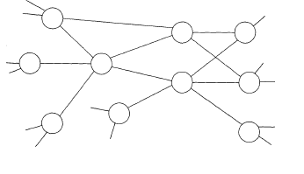

Business relationships as elements of a network structure

## A3: Managing Interfaces with Suppliers

**Luis Araujo, Anna Dubois, Lars-Erik Gadde**

### Preface

The movement from transaction to relational modes of buyer-supplier interaction has been highlighted as a dramatic shift. The article re-examines the nature of management of supplier relationships from the perspective of resource interfaces. **The authors propose a categorization of *four different interfaces based on how a focal customer can access its suppliers’ resources*.** They conclude by highlighting the costs and benefits of establishing and maintaining different suppliers interfaces. **The main implication stemming from the analysis is that buying firms need a variety of supplier interfaces to pursue productivity and innovativity objectives.**

### Introduction

In accordance with the shift from transactions to relationships, earlier recommendations for “arm’s length” relationships have been abandoned. “Partnering” with suppliers has been put on top of the agenda. The contributions from suppliers will be dependent on how “close” the relations are. **The benefits from closer involvement with suppliers must offset the investments to set up and maintain the relationship (!).**

### Purpose

The objective of the article is to analyze the character and consequences of different types of relationships via the notion of customer-supplier interfaces, with particular concern to *resource interfaces*. It is a well-established finding that a company can substantially expand its resource base through access to supplier resources. The authors point-of-departure is that a firm’s competitive advantage resides not simply within the boundaries of what it owns and controls, but also on idiosyncratic (særegne) interfaces it develops with other firms (e.g. suppliers). In short, *control of resources as well as access to resources controlled by other parties defines a firm’s competitive position*.

The authors identify a typology of interfaces defined from *the perspective of the customer*. Again, the interfaces are ways the buying firm can access the suppliers’ resources.

### Resource interfaces

No company controls all the resources they require. The productivity of firms is determined by the efficiency in the utilization of a given resource combination at any one time, whereas innovativity is related to the development of new resource combinations over time.

Two important issues can be singled out:

1. What resources should be controlled internally and what resources should be accessed externally from suppliers?
   * This relates to the efficient boundaries of the firm, the **make or buy** decision.
2. How should the buyer access suppliers’ resources?
   * This addresses in detail the question of how to access the resources that the firm has decided not to bring within its boundaries.

These two issues become inter-dependent over time – the forms of access to suppliers’ resources affects make or buy decisions and vice versa. The second issue will be the focus of the article.

Other authors have identified different types of exchanges between buyers and suppliers:

|  |  |
| --- | --- |
| 1. Parts manufactured according to the drawings provided by the customer 2. Parts manufactured according to the drawings provided by the suppliers 3. Parts bought through catalogues or “marketed goods” | Asanuma, 1989 |
| 1. “Supplier proprietary parts” 2. “Detailed controlled parts” 3. “Black box parts” | Clarke and Fujimoto, 1991 |

These classifications are based on the division of labor, in particular design and manufacturing between supplier and customer rather than by how each firm relates their internally controlled resource to those externally accessed. Hence, **the categorizations of parts provided by these authors are descriptions of the outcomes of resource interfaces (!) (we have to discuss this):**

The consequence of making a distinction between the interfaces, and the outcomes that flow from them, namely the products being exchanged, is that *a focus on interfaces provides a different way of understanding the dynamics of exchange relationships*. It shifts the managerial emphasis from the evaluation of suppliers current offers to the evaluation of suppliers capabilities.

The four interfaces are:

**Standardised Specified Translation Interactive**

A smooth way of remembering this is SUPER SEXY TITS INVOLVED (Sjøbakk, 2011), though this may be subject for further discussion.

The most important distinction between different resource interfaces is to what extent the customer and the supplier are aware of each other’s contexts.

**Oppgave 4 Eksamensoppgave fra it’s learning**

Gi en kort beskrivelse av hvert av de fire leverandørgrensesnittene som diskuteres i artikkel A3 til Araujo et al. (1999) ‘Managing interfaces with suppliers’.

**Oppgave 5**

Diskuter hvordan grensesnittene i oppgave 4 relaterer sig til typologien om ’none, white, grey eller black box’ involvering av leverandøren i produktutvikling, som diskuteres i boken til Cousins et al. (2008).

#### Standardized

**No direction and no specific connection between user and producer contexts.**

The knowledge of use and the knowledge of produce are unrelated to each other. The supplier does not need to know about the user context nor does the customer need to understand the producer context. The interfaces, *as well as the products exchanged*, are standardized.

This interface represents the classical *arm’s length* market relationship. There are no relevant technical or organizational interdependencies between the two parties and the two organizations only require a simple sales-to-purchasing functional interface to conduct exchanges.

For the buyer, prices act as the main coordinating device between buyer and seller. The cost of using standardized interfaces is low for both parties (low transaction costs, no dedicated investments, supplier can achieve economies of scale in production and marketing). Indirect costs may arise for the customer if it has to fit other parts of its production to the product purchased. In addition lack of direct contact may pose problems for new product development.

#### Specified

**Precise directions given by customer on how to produce.**

The buying firm might prefer a customized product. This requires an interface where the resources of buyer and seller to some extent are adapted to each other. The supplier needs certain directions from the customer. Example: prescriptions regarding the characteristics of the product and/or how it is to be manufactured.

Traditional subcontracting and outsourcing are good examples of this interface. These arrangements can work very efficiently; e.g. a subcontractor can achieve economies of scale that the buying firm would not manage to obtain.

Contrary to the standardized interfaces, the supplier requires specifications and production schedules from the customer. Hence, specified interfaces entail a degree of *interdependence* between the parties (production schedules need ex ante (before the event, bitches) coordination.

#### Translation

**Directions given by customer based on user context and functional requirements from a product (rather than the actual product).**

Labeled translation because the supplier has to translate the functional characteristics supplied by the customer into a product.

Although the division of labor between supplier and buyer may be similar to the one used in specified interfaces, the supplier takes on a greater responsibility in the relationship. As in specified interfaces the translation interfaces are based on directions given by the buyer. However, translation interfaces leave *important degrees of freedom for the supplier* on how to meet the buyer’s need.

#### Interactive

**Joint development based on combined knowledge of use and production.**

Based on open-ended dialogue based on how the buyer and supplier can join their knowledge of user and producer contexts and develop the specifications together. “Two resource holders will in an interaction process develop the knowledge and skills to utilize each other’s resources.

This interface enables the firms to consider productivity consequences for both parties as well as the benefits that can be jointly developed vis-à-vis specific third parties (e.g. buyer’s customers).

The return on an investment in interactive interfaces may be difficult to predict ex ante. However, because interactive interfaces open up the possibility of both high productivity and innovativity gains, these investments have to be considered as multiperiod to estimate the costs and benefits they yield over time.

**The four interfaces differ in terms of:**

1. The costs associated with the use of the respective interface; and
2. The benefits provided by them differ in terms of
   1. Productivity; and
   2. Innovativity

What benefits flow from the use of the respective interfaces must be balanced against the investments required to establish and maintain each interface. Furthermore, the cost of developing and maintaining different interfaces for the supplier will be reflected partly in the prices charged to customers.

The authors deal with innovativity in terms of the learning effects that can originate from use of each type of interface, there are 2 types of learning.

* Direct, situated and joint learning that takes place between the customer and the supplier.
* Indirect, to which extent the customer can benefit from what the supplier learns from interacting with other counterparts.

Summary of this can be seen here:

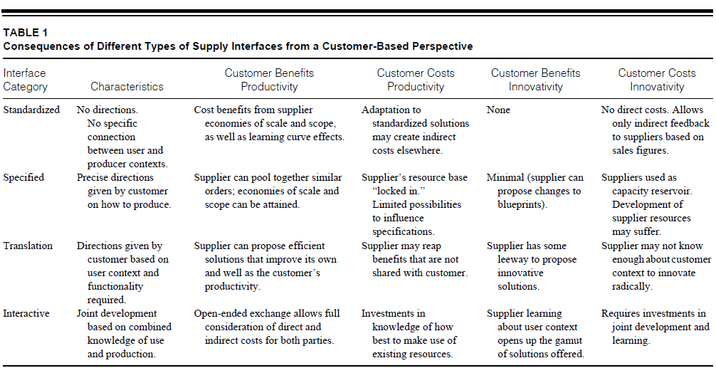

### Conclusions

Interfaces affect the way a customer accesses the resources of a supplier. Clearly each interface has its pros and cons. None of them performs better in any absolute sense. The advantages and disadvantages are determined by the context in which they are applied. Benefits and costs need to be weighed against each other. Conclusions from the article:

1. The buying firm must have a variety amongst the set of supplier interfaces

* Prioritise due to limited resources (on both the buyer and supplier side).
* Balance between productivity and Innovativity objectives.
* The capabilities of the suppliers are diverse.

1. Interfaces are interdependent
   * A major task for every customer is to coordinate and combine the solutions developed by suppliers with the in-house developed solutions (which is an important reason for limiting the number of interactive interfaces). Supplier hierarchies is a way to buy-pass this, as seen in the automotive industry.
   * The ability of the supplier to handle a certain interface must be taken into account
   * The ability can change over time
2. The choice of interfaces must take dynamic features into account. The need for, as well as modes of access to external resources, changes over time.
   * Necessary to monitor and manage interfaces with suppliers. A resource demanding relationship must yield substantive benefits.
3. Designing interfaces is a two-sided activity
   * The ability of the supplier to handle a certain interface must be taken into account
   * The ability can change over time

### Managerial Implications

Three managerial implications flows from the analysis:

* + - 1. Preserve variety amongst your set of supplier or customer interfaces
      2. Understand the interdependence amongst interfaces
      3. Avoid the dangers of focusing too narrowly on core competencies. The ability to develop complex interfaces with suppliers and customers require the development of competencies that are not considered “core”, but are nonetheless crucial for the successful operation and development of core competencies.

# Week 11 – Food Supply Chains

# Week 12 – Supply Networks

Sammendrag av artikkel 7, 8 og 9. Sammendragene dekker foilene, og går dypere. Sammendragene følger rekkefølgen artiklene ble gjennomgått i forelesningen.

## A9: A strategic review of “supply networks”

**John Mills, Johannes Schmitz and Gerry Frizelle**

### Abstract

The central aspect of the paper is to suggest that the field can be viewed from four perspectives which all researchers and managers implicitly or explicitly use:

* *Upstream*, as purchaser
* *Downstream*, as suppliers
* *Static network*, as an auditor of position within its supply network
* *Dynamic network*, as strategist, seeking opportunities to improve the firm’s position in an existing network or creating a new network, providing a strategic, dynamic and long-term view.

### Introduction and scope

**Supply chain management (SCM)**: *The integration of business processes from end user through original suppliers that provides products, services, and information that add value for customers (Lambert et al., 1998, 504)*

* A lot of different definitions of SCM
* As the concept of SCM evolved the term “network” came into use

There remain important distinctions between the SCM and logistics literatures:

|  |  |
| --- | --- |
| **Logistics** | **SCM** |
| *Presumed rational co-operation* between buyers, suppliers and service providers and on this basis strived to find optimal solutions for inventory, transportation, information flow etc. | Also considered the behavioral and political dimensions of trust and power, conflict and dependence between supplier and buyer. |
| *Focus on minimizing total cost* | *Concerned with the long-term profitability* of serving customers and customers’ customers |
| Traditional focus was often intra-organizational | Became inherently inter-organizational |

Cooper et al. (1997) (ikke nevnt i foiler, potensielt mindre viktig) identified seven business processes within supply chain management (in which interviewed managers generally considered some of them to be part of the marketing effort):

1. Customer relationship management
2. Customer service management
3. Demand management
4. Order fulfillment
5. Manufacturing flow management
6. Procurement
7. Product development and commercialization

As the concept of SCM evolved the term “network” came into use – predominantly because firms were generally part of a number of supply chains. The concept of “supply networks” developed in two distinct streams of research (Lamming et al., 2000):

* Largely descriptive (beskrivende) research on industrial networks conducted by researchers from industrial marketing and purchasing (IMP)
* More prescriptive (foreskrevet) research on supply chain management based on research within the fields of strategic management, operations management and logistics

Introducing the term “network” into the SCM arena has therefore extended the SCM concept into more strategic areas.

A lot of frameworks are developed to place research, e.g. Harland (1996), Bechtel & Jayayram (1997), Cooper et al. (1997). However, none of these frameworks focuses on a company’s point of view although this appears to be important to both practitioners who are concerned with their individual company’s perspective, and to researchers who often begin their analysis from a company’s specific angle. To cover the scope of SCM research, **four perspectives** are suggested necessary:

* *Upstream*: as purchaser, dealing with suppliers
* *Downstream*: as supplier, dealing with customers
* *Static network*: as auditor of its position in its supply network, typically comprising several supply chains. This perspective provides a static and comparative view.
* *Dynamic network*: as strategist, seeking opportunities to improve the firm’s position in an existing network or even creating a new network. This perspective provides a strategic, dynamic and long-term view.

### The four perspectives to cover the scope of SCM research

#### The upstream perspective

|  |  |
| --- | --- |
|  | **Two main areas of interest:**   * The structure of the supply base and the links between buyer and supplier. * The actual ongoing operations in the supply chain, namely the material and information flow. |

With regards to the first area of interest, long-term, co-operative and trusting relationships between buyer and suppliers are often recommended. On the other hand authors also refer to the potential risks of such policies of supplier development.

Looking at supply chain operation, the second area, a considerable literature focuses on logistical issues (e.g. supply chain logistics strategy and planning, order processing and integration of information systems, transportation modes, forecasting, inventory policies and warehouse management, facility location and network planning, and 3PL). Most call for an integration of logistical activities and increased sharing of information in the supply chain.

The majority of the supply chain literature concentrates on the up-stream perspective taking the buyer’s perspective. Objectives for a whole supply network are more difficult to define since those involved usually have competing goals (this may change in a “greening” (environmental) of the supply chain).

#### The downstream perspective

|  |  |
| --- | --- |
|  | * Less focus on the demand side in the literature * General work on relationships and trust are transferable to the supplier’s perspective * The supplier often less powerful than the customer, which may explain the lack of literature on the topic * Focus on finding the “right customers” * Efficient consumer response (ECR) |

Taking the downstream perspective is mostly concerned with identifying opportunities to reengineer internal processes or processes which a supplier can easily control to increase customer satisfaction. In greening the supply chain, the focused on the downstream has increased with respect to e.g. reverse logistics (in which Xerox is a large player).

The grocery industry initiated ECR (Efficient Consumer Response) in the beginning of the 1990s. One much sited definition of ECR is *“Working together to fulfill consumers’ wishes better, faster, and at less cost”*. Within ECR there is a distinct focus on logistical issues, which address the following objectives:

* Reduction of cycle time in the distribution channel
* Reduction of total inventories in the chain
* Avoiding duplications of logistics costs
* Increasing customer service

#### The static network perspective

|  |
| --- |
|  |
| * Views a focal firm’s whole supply network in order to :   + compare performance in its multiple supply chains   + Identify potential competitive problems and opportunities   + Identify overall process improvements * Focus on the firm’s position and role in a supply network |

**The static perspective is indicated in two broad situations**. ***In the first****, supply chains serving similar end-users are said to* ***compete****,* often accompanied with comparisons between these chains. From a focal company’s point of view it is important to understand how well its supply network is competing with its near neighbors. By looking at the figure, it is clear that this perspective unveils a host of customer-supplier relationships that no company seriously can manage. A structured analysis of opportunities and risk may be required to identify which relationships to manage, though no literature is found on this area.

**The second situation** is where companies reach beyond their immediate suppliers of customers to improve the competitiveness of their chain or defend their routes to market. Two examples:

* Tomato ketchup producer in New Zealand conducting research on tomatoes to provide the growers with nice plants, in addition to negotiating contracts on behalf of the growers to achieve economies of scale.
* Often important to manage beyond 1 suppliers for critical times. In one example it turned out that six tier 1 suppliers all purchased from the same tier 2 supplier. It became apparent that the critical relationship was with the tier 2 supplier.

#### The dynamic network perspective

|  |  |
| --- | --- |
|  | Two sub perspectives:   * The evolution of existing supply chains where incumbents are invested in the status quo – network evolution * The creation of new supply chains by entrepreneurs – network creation |

*The dynamic perspective of supply networks is the most strategic and long-term.*

#### Network evolution

The figure above is an example of evolution of existing supply chains. Ford initially was as vertically integrated as it was possible to be. Then it started to retain management control over its upstream customers and distribution while increasingly out-sourcing components and sub-systems. The latest action in this direction was to spin off their wholly owned internal component suppliers into a company called Visteon, who could sell to other companies as well, and had to compete with other suppliers on getting Ford contracts. Visteon could evolve as a company, and Ford did not have to bear Visteon assets on its accounts, in addition to a lowering of prices due to the competition.

Make-or-buy is mentioned with regards to network evolution, a lot is written about prioritizing your core competences.

#### Network creation

Entrepreneurs can, at the beginning of the twenty-first century, rapidly create a supply network that less than ten years ago could not have been attempted. Increased out-sourcing by established firms and a combination of social, economic, technological and political factors has produced an environment where firms have become increasingly specialized.

Li and Fung is mention with regards to “virtual structure”.

#### Summary and conclusions

From a managerial perspective we conclude that typically many managers are engaged in activities that affect their supply network and their positioning within that network. Managers need to make sure the coordination of these activities achieves both an appropriate balance and synergy between the four perspectives of their business.

## A8: Supply network initiatives – a means to reorganize the supply base?

**Elsebeth Holmen and Ann-Charlott Pedersen, Nikolai Jansen**

### Hensikten med artikkelen

*To conceptualise how a firm’s supply base may change over time as a result of an initiative to create a supply network among part of the firm’s supply base.*

Artikkelen er skrevet med utgangspunkt i et case-studie av en contractor i byggebransjen som endret sourcing-strategi, initierte utviklingen av et supply network og derfor restrukturerte deler av sin supply base.

## Litteraturstudie

### Supply base management – important issues:

#### The number of suppliers in the supply base:

* **Supply-base structure** = ”the number of suppliers to use, as well as how the suppliers should relate to one another” (Gadde og Håkansson, 1994)
* **Supply base management** = ”how many suppliers will be dealt with” (van Weele, 2000)

#### How firms can reduce the supply base

* ”buying firms have a growing interest in restructuring and rationalization [of] their supply base” (Liliecreutz, 1998)
* ”we see an inevitable reduction in the number of direct suppliers” (Calabrese, 2000)
* Whilst firms have significantly reduced the number of suppliers over the last years, such strategies have not lead to the rewards that were first expected. “firms appear to be adopting supplier reduction strategies without a thorough consideration of the market dynamics and firms appear to be pursuing supplier reduction without a clear assessment of the costs and benefits involved” (Cousins, 1999)
* The trend of reducing the supply base will continue (McGinnis og McCarty, 1998)

#### Management of supply performance

* “what conditions and qualifications the best-in-class suppliers should meet” is an important question in supply base management (van Weele, 2000)
* Empirical study of four automotive manufacturers: these manufacturers use performance measurements at the interface to their suppliers in the area of logistics (Schmitz og Platts, 2004)
* Managing the supply base is a complex issue that requires new measurement systems and frameworks. (Schmitz og Platts, 2004), (Handfield og Nichols, 2004).

#### How suppliers are organized, for example in tiers

* A number of studies in the auto industry where only a few suppliers have direct contact with the customer, and the rest of the suppliers are organized in a hieratically structure where “primary” (first-tier) suppliers are responsible for structuring the rest of the supply base. (Gadde og Håkansson, 2001)
* “a tiered system of primary and secondary suppliers is set up on the basis of the supplier capability to satisfy the new carmaker’s need” (Calabrese, 2000)

#### The nature of the relationships between the buyer and the suppliers

* Achieving deeper cooperation with selected individual suppliers is one of the most central issues in managing the supply base. (Gadde og Håkansson, 2001)
* Stronger buyer-supplier communication and inter-organisational coordination is necessary in global supply base management, and “trust is the foundation of positive and productive buyer-supplier relationships.” (Handfield og Nichols, 2004)

#### Changes in buyer-supplier relationships over time

* “A supplier base consists of a range of short, medium and long-term relationships and changes over time as new suppliers enter and established relationships are dissolved”. (Dubois et al., 2003)
* Dubois et al. (2003) discuss different drivers of change in the supplier base and suggest that purchasing policy, relationship-driven changes and technical modifications can be such drivers.

### Supply network management – important issues:

#### Interconnected relationships, i.e. creating relationships among suppliers in the supply network (which also incorporate the nature of the relationships)

* “Supply networks are nested within wider interorganization networks and consist of interconnected entities whose primary purpose is the procurement, use, and transformation of resources to provide packages of goods and services”. (Harland et al., 2001)
* An important issue of supply networks is that collaboration not only takes place between a buyer and its suppliers, but also among the suppliers thus creating connected relationships. (Dubois og Gadde, 2000)
* “Supply networks are characterized by sets of purposeful and connected exchange relationships”. (Andersen og Christensen, 2005)

#### The structure of supply networks

* Lamming et al. (2000) and Harland et al. (2001) present a model for classifying supply networks based on two dimensions:
  1. The degree of supply networks dynamics; and
  2. The degree of focal firm supply network influence

Basert på dette lager de en 2x2-matrise og diskuterer fire supply network types.

#### The process of initiating, creating, managing and/or changing of supply network

* Dyer and Nobeoka (2000) aim to understand how a core firm can successfully create and manage an efficient, knowledge-sharing network. They describe the evolution of the network in three phases:
  1. The development of weak ties between the buyer and the different suppliers in the network. They use the term “weak” to point out that the relationships were new and the frequency and intensity of the interaction was low.
  2. The development of strong ties between the buyer and the suppliers, where Toyota transferred know-how of for example production technologies.
  3. The development of strong ties among the suppliers, enabling the suppliers to create sub-networks within the full network to maximize the willingness to share information and knowledge.

### Supply base versus supply network management

* The two concepts are seldom combined within a single study or article.
* The researchers who discuss supply base management seem to emphasize reduction and rationalization whereas those who use the term of supply networks seem to pay little attention to such matters.
* Changes or processual issues are paid much more attention to within literature on supply network management (even though discussed in relation to both concepts)
* A lot of empirical studies of both supply base and networks within the *automotive[2]* industry, thus there is a need to observe and discuss supply base and supply network management in other industrial settings, including non-manufacturing ones.

### Methodology

* Real-time, theory-led and contextual case study of a contractor in the construction industry.
* Firms in the construction industry are frequently criticized for their lack of long-term supplier relationships and sourcing strategies, hence there is a need to investigate some of those exceptions.

### Empirical basis

* First, the firm organized its efforts by means of a sourcing project called: ”Network with technical sub-contractors” , the supply network consisted of subcontractors of three types of technical services:
  1. Electrical services
  2. Ventilation services
  3. Plumbing services
* Aim of the project:

*To develop a method for choosing and organizing co-operation partners which enable the firm to achieve competitive advantages. This should enable the firm to become better at:*

* 1. choosing ’optimal’ technical solutions for their customers
  2. handling interfaces among technical subcontracts
  3. capturing benefits from co-operative relationships
* Based on the aim the firm classified all the suppliers (the supply base) of one chosen business unit into a “Supplier Library”. The reason was a desire to reduce the number of suppliers used by the business unit.
* Preferred suppliers were selected using the following criteria:
  + that the supplier is financially ’viable’
  + that the construction firm had good experiences from working with the supplier in all phases of building projects
  + that the supplier is willing to co-operate - on several organizational layers
* The subcontractor subset of the supply base was singled out, and in total nine suppliers were selected, three for each type of technical subcontract.
* The designed supply network was tried out in a number of construction projects
* They were divided into different constellations which were to work together as ‘sub-networks’ with electricians, plumbers and ventilation installers.
* Out of the total purchase of technical services in 1999, approx. 95% were from the designed supply network
* Studied the supply network during the years (2000-2003) after the sourcing project ended
* Changes over time:

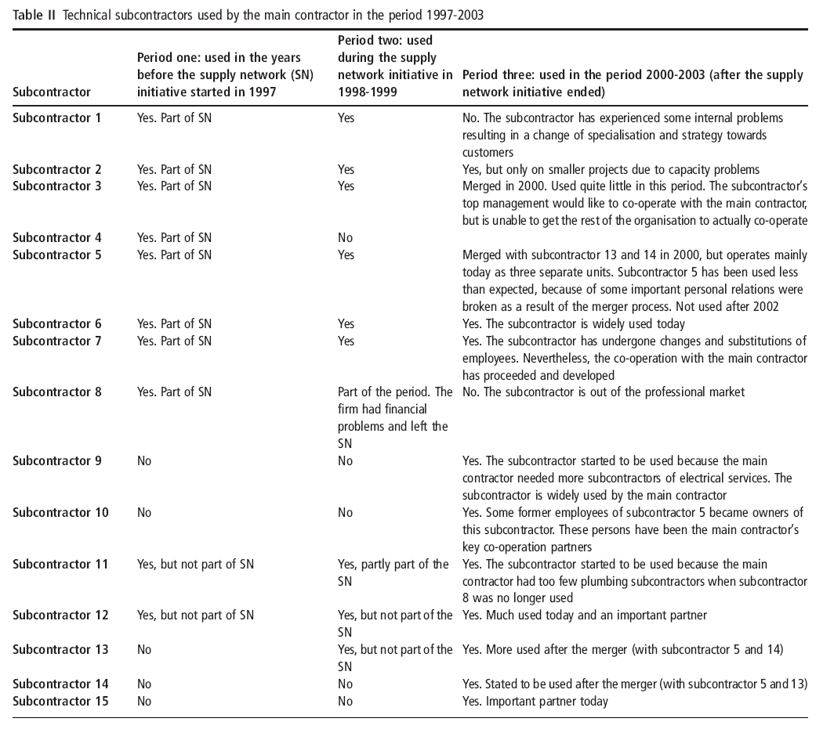

### Analysis and discussion

The empirical material is made into three different stages; pre-initiative stage, the ongoing initiative stage and the post-initiative stage.

#### The pre-initiative stage

The structure of the supply base prior to the supply network initiative is put into practice

|  |  |
| --- | --- |
|  | The relationships between the buyer and its suppliers were characterised by short term, arm-length transactions.  These transactional relationships changed from one construction project to the next depending on the price  Category A can be e.g. plumbing services etc. |

#### The ongoing initiative stage

The explicit supply network initiative as well as parallel, early outcomes of the initiative

|  |  |
| --- | --- |
|  | Suppliers were invited to partake in the initiative and subsequently become part of the resulting supply network  Organised “relationship building seminars”  Experimented with and learned how to work in sub-networks  The structured of the supply base changed |

## The post-initiative stage

The period after the explicit supply network initiative as well as the later outcomes of the initivative

|  |  |
| --- | --- |
|  | Some routines from the initiative had become “standard procedure” (kick-off meeting, early subcontractor involvement etc.)  Some selected sub-contractors were less used and some new were selected (however, the selection of new subcontractors seemed to follow a network logic.  In this stage the designed supply network is not so visible, and the supply network initiative is much less explicit. |

### Results and implications

#### Relation between supply base and supply network

* Supply base point of departure for designing supply network
* Supply network initiative as a means for transforming (part of) the supply base into a partly connected supply network structure.

#### Supply network initiatives as transient means (transient = forbigående, kortvarig)

* Costly to maintain over time
* Content of initiative may change over time
* Initiatives may be useful for both these purposes.
  + Creating a supply network (enable many potential connections)
  + Supporting a fragile supply network (with fewer connections)
* Initiative may be abandoned when network is resilient and ‘self-maintaining’

#### Supply network initiatives as self-reinforcing means

* Institutionalized supply network ‘support system’
* Toyota’s network seems to be an example of a supply network which after an initial phase turns into a self-reinforcing supply network in which the same (comprehensive and costly) network processes seem continuously to reproduce the same supply network structure.

## A7: A Conceptual Model for Researching the Creation and Operation of Supply Networks

**Christine Harland, Jurong Zheng, Thomas Johnsen and Richard Lamming**

### Abstract

Artikkelen presenterer en konseptuel modell for opprettelse og drift av *supply networks*. Forskningen er tatt fra en stor mengde fagfelt. Forfatterne identifiserer 9 typer nettverksaktiviteter og diskuterer disse. Fire forskjellige typer av kontekstuelle faktorer relatert til nettverksaktiviteter er identifisert.

### Introduksjon

Det er stadig mer vanlig for bedrifter å fokusere utenfor bedriftenes grenser (firm boundaries); oppstrøms til deres leverandører, til deres leverandørers leverandører, og i likhet nedstrøms til kunder og kunders kunder. Disse ”extended webs of operational relationships are termed ’**supply networks**’”.

Fra Ann-Charlotts foil, og artikkelen:

***Definition:*** *”****Supply networks*** *are nested (packet inn) within wider inter-organisation networks and consist of interconnected entities whose primary purpose is the procurement, use and transformation of resources to provide packages of goods and services. Supply networks therefore essentially consist of a set of interconnected supply chains, encompassing both upstream and downstream relationships.”*

### How the model was developed

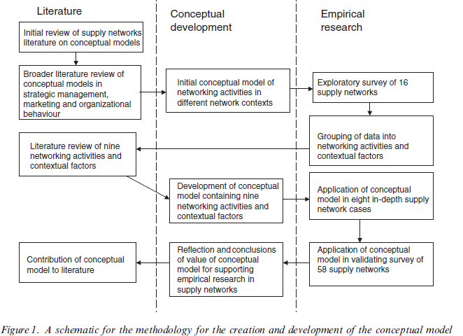

#### Initial review of supply networks literature on conceptual models

*The supply chain management literature focused more on logistics flow than on strategic or structural aspects of supply networks*. The supply network framework had contribution from Harland, providing a framework differentiating between four levels of analysis for considering supply. However, this gave no understanding of processes and activities occurring within networks. No models appeared to satisfy the requirements for the research project, and hence the search was expanded.

#### Broader literature review of strategic management, marketing and organizational behavior

#### Strategic management

* Structural orientation
* Power and opportunism
* Useful frameworks on transformation processes

#### Marketing network research

* Interaction processes
* Dyadic relationships and embeddedness
  + IMP Group’s model characterized short-term episodes of exchange and longer-term features of a relationship between a customer and a supplier. This interaction was conceptualized as occurring within an atmosphere arising from closeness, dependency, expectations and cooperation of the parties.

#### Organizational behavior research

* Coordination mechanism
  + What configuration of flows of resources and information can be effectively governed and, second, what coordination mechanisms enable this governance?
* Roles
* Processes, tools and techniques for networking
* (focus on dyadic relationships rather than wider networks)

There was little evidence in any of the literature of understanding of different types of networks and contingent (mulig) behavior appropriate to different circumstances; this required an understanding of network context.

The findings from the initial literature review were used as the basis for development of an initial conceptual framework of networking activities in different network contexts.

### Initial conceptual framework

Basically using the transformation model by Slack et al. (input – transformation – output) and adding so called *enablers* and *constraints*, in addition to adding the network context as an element of the framework. The model was used to conduct an exploratory survey of supply networks.

|  |
| --- |
|  |
| Key principles:   * Taking an operations management perspective, supply network actors and resources can be considered ‘inputs’ to the process of ‘operating a network’ * Operating a network involves transforming resources into goods and services which are ‘outputs’ of the supply network * This operation a supply network involves a range of tangible and less tangible activities * Supply networks operate in different network contexts * Networking activities should be appropriate to the network context. |

### Exploratory survey of supply networks

A semi-structured interview was designed containing sections on inputs to supply networks, networking activities, outputs from the supply network, the supply network context, enablers and constraints of networking. Within these subjects no specific questions were asked, in order to learn from the interviewees.

The exploratory survey revealed that *the initial conceptual model should be modified to highlight supply-network creation as a different process to supply network operation*, where the first includes finding suppliers. The survey led to a finding of **nine networking activities**:

|  |  |
| --- | --- |
| * Partner selection * Resource integration * Information processing * Knowledge capture * Social coordination | * Risk and benefit sharing * Decision-making * Conflict resolution * Motivating |

*Of these, partner selection was only appropriate in creation or recreation of product/service supply networks.* All the others related to both creation and operation.

The exploratory survey also gave rise to an initial grouping of **contextual factors**:

|  |
| --- |
| * Market environment * Product/service package * Operations process * Supply network structure * Focal firm supply-network strategy |

It appeared that it was difficult to distinguish between **enabling and constraining factors**. For example EDI enabled quicker exchange of order transaction data between supply network actors, but in itself it imposed constraints on the parties as they had to conform to a common standard of data specification and compatible information systems.

*In general,* ***‘enablers’ and ‘constraints’*** *are broad terms for factors influencing the product/service supply network creation and operation activities*. These factors may be resources, such as information technology systems; they may be other activities or processes, such as public relations activities.

#### Literature review of networking activities

The next step was a literature review of the nine networking activities mentioned above. Each activity is to some extent explained in the article, but the discussion is to comprehensive to include in this summary.

#### Literature review of supply network context (contextual factors)

The same as in 5), but for the contextual factors.

#### Development of a conceptual model for analyzing supply networking activities

Following the preceding steps, a conceptual model was developed.



### Reflections and conclusions

The conceptual model informs research in supply networks in three key ways:

* 1. Investigating the set of networking activities within the model in supply networks provides a rich and structured understanding of what occurs in supply networks between network members.
  2. The conceptual model contributes to the connection of networking activities within a supply network, with elements, and configurations of elements of, the supply network context.
  3. If applied in future empirical research in supply networks, it will provide analytical consistency that will enable greater sharing and comparison of different research teams’ work.

**Limitations to the model:**

1. The categorization of networking activities is, in itself, a false structure applied to messy interactions between parties in a network.
2. The model has a lack of support to identify what enables and what constrains the activities.
3. It is an uncertainty of classifying what enables and what constrains.
4. The main limitation is that it has only been applied by one research team in a limited number of product/service supply networks. Until other researchers attempt to use the model, its value will not have been rigorously tested.

# Week 15 – Corporate Alignment; organization of purchasing

## Logistics effectiveness & efficiency vs. organizational structure and systems

There are two main logistical advantages that can be reaped; cost and service. Every advantage gained will be a function of the three dimensions shown on the left side of the figure. The organizational structure must therefore also fit the material system and the environment the firm operates in. A question that arises is the question of how to balance the three dimensions in order to get the best possible output. In making changes, one should ask what changes in the different dimensions means for the organization.

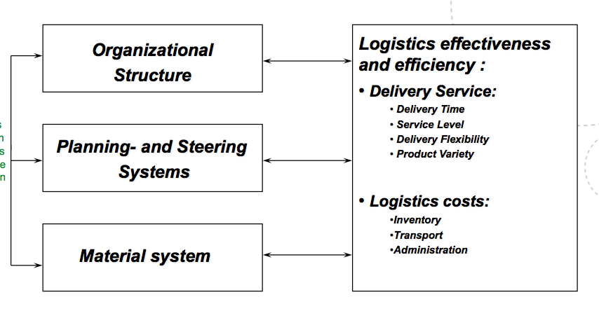

The model has the same function as the supply wheel model that is to follow, but has less text and more obscure references. The supply wheel concept might therefore be easier to use.

## Supply wheel concept

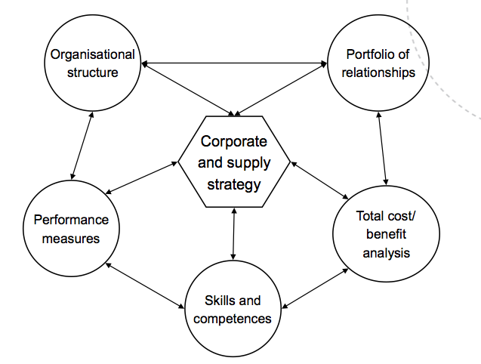The supply wheel was developed through many years of research (literature studies and experiments). The various elements of the supply wheel are all linked; therefore one must change, or allow change, in other elements if one element is to be changed. The variety or level of strategic attainment will be limited by the lowest common denominator in the model. Any assessment of sourcing strategy and positioning should therefore be considered in the light of each element of the model. The level of skills and competences can for example constrain the organization to a tactical level of purchasing despite greater aspirations.

The system can thus be said to be “continuous and dynamic - one must therefore see how the elements are affecting each other. Are some elements missing? What needs to be improved? Is there a good balance, or opportunities for improving it?“

### Rationale of the supply wheel:

* **Appropriateness**

Making appropriate choices – must ensure that the most appropriate strategy is balanced against the other elements of the model. The wheel must stay in balance => it must either contract or expand at the same rate.

* **Strategic planning tool**

The model can be used as a template for understanding where the organization is (strategic analysis) and where the organization wants to be (strategic choice). Gaps can then be identified, the various elements can be aligned and the strategy put into place (strategic implementation).

* **Link to sourcing strategies and the Kraljic’s model**

The model shows that the level of skills, measures etc. must be appropriate to the sourcing strategy.

### Supply wheel elements

* **Alignment of corporate and supply strategy**

The supply structure has to fit the supply strategy and policies of the firm. Without this, the firm will be unable to deliver on its chosen approach.

* **Skills and competencies**

Often overlooked by firms when developing supply strategies. However, no matter how logical and innovative an organization’s strategy, the important questions concerns the capabilities of its people. They have to make the strategy happen, and if they are unable to implement the new approaches the strategy will simply not work.

* **Organizational structure**

There are three basic types; centralized, decentralized and hybrid structures. The firm structure can have a profound effect on how well and which types of strategy that will work.

* **Strategic performance measures**

Essential for the delivery of strategy as they ensure that both internal and external elements of the organization is aligned. PMs act as both a signal and motivating system to alert the organization to act in a particular way. The firm must employ the correct measure to achieve the maximum output of the chosen strategy.

* **Cost-benefit analysis**

For a firm to follow any strategy it would make sure that is has support of a sound business case and a clear understanding of the cost structure. The benefits and costs must align with the central strategy and produce a business case for following any of the various relationship approaches.

* **Relationship portfolio**

Consider the type of relationships operated by the organization. It is important to be ware of the different relationship approaches and decide on the one that best fits a particular firm scenario. The type of relationship chosen will depend on the wanted output. If complex relationships are needed to achieve complex outputs, it is likely that these will require highly skilled personnel and a measurement system.

## The strategy concept – aligning supply with corporate strategy

**A strategy is** “*pattern or plan that integrates an org. major goals, policies and action sequences into a cohesive whole. A well formulated strategy helps to marshal and allocate an organization’s resources into a unique and viable posture based on its relative internal competencies and shortcomings, anticipated changes in the environment, and contingent moves by intelligent opponents”.*

**Cousins et. al highlights three important points from the definition above:**

* Strategy affect the scale and scope of an org. activities over the long term
* Strategy is about being responsive to changes in the external environment
* Strategy is about aligning activities w/ strategic resources & capabilities

**There are three levels of strategies within an organization:**

* **Corporate level –** *“what businesses are we in?”*

Organizational boundaries: integration along SC and range of activities.

* **Business level** – *“how do we compete in our chosen markets?”*

Decisions over individual products within a given market

* **Functional level –** *“how can our function support b&c level strategies?”*

Developed by the major functions; finance, marketing, operations, HR, SCM

**Other useful frameworks:**

* Intended, deliberate, emergent and realized strategies
* Outside-in (positioning school) vs. inside-out (resource based view)

### What is strategic alignment?

Functional strategies should connect with business- and corporate-level strategies so that resource allocation and activities at the functional level are consistent with high-level objectives. The strategy process can be both “top-down” and “bottom-up” – meaning that functional level activities are not always constrained to passively accepting strategies handed down from corporate.

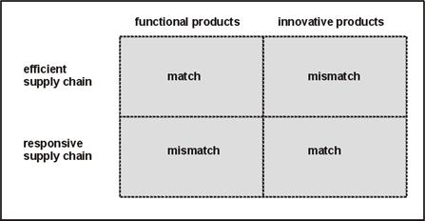The strategic alignment between SC and corporate strategies is achieved where SC strategy supports and facilitates corporate strategy. In other words, the goals of the SC function are aligned with the organizations **competitive priorities:**

* Cost
* Quality
* Flexibility
* Delivery
* Innovation

It is important that **changes to corporate strategy** are discussed with the SC function. A previously aligned strategy will become misaligned if change is not communicated across the organization. In **developing a corporate strategy** it is critical to involve the supply chain function, excluding them would mean that supply’s capabilities and limitations are ignored in strategic decisions.

Competitive priorities are generally developed by the operations/manufacturing functions in conjunction with corporate planners. As strategies are about focus, and competitive priorities are necessarily in trade-off, organizations will have to emphasize one or two competitive priorities. The supply strategists can then set about operationalizing these priorities for their function.

|  |  |  |
| --- | --- | --- |
| Priority | Description | Measurement criteria |
| Cost | Supply, production and distribution of products at low cost | Total cost, pricing terms, exchange rates |
| Quality | Supply, production and distribution of products with high quality and performance standards | Product durability, performance reliability and conformance quality |
| Delivery | Supply and distribution of products on time and /or at short lead-time | Delivery speed, delivery reliability |
| Flexibility | Supply, production and distribution of different mixes and volumes of product with little/no impact on cost | Volume flexibility, mix flexibility |
| Innovation | Supply, production and distribution of new products | Supplier technological capability, speed of NPD |

**These objectives translate into specific measureable targets, and should all conform to SMART:**

**S**pecific – explicitly state what they want to achieve

**M**easurable – quantifiable to gauge achievement

**A**chievable – context specific and realistic

**R**elevant – relevant to the specific function

**T**ime bound – explicit time frame for completion

It is critical that strategy, not best practice, drives the implementation of supply chain practices.

## Competency and skills (Ch. 9)

*“It is true as they say in the book; this issue has been overlooked for a long time. However, purchasing is no longer a gathering place for people that is unsuitable in other positions”.*

An organization is only as good as the skills and competencies that the purchasing personnel possess. Supply can only be strategic if the people working in that area possess the requisite skills and competencies to operate in that way. The skills and competencies of the individuals in the organization will allow only a certain level of attainment (as the figure illustrate).

*“As purchasing becomes more strategic it must fill a role in such areas as:*

* *Logistics*
* *Make vs. buy decisions*
* *Outsourcing and in-sourcing*
* *Supply chain management*
* *Performance assessment*
* *Inter-firm networking*
* *Innovation scanning*

*Competency development should thus be seen (and evaluated) in the light of a more comprehensive ‘supply management’ context.”*

### Competence requirements for strategic supply

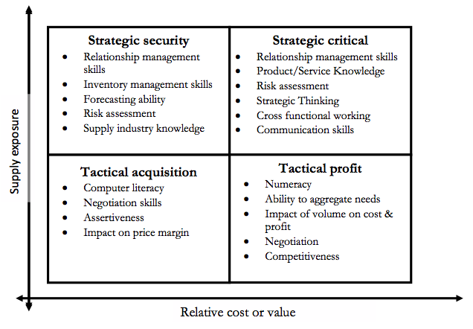Kraljic’s matrix can be used to show how competencies can be populated against various areas of the matrix. Clearly it is not appropriate to adopt a standardized approach towards competence development, as businesses vary in terms of sourced product types. It is difficult to identify a list of generic competencies that are supportive for effective purchasing behavior for all companies.

### Purchasing competency development model

Designed to make purchasing supportive of overall business goals and objectives. The model is built on thinking that purchasing is a process (rather than a function) at which an organization must become competent in order to succeed in the marketplace. Though the model is of linear nature with 6 steps, it is also contains elements of cyclical nature as the needs and requirement s of the purchasing role may be expect to evolve.

#### Step 1: Strategic stance

Clarification of the strategic stance of the organization and how the role of purchasing is required to add value to the business operation. There are several sub-steps in order to accomplish this:

**Supply positioning**

The purchasing role and activates can be disaggregated by use of the Kraljic matrix, and appropriate purchasing strategies and procedures must be identified for each area of the matrix.

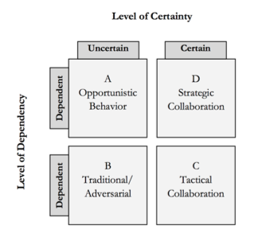

**Relationship type**

In order to realize the objectives of distinct strategies for the different purchasing categories in the Kraljic matrix, the supply base interaction must be supported by the appropriate relationship option. As seen in the relationship-positioning matrix, it is clearly not the most appropriate action to enhance all supplier relationships to partner status.

**Purchase life-cycle assessment**

It is important in the development of purchasing staff to understand the dynamics of activities that are seen to be supporting the current purchasing strategy. It is essential to identify the different purchasing activities and understand the nature of how the currently supports strategy, and how they will continue to do so in the future. Some activities will continue to support the strategy; others become redundant over time, and new activities will emerge.

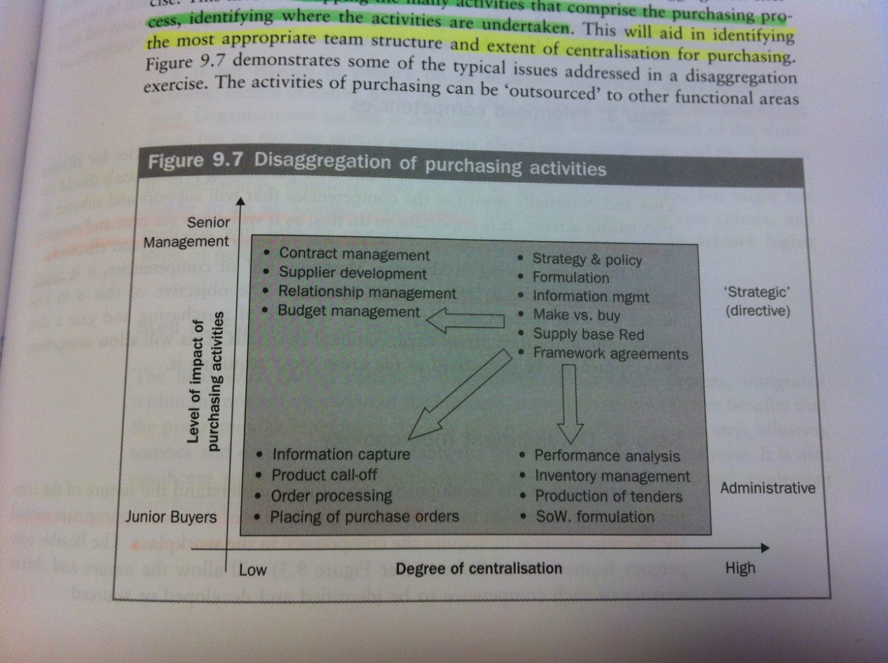

**Purchase disaggregation**

This involves mapping of the many activities that comprise the purchasing process, identifying where the activities are undertaken. It will aid in identifying the most appropriate team structure and extent of centralization of purchasing. The exercise will make the purchasing manager understand *what* needs to be developed and *where*.

#### Step 2: Purchasing objectives and themes

Step 2 is to clarify the broad objectives of purchasing, and break them down into smaller and more manageable themes for which supporting competences can be clearly defined.

#### Step 3: Prioritized competencies

A number of purchasing professional should discuss and eventually prioritize the competencies that will support and enhance the purchasing activity. It is important to do this, as it will allow the time and resources spent on purchasing development to be utilized most efficiently and effectively. At this point it is also appropriate to make a ‘gap analysis’ identifying the existing competency base and understanding the current organizational shortfalls (allowing competency development to be prioritized to areas with the greatest need).

#### Step 4: Development methodology

This step consists of understanding the nature of the competencies that have been listed. This will give an overview of the most appropriate method for the organization to acquire the competence in the workplace.

#### Step 5: Purchase integration

It is essential that the competencies being developed integrate well with, and are supported by, other critical areas of purchasing (purchasing structure, extent of decentralization, team vs. individual assessment, IT systems, corporate culture & purchasing climate, communication channels, remuneration). Careful consideration of remuneration, corporate culture and feedback will help to motivate the purchasing professional to achieve higher levels of performance.

#### Step 6: Evaluation of benefits

Evaluation of relative benefits brought to the role of purchasing, and evaluation of the effectiveness of the integrated system and implementation of modifications where necessary.

### Know-what vs. know-how

The book covers other topics quite well, both has according to Luitzen a blind spot considering this point. The difference between know-what and know-how is a challenge in many organizations, and is a typical area for pressures and conflicts in the purchasing organization.

|  |  |
| --- | --- |
| Type of knowledge | Characteristics |
| Know-what | Actual knowledge created by a process of “learning-by-using”. Includes how to work with concrete, windows, elevators, lighting etc. |
| Know-how | Created by a process of “learning-by-doing”. Includes how to write an application, how to evaluate total cost, how to evaluate environmental performance etc. |

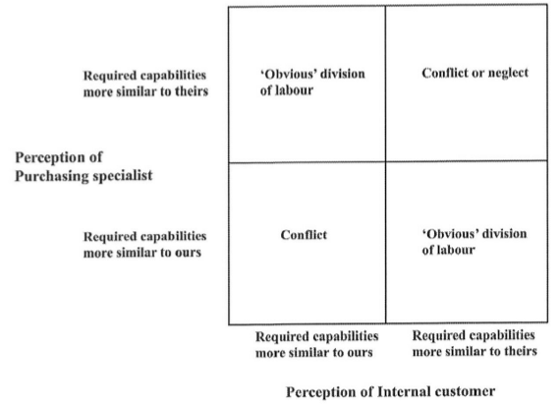

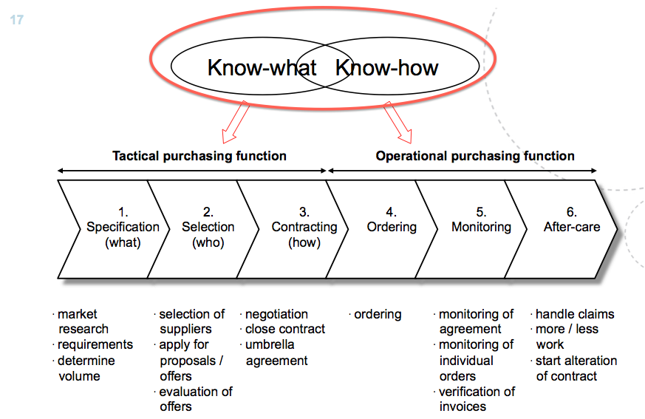

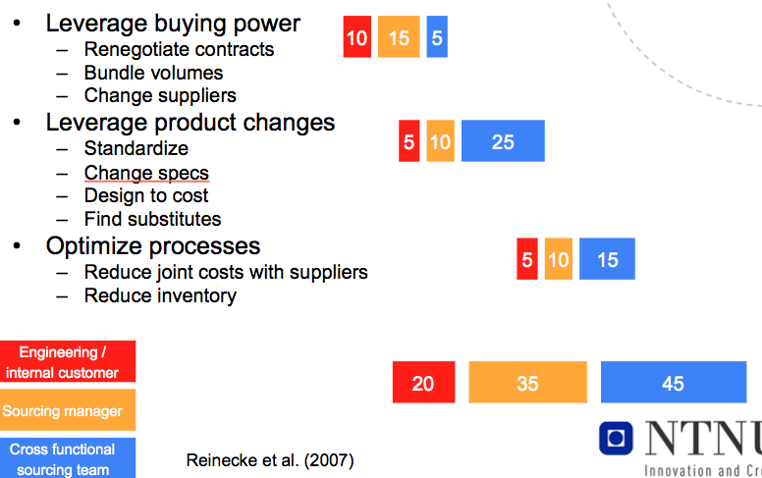

**Sources for conflicts:**

**Need for cooperation, or at least coordination**

The necessary knowledge for an effective purchase is often not present in just one single person

**Overlap and gaps can cause conflicts**

**Different views**

The different people involved do not necessary have a similar picture of what each of them know and is able to do

**Dynamic nature of knowledge**

Knowledge is not static but develops with time and experiences

**Power of teamwork:** Overall a cross-functional sourcing team is the best solutions. This is illustrated in the figure.

## Organizational structure (Ch. 10)

The purpose of organizational design is to arrange the intelligent resources of the organization (people and ICT) in such a way that it can engage with the markets effectively. It follows that as the needs of the markets change, so the design of the organization must be reviewed. However, it is important to note “although the structure of the purchasing function says something about the work among suppliers, it does not state anything about the one between purchasers and internal customers”.

### Historical overview

Many of today’s organizations still display structures and mechanisms demanded by the mass production concepts of the 19th century – a traditional hierarchy with vertical functional silos taking responsibility for the activities and specialism into with the organization divides itself (Finance, Marketing & sales, Operations, HR, etc.). The silos were strengthened over the 20th century by the professionalization of specialism. In the 1970s a more practical approach were discussed to approach the flow of horizontal communication flow. Organizations could not wait for procedures to run their course, and the operational-level impact was the concept of cross-functional teams. However, breaking down the silo walls in this way was not easy, and cross-functional teams still appear to present major problems for some organizations today.

### The classic choices –Centralization vs. Decentralization – and the hybrid

**Centralization** is characterized by a *powerful centralized purchasing office, which specifies and buys on behalf of the divisions.* It stems from the original silo format, which often included co-location of all the functions on one site. When divisions were formed in the organization, satellite plants would be managed from the center, where the expertize records and political power lay. Once the divisions began to gain different political power and expertise, tensions built up around them and the center. The advantages and disadvantages displayed in the model are quite self-explanatory (see p. 131 for detailed explanations).

**Decentralization** is characterized by a *central purchasing office making policies and corporate deals, while the divisions purchase on their own behalf.* Many of the advantages of decentralization come from removing the disadvantages of centralization.

**Atomization** – *“a slightly more relaxed version of centralization?”*

Characterized by a small central purchasing office that makes policy, while the responsibility for sourcing and supply management is given to budget holders. The advantages and disadvantages are explained in the figure (for details see p. 138).

**Federal structure –** *“a more controlled structure of decentralization?”*

Characterized by the *divisions awarding power to the central office to develop policy and provide necessary services to them with specific mandates*. The concept of federalism has three basic characteristics:

**Common rules and procedures:** Basic ground rules are agreed and used throughout the organization. Local ways of working may vary, but not conflict with corporate policies and strategies.

**Dual citizenship:** People in the organization are showing genuine concern both for the good of the corporation as a whole, and for their local divisions.

**Subsidiary:** Activities are carried out, and decisions taken, at the lowest level possible. The center becomes a coordinating device, but answerable to the divisions.

**Hybrid systems**

The most common hybrid is seen on organizations that decide to buy some commodities centrally and others locally – combining the strength of central planning with the necessity and opportunities of local sourcing. True commodities are almost always bought centrally unless the global nature of the organization provides sufficient bargaining strength for traders in several countries to buy independently. The hybrid organization will require (or allow) it divisions to purchase other requirements locally.

## A6: Developing a typology of organizational forms of cooperative purchasing

*Cooperative purchasing is defined as the cooperation between two or more organizations in one or more steps of the purchasing process*. The emergence of such purchasing groups is an important trend within purchasing – especially in public sourcing. It can be driven by three possible objectives (or means):

* **Sharing of information**
  + Market- & product info, best practices, specs, RFP, contracts
* **Pooling of resources**
  + Pooling of efforts and systems, reducing transportation costs, improving capacity and sharing risk
* **Bundling of volumes**
  + Reduced prices and improved conditions, purchasing power and efficiency

|  |  |
| --- | --- |
| Advantages | Disadvantages |
| Lower purchasing prices | Set-up costs |
| Higher quality | Coordination costs |
| Lower transaction costs | Loosing flexibility |
| Reduced workloads | Loosing control |
| Reduced supply risk | Supplier resistance |
| Learning from each other | Possible anti-trust legislation |

Table 4 – Typical advantages and disadvantages of cooperative purchasing

The concept of cooperative purchasing seems to be especially interesting for public organizations, as there is no or almost no mutual competition. In addition there is often a common external environment, mutual trust, mutual interests, similar organizational structures, similar networks, similar purchasing needs and one common goal: maximizing the value of tax payers money.

This article focuses on developing a typology of different forms of cooperative purchasing. Such a typology can be used to clearly define and position the studied organizational form of a purchasing group, and it can be used to design a purchasing group in which the different dimensions of the group fit together.

The main dimensions of cooperative purchasing

1. Extent of cost and gains for the members
2. *Influence by all members on the activities of the group*
3. *Number of different activities for the group*
4. Organizational design of the group
5. Member characteristics
6. Size of the group
7. Life span of the group

### 5 different types of purchasing groups

There are several differences within each form of cooperative purchasing, however there are also dimension which distinguish the forms from each other – namely the influence all members have on group activities, and the number of different activities for the purchasing group (see figure below). For all purchasing groups, it is recommended to find the best balance between the two dimensions.

In intensive forms of purchasing groups, the coordination costs are higher and the total numbers of members lower than for non-intensive forms. *Intensiveness* is defined as the extent to which a group member is compelled to perform an active role in a purchasing group. Large organizations are usually involved in intensive forms, as there is a relation between the organization’s size and the profitability of a piggyback contract as more specific contracts are often necessary. Smaller organizations are usually involved in third-party groups and piggy backing, as the lack economies of scale of their own.

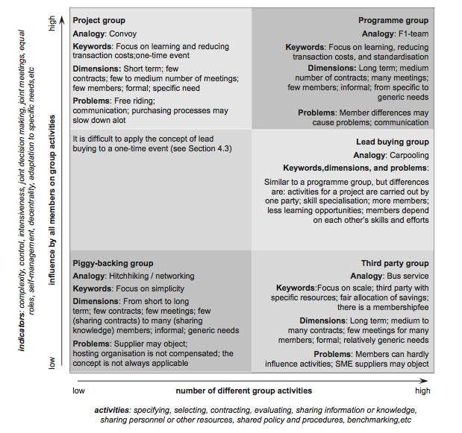

#### Piggy-backing groups (Hitchhiking)

In some cases, this form of cooperation only involves the sharing of purchasing information and knowledge with other organizations in a large network. In most cases, however, it involves involve a relatively large organization establishing a contract on its own specifications which in turn can be used by smaller organizations under (almost) the same contract decisions. The piggyback groups are therefore informal purchasing groups with a focus on keeping the cooperation as simple as possible. For the piggybacking organizations, the concept can be quite beneficiary. For the hosting organizations, there is no direct incentive to allow piggyback riding. Therefore, to make a piggyback group work on the long term, the host preferably receives some compensation.

There are 3 difficulties with this arrangement: Piggybacking organizations can usually not influence the purchasing decisions and supplier choice, therefore the coordination cost are low although the concept is not always applicable. Often organizations are not aware of the possibility for piggyback riding on contracts of others, and in addition some suppliers do not allow smaller organizations to piggyback on a contract under the same conditions (can be solved by a somewhat higher purchase price).

#### Third-party groups (Bus service)

In these groups a third-party focuses on achieving a large scale and carries out most of the purchasing activities by itself. The purchasing activities are based on expected aggregate purchasing volume and are carried out with the specific purchasing expertise of the external party. Third-party groups mostly involve long-term piggybacking made possible by public or private external parties or central authorities with devoted resources. A third party is a for-profit/non-profit organization and may be owned by the members of the group.

The members of the group do not have to communicate with each other. Thus, just like in a piggybacking group, there is no need for a high involvement relationship with each other, nor discussion of purchasing specifications. The members only have a formal relationship with the third party hosting organization. The disadvantage of third-party groups is that the members have hardly any control over the purchasing process, and custom-made items are therefore usually not suitable. It may also be difficult for SME to supply very large third-party groups.

#### Lead buying groups (Carpooling)

Involves outsourcing of purchasing activities to one of the other members of the group, and each item is therefore purchased by the most suitable organization or external party (according to their expertise, resources or purchasing volume). The members of the group can therefore specialize in purchasing typical items.

In order to select which member should be carrying out which activities, consideration and evaluation meetings must be held. Under these evaluation meetings the members can influence the tenders put out by others to a certain extent. To become a successful intensive purchasing group, the members should have at least some similarities (geographic location, similar network etc.). As more consultation is necessary than in third party purchasing, the lead buying groups usually have fewer members. Advantages and disadvantages of lead buying are similar to that of general outsourcing of purchasing activities. An example of *a disadvantage is the dependence of other members’ knowledge and skills.*

#### Project groups (Convoy)

A project group is typically a one-time purchasing group for a shared purchasing project. The members of the group bundle their forces for one time and together carry out the purchasing activities. The members typically focus on a shared problem and try to learn from each other during the project. There are regular meetings during the projects (intense form of cooperative purchasing), but as the group is a one-time event the organizational structure is quite simple and the number of cooperative activities limited. The group usually breaks up after the project ends.

The project groups usually do not require a long-term binding process, but do involve some consultation between the members to agree on specifications and supplier choice. This can lead to problems as the members do not know each other very well, and one should also try to prevent or limit the effects of free riding. If an organization is carrying out more work than others it should be compensated.

#### Programme groups (F1 team)

Often involve representatives of the management teams of the cooperating organizations meeting regularly in a steering committee to discuss cooperative projects (intense form of cooperative purchasing). The members have high involvement relationships with each other and can all influence specifications and supplier selection. The members share the administrative work and focus on learning from each other and on reducing transaction costs. Cooperative projects are usually carried out by at least one member of the steering committee together with representatives of all cooperating organizations. To be able to work efficiently, several purchasithng processes are usually standardized or synchronized in both programme and lead buying groups.

The analogy to F1 teams is chosen as everyone plays an important role in the group. In addition, public or private external parties are regularly used to coordinate some of the activities. Each member typically has an individual contract with the shared supplier. Typical difficulties include sharing of confidential information, communication problems and the allocation of savings.

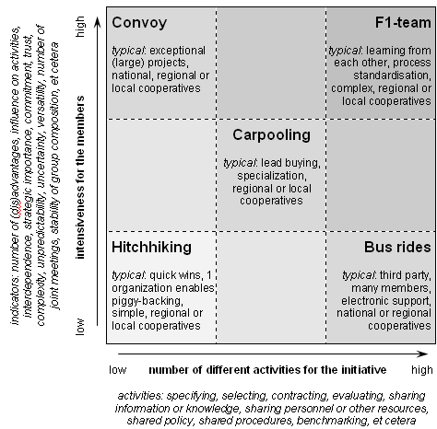

**The**

**Highway**

**Matrix**

Some general considerations worth mentioning are that for intensive forms, the coordination costs are higher and the number of members is lower than for non-intensive forms. There also can exist a wide range of different hybrid organizational forms of cooperative purchasing. These organizational forms are defined as coordination by network and range between coordination by hierarchy and coordination by market.

# Week 16 – Strategic supplier selection, performance measurement, cost benefit analysis

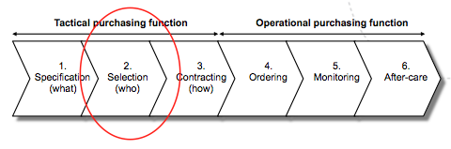

Practices such as outsourcing, supply base rationalization, long-term collaboration and supplier involvement in product development raise the firm’s dependence on its suppliers. The ability to switch between suppliers are often reduced as relationship specific assets increase, as a result there is an increasing pressure to select the ‘right’ supplier first time to maximize value creation.

## The 4 main stages of supplier selection

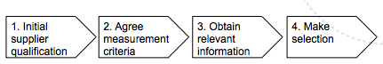

### 1. Initial supplier selection

The goal is to identify suppliers who meet requisite product and process standards and are capable of supporting the buyer’s long-term objectives. As there is a resource constraint, qualification helps reducing the pool of potential suppliers to a more manageable number for detailed evaluation and selection. Buyer firms will typically want to assess two categories:

* **Manufacturing capabilities**
  + Strategic assets accumulated through a pattern of investments over time and cannot easily be imitated, acquired by trade or substituted.
* **Financial viability**

Suppliers meeting the minimum standards set for each of these measures may then be included in a more detailed selection procedure.

### 2. Agree on measurement criteria

In this step it is important to identify relevant and appropriate selection criteria; the criteria must be specific to a particular product purchased and not demand more effort than necessary by a resource-constrained organization. High performing firms are likely to have a smaller number of measures than low performers, but they are likely to be more relevant to the context. The most significant trend has been the move away from price and towards a total cost approach.

**There are 5 major competitive priorities of various criteria:** cost, quality, delivery, flexibility and others.

|  |  |  |
| --- | --- | --- |
| Criteria | Description | Examples |
| **Cost** | The most common criteria used in supplier selection | **Unit price** – Easy to compare across various supplier firms due to objective and comparable data |
| **Pricing terms** –*Quantity discounts* must be seen in relation to cost of holding inventory, inventory depreciation and reduced flexibility. Longer *payment terms* have a positive effect on working capital. |
| **Exchange rates, taxes, duties**– fluctuations can have an enormous profit impact |
| **Quality** | Apart from price and delivery probably the most used criteria in supplier selection | A wide range of proxy criteria is usually applied. Most common is **quality system certification** (ISO9000). Visits to supplier plants checking for **quality circles, continuous improvement**, state of plant floor and amount of rework. |
| **Delivery** | Much used, especially in JIT production places which requires delivery exact to their build schedule, more frequently and smaller lot sizes. | **On-time delivery –** variability of delivery compared to the agreed time. Low variability reduces the need for safety stock.  **Minimum lot size** – the minimum order quantity that can be placed. Maintained by supplier to gain economies of scale.  **Lead time, delivery frequency, location, inbound delivery cost** |
| **Flexibility** | The ability of the supplier to manage variation from buyer firm w/o significant trade-offs with other competitive priorities | **Volume flexibility** – ability and willingness to change order volumes w/o significant penalties  **Mix flexibility** – Ability and willingness to change the mix of ordered product w/o significant penalties |
| **Other** |  | **Financial risk, ethical or environmental analysis**  **E-commerce capability**  **Reputation**  **Diversity of ownership**  **Innovation capability** |

Table 5 – Competitive priorities and criteria for supplier selection

Buyers may have to handle criteria that are in trade-offs. Especially trade-offs between delivery characteristics and unit price escalates as buyer firms seek to balance production in low-wage economies with the need to be flexible and responsive towards customers. This is not an argument against outsourcing, but meant to highlight the importance of building **total cost models** during supplier selection. It is also important to remember that not all criteria should be used for any one decision. Only the criteria relevant to a particular product should be used, and one can here often distinguish between functional and innovative products.

|  |  |  |  |
| --- | --- | --- | --- |
| **Product type** | **Characteristics** | **Requirements** | **Selection criteria** |
| **Functional** | Relatively stable, predictable demand. Long product life cycles. | Physically efficient suppliers | Cost  Delivery (on time, cost, minimum lot size) |
| **Innovative** | Lumpy, unpredictable demand. Shorter product life cycles. | Responsive to changes on the market place | Flexibility  Innovation capability  Delivery (location, lead-time) |

Table 6 – Functional vs. innovative products and supply chain strategies

## 3. Obtain relevant information

In this stage it is important that the information is comparable across suppliers, timely and accurate. The information can stem from different sources including information from suppliers, supplier visits and supplier performance measures.

## 4. Make selection

There exist a range of selection models, ranging from highly qualitative to highly quantitative methods, and from very simple to very complex methods. The different methods may lead to different results, but there is not one best method. The models are tools for expressing, analyzing and constructing values, and the purchaser always remains responsible!

The model and amount of effort put into the final selection should reflect the impact on the business and market complexities.

|  |  |  |
| --- | --- | --- |
| **Impact on business** | **Low value products** | Selection often not involving more than comparing information gathered in RFQ or RFP |
| **High value products** | More complex selection, often involving use of multi-criteria decision making models |
| **Market complexity** | **Few alternative supply sources** | Comprehensive selection, due to low possibility of substitution |
| **Many alternative supply sources** | Less comprehensive selection |

Table 7 – Selection process relative to impact on business and market complexity

### Decision models

**Stakeholders and their myths**

|  |  |  |
| --- | --- | --- |
| **Stakeholder** | **Myth** | **Resulting problem** |
| **Policy makers** | There exists 1 objective and accepted way of scoring and evaluating suppliers | Confusion among users; what about all the other ways we know? |
| **Buyers (believers)** | Using formal models a truly objective and right choice is made | Overconfidence in a formal approach, ignorant of values driving the design of the model |
| **Buyers (disbelievers)** | Models can easily be manipulated to give any desired outcome | Misuse of models, missing the point: wasted chance to learn and deepen understanding |
| **Researchers (positivists)** | Buyers (as a rule) need help, there is room for interaction, repeated information gathering and fine-tuning of models | Models may appear redundant and/or impractical as they don’t fit the practice of supplier selection |
| **Researchers (constructivists)** | Supplier selection models are irrelevant and (virtually) absent in practice | Ignorance of actual (attempted) use of formal methods in supplier selection and e-auctions |

Table 8 – Stakeholder myths and consequences

### AHP-technique (fully compensatory)

A MCDM (multi-criteria decision-making) model that enables decision makers to weight criteria according to their importance to the decision and the extent to which each alternative meet the criteria. It uses pairwise comparisons to express the relative importance of one criterion vs. another. It is designed to handle tangible, as well as intangible criteria. In its use it forces the user to think seriously about criteria used to select supplier and weights that are consciously or unconsciously ascribed to the criteria.

|  |  |
| --- | --- |
| **Preference** | **Numerical rating** |
| **Equally preferred** | 1 |
| **Moderately preferred** | 3 |
| **Strongly preferred** | 5 |
| **Very strongly preferred** | 7 |
| **Extremely preferred** | 9 |

Table 9 – Measurement scale for pairwise comparison

**Method**

1. **Assign weights to criteria**

Following the scale shown above the criteria are compared pairwise to rate the relative importance of each criteria. After filling out the first line of the table below, 1s can fill the diagonal elements and the elements below the diagonal can be filled with the inverse of their counterparts above the diagonal.

**First row: Diagonal elements: Off-diagonal elements:**

|  |  |  |  |  |  |  |  |  |  |  |  |
| --- | --- | --- | --- | --- | --- | --- | --- | --- | --- | --- | --- |
|  | **Innovation** | **Quality** | **Price** |  | **Innovation** | **Quality** | **Price** |  | **Innovation** | **Quality** | **Price** |
| **Innovation** | 1 | 3 | 5 |  | 1 | 3 | 5 |  | 1 | 3 | 5 |
| **Quality** |  |  | 4 | => |  | 1 | 4 | => | 1/3 | 1 | 4 |
| **Price** |  |  |  |  |  |  | 1 |  | 1/5 | 1/4 | 1 |
| **Column total** |  |  |  |  |  |  |  |  | **1.533** | **4.250** | **10.00** |

1. **Calculate weights**

Achieved by dividing each column element by their column total and computing the row averages. The row averages will then be the weight of each criterion.

|  |  |  |  |  |
| --- | --- | --- | --- | --- |
|  | **Innovation** | **Quality** | **Price** | **Weights** |
| **Innovation** | 1/1.533=0.652 | 0.706 | 0.500 | **0.619** |
| **Quality** | 0.217 | 0.235 | 0.400 | **0.284** |
| **Price** | 0.130 | 0.059 | 0.100 | **0.096** |
| **Column total** | 1.000 | 1.000 | 1.000 | 1.000 |

1. **Evaluate individual suppliers**

Each supplier is first rated pairwise against each criterion (marked red), before the diagonal elements are filled by 1s (marked blue), and the elements below the diagonal are filled by the inverse element of their above-diagonal counterparts (just as in ‘assign weights’). Finally each column element is divided by the column sum, and the row average computed in order to obtain the weight of each supplier relative to the criterion.

|  |  |  |  |  |  |  |  |  |
| --- | --- | --- | --- | --- | --- | --- | --- | --- |
| **Original** | | | |  | **Adjusted** | | | **Weights** |
|  | S1 | S2 | S3 |  | S1 | S2 | S3 |  |
| **Innovation** |  | | | | | | | |
| S1 | 1.000 | 9.000 | 2.000 |  | 0.621 | 0.822 | 0.250 | **0.584** |
| S2 | 0.111 | 1.000 | 5.000 |  | 0.069 | 0.098 | 0.625 | **0.264** |
| S3 | 0.500 | 0.200 | 1.000 |  | 0.310 | 0.020 | 0.125 | **0.152** |
| **Total** | 1.611 | 10.200 | 8.000 |  |  |  |  |  |
|  | | | | | | | | |
| **Quality** |  | | | | | | | |
| S1 | 1.000 | 0.200 | 3.000 |  | 0.158 | 0.153 | 0.231 | **0.180** |
| S2 | 5.000 | 1.000 | 9.000 |  | 0.789 | 0.763 | 0.692 | **0.748** |
| S3 | 0.333 | 0.111 | 1.000 |  | 0.053 | 0.085 | 0.077 | **0.072** |
| Total | 6.333 | 1.311 | 13.000 |  |  |  |  |  |
|  | | | | | | | | |
| **Price** |  | | | | | | | |
| S1 | 1.000 | 0.333 | 0.200 |  | 0.111 | 0.063 | 0.138 | **0.104** |
| S2 | 3.000 | 1.000 | 0.250 |  | 0.333 | 0.188 | 0.172 | **0.231** |
| S3 | 5.000 | 4.000 | 1.000 |  | 0.556 | 0.750 | 0.690 | **0.655** |
| **Total** | 9.000 | 5.333 | 1.450 |  |  |  |  |  |

1. **Calculate supplier weights**

The supplier weights are calculated by multiplying the supplier criteria weights by the criterion weight. The final weight is the row sum of the supplier weights for each criterion.

|  |  |  |  |  |  |  |  |
| --- | --- | --- | --- | --- | --- | --- | --- |
|  | **Innovation** |  | **Quality** |  | **Price** |  | **Weights** |
| **S1** | (.619)*(.584) | + | (.284)*(.280) | + | (.096)*(.104) | = | **.423** |
| **S2** | (.619)*(.264) | + | (.284)*(.748) | + | (.096)*(.231) | = | **.398** |
| **S3** | (.619)*(.152) | + | (.284)*(.072) | + | (.096)*(.655) | = | **.178** |

Here supplier 1 should be selected.

**Limitations**

* Driven by the judgments of the decision maker
* Susceptible to manipulation or simple errors
* Pairwise comparison allows some inconsistency in the decisions
* A new matrix must be calculated each time a new criterion is added
* Fully compensatory – might not be very realistic in practice
  + If one supplier scores high on all scores except quality, it is not certain that a buyer thinks good scores on almost all criteria are worth the quality difference.
* Assumption of comparability between any two alternatives
  + In many real-world situations the assumption of comparability is not valid due to the lack of information and/or willingness to compare to alternative with the respect to some criterion.

## A5: Outranking methods in support of supplier selection.

Many decisions concerning initial purchasing decisions (make/buy and sourcing) are considered to be of high strategic importance. However, the nature of many of these decisions is unstructured and complex. Traditional decisions support systems and information systems that support routine operational purchasing decisions and administrative activities do not seem to address the complex and unstructured nature and context of many present-day purchasing decisions. Several factors may complicate the decision-making process, including incomplete information, qualitative criteria and imprecise preferences. *The outranking model is well suited to deal with multiple criteria decisions with qualitative as well as quantitative nature*.

##### Review of existing models (not very important?)

When evaluating and reviewing decision models for supplier selection the following properties are worth considering.

1. **Number of criteria and their nature**

Criteria may have qualitative as well as quantitative dimensions, and they may also be conflicting. A strategic approach may further emphasize the need for considering multiple criteria.

1. **The interrelatedness of decisions**

Interrelated decisions are likely to be present in purchasing, *as a single buying decision cannot be isolated and evaluated alone*. Typically a first decision is made to create a set of acceptable suppliers, which in following stages is reduced until one supplier is left.

1. **The type of decision rule used**

Two types of decision rules can be used; compensatory decision rules leading to an optimal solution, and non-compensatory decision rules in which a bad score on a particular criterion can be compensated by high scores on other criteria. With choosing an ‘optimal solution’ it can be difficult to define a precise optimality criterion.

1. **The number of decision makers**

Many purchasing decisions are taken, or at least influenced, by several actors. Multiple views on the same reality may add to the complexity of the decision situation.

1. **The various types of uncertainty**

Imprecision – Difficulty of determining the score of an alternative on a criterion, or the importance of some criterion, with a high degree of precision due to the inability to express a preference in a completely consistent way.

Stochastic uncertainty - classical

Indetermination – If the actual definition of a criterion is far from univocal (entydig). R&D capabilities can for instance be measured through a wide range of measures.

A literature search in the article concludes that there is surprisingly little attention paid to the following properties:

* **Non-compensatory decision rules aimed at selecting acceptable alternatives when an optimal solution is difficult to find**.
* **Uncertainty, indetermination and imprecision**

The outranking techniques may provide the basis for developing supplier selection models that can effectively deal with these properties.

The literature search also reveals that the need to incorporate several multidimensional criteria is well recognized, many models only use quantitative criteria. Furthermore most models assume that precise and accurate data and preferences are available.

##### ELECTRE 1 – An outranking method

*“a outranks b (aSb) if, given what is known about the decision maker’s preferences and given the quality of evaluations of the actions and nature of the problem, there are enough good arguments to decide that a is at least as good as b, while there is no essential reason to refute that statement”.*

The ELECTRE ‘ model is introduced as an example of an outranking method. Not surprisingly the outranking methods provide the basis for developing supplier selection models that can effectively deal with the properties pointed out above. *Both the AHP model and the outranking methods are capable of dealing with quantitative as well as qualitative dimensions, and both of them are also able to deal with imprecision* caused by the decision makers inability to translate his preference for some alternative to another into a totally consistent preference structure. However, AHP is fully compensatory – which in practice might not always be very realistic (see AHP limitations). Another negative aspect with is the assumption of comparability between any two alternatives (see AHP limitations). **Outranking methods on the other hand are only partially compensatory and are capable of dealing with situations in which imprecision is present.**

Being forced to think about these aspects is one of the strengths of the outranking approach as it contributes to a better understanding of the decision problem. However, the experience, feel and subjective estimates should determine the model, rather than the model forcing a rigid format upon the decision maker. The outranking models do not dictate specific criteria, weights, ways of gathering information, or thresholds. It merely serves as a structure for guiding the process of making these elements more explicit.

**Method**

1. **Agree on profile of selected supplier (criteria)**

E.g. Turnover, location, cost level, quality image

1. **Evaluate an initial set of suppliers based on the criteria**

|  |  |  |  |  |  |
| --- | --- | --- | --- | --- | --- |
|  | **Supplier a** | **Supplier b** | **Supplier c** | **Supplier d** | **Supplier e** |
| **Turnover (M$)** | 7.5 | 8 | 11 | 9 | 8 |
| **Distance (km)** | 50 | 500 | 900 | 200 | 550 |
| **Cost level ($)** | 20 | 15 | 18 | 25 | 11 |
| **Quality image** | moderate | excellent | good | good | bad |

1. **Application of ELECTRE 1**
   1. **Agree on weights for the criteria**

|  |  |  |  |  |
| --- | --- | --- | --- | --- |
| **Criterion** | **g1** | **g2** | **g3** | **g4** |
| **Weight** | 0.20 | 0.15 | 0.30 | 0.35 |

* 1. **Definition of discordance sets**

Discordance set: a relative bad score of an alternative on a particular criterion may be unacceptable for the decision maker regardless of the possible superior performance on other criteria.

For this example: Refuse outranking of supplier a by supplier b when:

* + - 1. General cost level of supplier a is at least twice as high as that of supplier b
      2. The quality image of supplier a is bad, while the quality image of supplier b is excellent

The discordance set should be checked each time concordance indices are compared to concordance thresholds

* 1. **Calculation of concordance indices**

Concordance index: a measure of the strength of arguments in concordance with proposition “a outranks b” (conc(a,b)) – the strength of preference of the decision maker of the first alternative above the second.

Equals the sum of weights of the criteria on which supplier a scores at least as good as supplier b {0,1}

* + - 1. Conc(c,e) = k1 + k4 = 0.20 + 0.35
      2. Conc (e,c) = k1 + k2 + k3 = 0.65
  1. **Define concordance threshold**

Determined by the decision maker in such a way that he feels that in case the concordance index of two alternatives exceeds the threshold, there are considerable supporting arguments for the assertion ‘a outranks b’.

The choice of 0.8 for the concordance threshold is rather arbitrary.

* 1. **Evaluate outranking results**

|  |  |  |  |  |  |
| --- | --- | --- | --- | --- | --- |
|  | **Supplier a** | **Supplier b** | **Supplier c** | **Supplier d** | **Supplier e** |
| **Supplier a** | - | 0.1 | 0.15 | 0.45 | 0.50 |
| **Supplier b** | **0.85** | - | **1.0** | 0.65 | 0.70 |
| **Supplier c** | **0.85** | 0.20 | - | 0.65 | 0.55 |
| **Supplier d** | 0.55 | 0.35 | 0.70 | - | 0.70 |
| **Supplier e** | 0.50 | 0.50 | 0.65 | 0.30 | - |

* Supplier b outranks suppliers a and c
* Supplier c outranks supplier a

It is now clear that supplier b is preferred to suppliers a and c, but that a comparison between suppliers d and e and the other suppliers cannot be made. This implies that suppliers b, d and e are incompatible. In order to be able to choose between these alternatives, a more precise evaluation of the given criteria and/or other criteria has to be carried out.

* 1. **Analyze the influence of the concordance threshold**

If the concordance threshold is lowered to 0.7:

* Supplier b outranks suppliers a,c and e
* Supplier c outranks supplier a
* Supplier d outranks supplier c

Now, suppliers b and d are the most attractive ones.

The insight gained from use of ELECTRE 1 allows a supplier selection task force to focus their attention on a subset of suppliers (here supplier b, d, e or b, d depending on concordance threshold). For this subset additional information and/or criteria can be used in order to make an ultimate decision on the supplier selection.

**Extensions – ELECTRE III**

Indifference interval taken into account - as one might find it difficult to distinguish between distances of 500 and 525 km. If the decision maker is indifferent between two alternatives with respect to the criterion distance as long as the difference is less than 5% of the nearest alternative under consideration, but strictly prefer the nearest alternative in case one is 20% further away than the other, thresholds can be introduced. An important advantage of these thresholds is a more subtle weighting. A disadvantage is that scores of qualitative nature have to be quantified.

The ELECTRE model merely serves as a means for structuring data that are collected anyway and making the uncertainties and vague preferences surrounding these data more explicit.

## Performance measurement (Ch. 11)

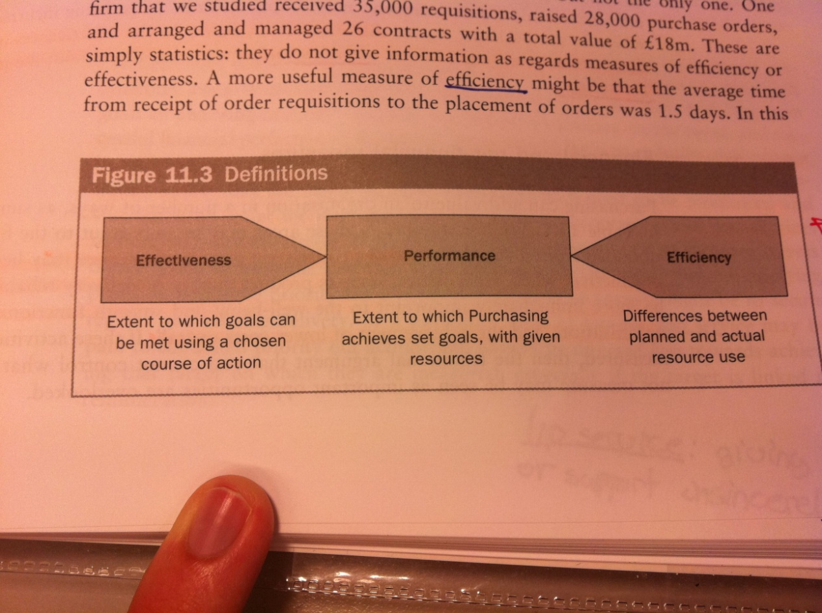

Table 10 - An importance difference between effectiveness and efficiency

The fundamental objective of a purchasing and supply chain performance measurement system is to aid in strategy implementation through a formal, systematic approach to monitoring and evaluating purchasing activities. Traditionally most measures of performance have focused on the internal operations of the purchasing functions, with few outward looking measures assessing supplier performance. Although the vital role of purchasing in the achievement of strategic goals has been recognized, there has generally not been a corresponding change in the types of measures used.

## PM as signaling devices and design of PM

Management can use performance measures as means of signaling and influencing the actions of the people who are responsible for performing the tasks. If the quality of inputs gets only lip service from top management, and only the costs of inputs are measured, then quality essentially becomes a secondary issue. Performance measures must therefore be carefully designed to suit the organization in order to avoid resources being allocated in a sub-optimal way. In this design it should be emphasized that effective PM cascade the high-level corporate strategy down into the lowest levels of the organization, signaling expectations and desired behaviors. The aim is to create an alignment between corporate strategy, supply strategy, goals & objectives, performance measures and actions of individuals.

### Benefits of measurement

* **Decision making**
  + Directing activity that is aligned to the needs of organization, and identify variance from planned results. Cause & effect relationships can be seen more clearly.
* **Communication**
  + Establish relevant targets for purchasing personnel and internal customers that can facilitate communication throughout the org.
* **Visibility**
  + Improves visibility of activities within and outside the purchasing function by identifying areas of waste in terms of defects, delays, surpluses and mistakes.
* M**otivation**
  + Measurements have a motivational influence, helping to shape perceptions of what is important and to concentrate on actions relevant to them.

### Pitfalls in performance measurement

* **Price performance indicators may be misleading**
  + Real price might be blurred by quantity discounts, payment terms, credit and currency fluctuations.
  + Who is responsible for a fall in market prices?
* **Focus entirely on price performance**
  + Other issues such as product quality or delivery reliability may be more immediately important for to the well-being, smooth functioning and low overall costs for the organization.
* **Focus on historic rather than future performance**
* **Focus on financial rather than operational indicators**
* **Focus on internal rather than external data**
* **Focus on numeric rather than qualitative results**
  + While it is difficult to quantify performance in areas as supplier development, interdepartmental relationships and negotiation skills, they are often the very activities that need to be monitored and stimulated.
* **Not identifying relevant stakeholders**
  + Identifying who the internal customers are, and gathering information they actually need to gauge performance can be frustrating steps in the performance measurement exercise.
* **Not gaining sufficient buy-in**
  + The management system will achieve a greater degree of credibility with employees than if the measures are imposed on them from top down. Therefore managers will be required to set the strategic context, but should allow the teams to think about the most effective ways they can achieve them to suit that strategic context.

## Categories of performance measures

|  |  |
| --- | --- |
| **Category** | **Example of performance measures** |
| **Cost** | Total distribution cost  Total inventory cost |
| **Quality** | Production quality  Defects per supplier  Customer returns |
| **Time** | On-time deliveries  Customer response time  Backorder/stock |
| **Supplier performance** | Level & degree of information sharing  Number of buyer-vendor cost saving initiatives  Extent of mutual assistance in problem solving efforts  Percentage of certified suppliers  Number of suppliers per commodity purchased |
| **Customer satisfaction** | Internal & external |

Table 11 – Categories of performance measures

### Developing a performance measurement system

1. **Determine goals to measure**
   1. A key pitfall is to select goals which do not reflect corporate- and business-level strategies, or that has not been re-evaluated as the strategy and operations change.
2. **Establish performance measures**
   1. Use of the SMART test (Specific, Measureable, Actionable, Relevant, Timely)
   2. Not too many measures, leading to a lack of focus
   3. Not too few measures leading to missing information
3. **Establish standards for comparison**
   1. Analysis of historical data
      1. Important not to rely excessively on these measures, as seemingly minor changes in manufacturing or sourcing can make the standard irrelevant.
   2. Planned performance
      1. Company-wide best practice identification – guard against dysfunctional rivalry
   3. Competitive benchmarking
      1. Motivator for best practice and world-class manufacturing
4. **Monitor progress**
   1. Must here make decisions regarding the type of feedback required from performance measures (identify users, required information, frequency and data collection).
5. **Evaluate progress**
   1. The PM system must have feedback mechanism (closing the loop). The measures should capture performance and identify exceptions to what is planned. A problem at this stage is over-aggregation of data – masking potentially important trends/events.
6. **Implement improvement actions**
   1. Correction of problems/issues identified. It is important to be sure that the measures used will result in desired actions (not encouraging internal competition/discourage teamwork).
7. **The purchasing balanced scorecard**
   1. The balanced scorecard attempts to attain a balance between the strategic measures. The scorecard is based on four perspectives (Financial perspective, Customer focus, Internal business processes, Innovation and learning). A fifth dimension can be added; the Supplier perspective measuring supplier performance and how well purchasing performs vis-à-vis its suppliers.

|  |  |
| --- | --- |
| **Perspective** | **Example of measures** |
| **Financial perspective** “How do we look to stakeholders?” | Material price variance, total purchasing cost, cost avoidance |
| **Customer focus** “How do customer see us?” | Customer satisfaction, # of complaints, # cross-functional projects |
| **Internal business processes** “What must we excel at internally?” | On-time delivery, order cycle time, supplier defect rates, % spending through e-auctions |
| **Innovation and learning** “How do we learn and innovate?” | Staff attitude, # improvement proposals, % professionally qualified buyers, hours of training per employee |
| **Supplier perspective** “How well do we manage suppliers?” | Certified supplier base, # suppliers/commodity, supplier satisfaction |

Table 12 – A purchasing balanced scorecard

### Characteristics of effective performance measurement systems

1. Link to corporate objectives
2. Combination of different measures to meet requirements at different org. levels (cascading goals)
3. Capture elements of both efficiency and effectiveness
4. Allow trade-off identification between different performance dimensions
5. A balanced mixture of qualitative and quantitative measures
6. A mix of leading and lagging indicators
7. Incapable of manipulation
8. Allow systematic collection of data and analysis over time
9. Differentiate between incremental/control measures and radical objectives
10. Encourage cross-functional working

## Cost-benefit analysis (Ch. 12)

The traditional role of purchasing has often led to purchasing decision being taken without the production of a business case. Typically management would look at how much money purchasing managed to save relative to a year-on-year target. This approach appeared to work well until firms started to consider the ‘cost of quality’, or rather the ‘cost of poor quality’ arguments. With supply management being seen as a strategic player, there is much more emphasis on providing accurate information for management decision-making purposes. There is a link between the type of cost measurement used and the strategic capability of the supply function. Thus, if purchasing is going to act strategically, it needs to be measured this way.

### Price-focused approach consequence: The business cycle effect

There are three broad categories of cost; fixed costs, variable costs and profit. If one takes a price-focused approach as a supplier, the number of choices is limited. Fixed costs does often not enter into consideration, while variable costs are inevitably influenced by the customer-supplier relationship and thus only possible to affect to a limited extent without the influence of both parties. This leaves profit as a mean the supplier can use, without depending on others, in order to reduce prices.

When customers adopt a price-focused approach they generally expect the supplier to reduce prices, leaving it with no other short-term alternative than reducing the profit margin. In the medium term the price reduction strategies drives down industry profits, eventually leaving the suppliers with the choice of staying in the market in an attempt to survive, leaving the market for a more lucrative industry or go out of business. As a consequence, a ‘business cycle effect’ arises. The buyers with the market power have driven down prices and thus profit levels. Suppliers reduce profits and attempt to cut cost (often reducing quality), before some begin to move out of the industry to more lucrative markets. After a period of time the market dynamics have changed, with fewer suppliers and many buyers (relatively speaking). This leaves suppliers in a dominant position and prices are pushed up in an attempt to recoup the losses made over the previous time period. This increased cost is commonly passed on to the final customer, leading to reduced market share. The situation is not static, but dynamic and cyclic. Thus starting the cycle all over again as more suppliers enter what is now considered a lucrative market.

### Total cost of ownership

The total cost of ownership considers all costs involved in the company’s supply chain, typically focusing on a particular supplier, a particular good or service, or a particular process. Many consumers, businesses and governments fail to understand and calculate TCO and instead rely on total cost of acquisition (TCA) to make buying decisions. The two analyses can and often does vary dramatically, and TCO is far more relevant in determining the viability of any sourcing alternative.

The TCO concept requires an analysis of all activities performed by the firm that incurs costs. By explicitly identifying the activities incurred across the entire purchasing value chain and related costs, buyers can calculate the true cost of supply. Existing managerial accounting systems have not enabled firms to track these potential cost savings, but the TCO concept and activity based costing systems enables this.

A TCO matrix has been developed in order to help firms evaluate all relevant costs of procurement. The horizontal axis consists of the sequential steps in the procurement value chain, while the vertical axis represents the three main levels of cost aggregation.

**Procurement stages**

1. Initial acquisition
   1. Activities that take place prior to receiving the product from supplier.
   2. Product price, negotiation costs, contracting costs, supplier vetting costs
2. Reception
   1. Receiving goods, processing invoices and payments, and performing inspections on a sample of received goods
3. Possession
   1. Occur between reception and actual utilization in production/service.
   2. Internal transportation, inventory holding costs
4. Utilization
   1. Installation, personnel training, impacts of product failure
5. Elimination
   1. Cost of elimination or re-use
   2. Cost of recycling/safe disposal

**Cost aggregation**

At each cost level it is distinguished between potential savings that are realized as cash, versus saving that result from freeing up capacity or other resources (cash vs. non-cash).

1. Supplier level
   1. Occurring each time a given supplier is used
   2. Cost of supplier audits, salary of responsible buyer
2. Order-level
   1. Occurring each time an order is placed with a supplier
   2. Receiving, invoicing, external transportation
3. Unit-level
   1. Incurred on a per-unit basis, often incurred in the utilization and elimination phases of the procurement life-cycle
   2. Cost of production shutdown due to faulty product, inventory carrying costs, disposal/recycling, pallet movement, damaged items

# Week 17 – Green Purchasing and logistics CSR in a SCM context

## Creating a sustainable SC (Ch. 13)

“Meeting the needs of the present without compromising the ability of future generations to meet their own needs”

### The triple bottom line

The triple bottom line concept emphasizes the importance of examining the impact of business decision on three key areas:

* **Environment**
  + Pollution, climate change, the depletion of scarce resources
* **Economy**
  + Effect on people’s livelihoods and financial security, profitability of the business
* **Society**
  + Poverty reduction, improvement of working and living conditions

These three elements are intertwined and they serve to remind us that for a business to be sustainable, it must pay regard to the wider impact of the activities it undertakes if it seeks to remain viable and profitable

* Sustainability is concerned with ensuring the long-term viability and continuity of the business as well as contributing to the future of well being of society
* These two goals are mutually supportive, i.e. SC strategies that benefit the wider environment are likely also to involve the business in less cost in the long term as the result of a better use of resources.
* We need to understand the impact on sustainability of everything we do from product design thorugh to end-of-life disposal.

For SC managers, greenhouse gas emissions are a particular call to action since some of the major causes of greenhouse gases arise from industrial activities such as manufacturing, energy production and transportation.

#### Reducing the transport intensity of SCs

* As global economic growth continue, so too does international trade increase and hence transport (+global sourcing, increased distances).
* This end results in what might be termed the transport-intensity of the SC.
  + Reflection of the miles travelled per unit of product shipped
* Since transport of raw material and finished goods globally is estimated to consume 15 million barrels of oil each day- almost a fifth of the world’s daily production - there is clearly a correlation between transport intensity and a SCs carbon footprint.
* Not only is there a economic benefit to be gained by improving transport intensity but also a potential positive environmental impact – this is the concept of eco-efficiency, which is now rapidly becoming a major issue in global commerce.

**Practical steps that an organization can take to improve the transport-intensity of their SC:**

* Review product design and bill of materials
  + E.g. packaging
* Review sourcing strategy
* Review transport options
* Improve transport utilization
* Use postponement strategies

#### Peak oil

All oil production, whether for an individual field, a country or the entire world, follows a normal distribution. All the current indicators are that we have reached the top of that curve, or that we shortly will. Even with new discoveries, the total amount of oil reserves will still be in decline once the peak has passed.

* The supply will decline, while demand will grow. The gap will grow. This leads to that the cost of oil will increase dramatically to reflect the shortfall in supply.

**Reasons for this:**

* Focused factories and centralized distribution
* Global sourcing and offshore manufacturing
* JIT deliveries
  + Smaller, more frequent shipments

It is quite possible that if oil prices continue to rise over time, current SC arrangements will prove to be too expensive. There is clearly a need for SC strategists to review their network configuration and to ask “shat if questions” based upon worst case scenarios of transport costs

#### Beyond the carbon footprint

Rather than limiting the focus of attention to reducing greenhouse gas emissions, it is important to recognize the effect of economic activity on the use of scarce resources across the SC as a whole.

* **Design**
  + The choice of materials for both the product and packaging
  + The physical characteristics of the product
  + Focus on opportunities for reuse and recycling
* **Source**
  + Location of suppliers can impact differentially on a resource footprint
  + Environmental implications of supply source, e.g. *food miles*
  + Society and ethical issues
* **Make**
  + Improve energy efficiency
  + Reducing waste, rework and scrap
  + Reduce pollution and emission
* **Deliver**
  + Optimize network configuration
  + Minimize transport intensity
  + Recognizer transport modes
* **Return**
  + Develop “reverse logistics” capabilities
  + Manage product end of life
  + Create “closed loop” SCs

#### Reduce, reuse, and recycle

Many companies are now actively seeking to create marketing strategies that emphasize the greenness of their SCs. Whilst the more cynical observers may dismiss these moves as opportunism what some have dubbed “greenwash” –there can be no question that customers and consumers in markets around the world are starting to demand that suppliers reduce their various footprints

Unless upstream suppliers are able to reduce their own footprint the additional costs that they will incur will inevitably end up in their cost of goods sold – and ultimately in the price of the product in the final marketplace.

#### The impact of congestion

One of the key issues when considering sustainable SC solutions is traffic congestion and the related infrastructure issues.

* Emissions from traffic jams, container vessels waiting etc

Smart logistics and intelligent transport:

* The idea here is to combine the opportunities that exist for greater partnership and collaboration, both vertically and horizontally, in the SC with advanced information and communication technology
* Smart logistics works by aggregating and combing individual shipments into consolidated loads for final delivery.
* When advanced IT solutions such as dynamic vehicle routing and scheduling and intelligent agent modeling are used alongside these collaborative strategies, many things become possible – particularly enabling the better management of constrained capacity against a backdrop of uncertain demand.

## The SC of the future (Ch. 14)

### Emerging mega-trends

Of the many emerging trends that will affect the shape of SC in the future, perhaps the most critical are those to do with demographics and changes in global spending patterns

* Increase in the world’s population
* Changing age profiles
* Cross-border migration
* Spending patterns will change causing some markets to expand and others to decline
* Growth of mega cities
  + Increased focus in city logistics
* Redistribution of wealth from the western world to the newly emerging economies
* The middle classes in the emerging economies are likely to increase

Changes may make existing SC arrangements less than optimal. Businesses that have established production and supply arrangements designed to serve the “western centric” demand patterns that prevailed in the past may need to substantially reconfigure their SC networks to take advantage to the rapidly developing markets of Brazil and India, for example.

### Shifting centers of gravity

* Because of the uncertainties that surround the future patterns of demand and supply and the potential changes in output costs such as energy and other basic commodities, it becomes imperative that any decisions to redesign SCs reflect the need to maximize flexibility
* Ideally, the SC of the future will be capable of adapting quickly to any shifts that might occur on both the demand side and the supply side of business

The use of logistics platforms located on the edge of large cities is likely to increase to enable the consolidation of shipments for delivery into those cities. This will be accompanied by a growing number of collaborative arrangements amongst companies that will share logistics assets such as transportation and distribution centers.

There will be a need to bring supply much closer to demand. This change will be driven by the growing environmental concern over carbon footprints but also by cost considerations as transport costs continue to rise.

**The multi-channel revolution**

* There has been a growth in alternative channels of distribution
* More direct contact between the supplier and the customer/consumer
* Many companies have a range of options for ordering and for delivery/collection
  + Outlets, internet service, telephone, home delivery, collection from store
* The challenge for logistics management is to ensure firstly that the customer experience is consistent across all the channels and secondly that the channels can complement each other to enable, whenever possible, the most efficient use of resources, e.g. shared distribution centers and single inventories
* From a logistics and SCM perspective, the multi-channel revolution has a number of implications. Ideally all channels should be served by the same logistics infrastructure, e.g. smart sharing distribution assets such as distribution centers, vehicles and inventories. If this can be achieved then significant benefits can be obtained through gaining incremental revenue greater than the additional cost.

**The need for adaptability**

* The rate of change has accelerated to the point where the business models that have served us well in the past may no longer work at all tomorrow.
* We have moved from a business environment where the supplier held the power – often through their ownership of resources, technology and brands – to a situation where the customer, or even the consumer, is now in the driving seat.
* The traditional SC business model was based around maximizing efficiencies, particularly through the exploitation of the “economies of scale”. So our factories were designed to produce things in large volumes and to maximize the use of capacity.
* What now is required are SCs that are far more agile and better able to cope with rapid change and higher levels of variety and even customization

**Seeking structural flexibility**

Structural flexibility reflects the ability of the SC to adapt or reconfigure its architecture in response to major changes on the demand side or the supply side. SCs with high levels of structural flexibility are well able to cope with the levels of volatility that are a feature of the twenty-first century business environment.

Key enablers of structural flexibility

* Corporate culture and a mindset that is open to change and is comfortable with frequent changes to processes and working practices.
* Higher levels of collaborative working across organizational boundaries
* Visibility and information sharing
* Access to additional capacity
* Access to knowledge and talent
* Inter-operability of processes and information systems
* Network orchestration
  + Need for coordination

Structural flexibility is increasingly a prerequisite for doing business in a volatile and turbulent environment

**Rapid manufacturing**

One of the rapidly developing technologies that has the potential to transform SCs is “rapid manufacturing” (RM) – also sometimes termed “digital manufacturing” or “additive fabrication”

The foundation of this technology is that products are built up layer by layer using laser-fused metal powders of polymers. Thus, rather than casting or machining a metal item or injection molding a plastic product, this item is created from a series of very thin layers of material

RM technology can enable local-for-local manufacturing to be achieved more cost-effectively; secondly, a much higher level of product customization will be possible; thirdly, there is no need for inventory of finished products to be held; and fourthly energy use and materials waste are likely to be minimized.

## Environmental and ethical issues in supply management (Ch. 14 – Cousins)

* Media knows if you are dealing with suppliers doing child labor, and then everybody will know. That is not good for business.
* Firms increasingly assess their own environmental footprints and those of suppliers, using standards. This is good PR
* The difficulty for purchasing and supply managers is establishing the scope of their responsibility for activities in the operations of their direct and indirect suppliers. There appear to be two goods reasons for acting in a responsible way in this matter. The first is a genuine concern for the sustainability for the earth’s ecology. The second is improved risk management –avoiding the penalties associated with breaking civil or criminal law
* Business face mounting pressures from consumers, regulators and event stock markets to assume more responsibility for their environmental performance.
* Studies have shown that consumers claim more interest in environmental issues in products than their buying behavior show. Then years ago, there is still no evidence that anyone will pay a “green premium”
* Although consumers may not explicitly ask for ethically produced items, they expect them
* Environmental and ethical problems are linked to the SC through designing, controlling, purchasing and so on for the environment.

### Sustainability, green, and environmental soundness

The environmental pressures that affect a business may come from sources inside and outside the firm. External sources include industry requirements, (i.e. customers and suppliers), financial institutions, regulatory authorities, and public bodies). The overall strategy should be designed to address this external environment

Internal sources include the desires of marketing departments to “green” their respective organization’s image; the legal mandates of health and safety inspectors; the fiduciary and stewardship concerns of board members; and the desire of employees who feel the effects if pollution personally not to be associated with recognized polluters.

Developing environmentally sound SC policies and strategies to address the related market needs therefore requires a clear understanding of each of the stakeholder’s perspective and priorities.

In describing sustainability as it applies to business organizations, it is common to speak of the triple bottom line. This line refers to an organization’s responsibilities in areas of economic behavior, environmental impact and social policy.

For everyday sourcing decisions, firms need to develop policies and strategies for environmental and economic performance according to governments’ and agencies’ definitions of what constitutes socially accepted behavior. The combination of the two bottom lines of environment and economics, provides a definition of environmental soundness that should be seen as a continuous process with respect to improving environmental performance.

### Purchasing and supply management’s environmental contribution

A checklist of the purchasing manager’s basic environmental concerns would include;

* An understanding of the types of pollution associated with goods and services being purchased
* A policy on environment soundness in purchasing and supply
* A strategy to minimize the impacts of sourcing decisions
* A plan for working with the risks associated with environmental performance

**Establishing a policy on environmental soundness**

Pollution requires additional cost, for example in terms of dealing with hazardous materials, double handling of returned or recycled products, and disposal or cleanup activities, all of which incurs cost, but little value.

As regulation changes, the external costs cease to be negligible and must be added to the direct costs of the product. In effect, the SC implications of the product must be managed at the primary costing level.

As an alternative they suggest that the firm’s goal should be to develop a strategy that internalizes the external costs brought about by environmental pressures. Managers must adopt a value approach, carrying out trade-offs between the costs of responding to environmental issues against the benefits.

A supply strategy must be developed to face the implications of environmental responsibility head on.

Environmental issues should be dealt with in the same manner as say design, logistics, quality improvement, by integrating the issues in the overall management, and assigning management responsibilities and goals, on a continuous improvements basis, which will minimize the possibility of mistakes occurring. This approach has been dubbed “total quality environmental management”.

Rather than concentrating on pollution control and clean-up, purchasing and supply managers could encourage their suppliers to examine the potential for pollution avoidance, which is ultimately related to improved resource productivity, and understanding the opportunity costs of pollution.

* Reduce total amount of resources used
* Extend life time
* Reduce unwanted side effects
* Reuse, recycle, incineration

### Strategy for minimizing impacts

There appears to be a link between SCM and product stewardship (forvaltning). This concept illustrates that the extent of a company’s influence lies well beyond the traditional boundaries of a firm: it includes the environmental impact of goods upstream and downstream in the SC, from raw material to end of life disposal. To understand the full impact of products throughout their whole life cycles, proactive companies need to examine not only their own processes, but also those along the whole SC of materials sourcing, production and use.

Suppliers need to be drawn into the process of environmental improvement if an organization is to make substantial improvements in the environmental performance of its products and processes.

The challenge is to urge the suppliers to improve their environmental performance in each stage of the SC, through implementing the appropriate features of the waste hierarchy at each stage. Some of the key areas to address in this process include:

* Customer specification
* Quality requirements
* Interface waste due to distance, and differing customer-supplier processes
* Company internal processing of materials; scrap, stock and transport requirements
* Progression to the next processing/manufacturing firm in the value chain
* Post-consumption waste, not consumed by the end user

Standards, legislation, expectations and competition will only become tighter and more stringent over time, so continuous improvement is the key to succeeding in this area of business.

### Risks for purchasing and supply managers

Environmental issues pose a number of risks to purchasing and supply managers;

* **Non-compliance with legislation/protocol**
  + Fines, loss of goodwill
* **Bought-in liability**
  + Customer trust that the product will not pollute once it is in use
* **Security of supply**
  + Legislation will increasingly restrict the availability of certain key items.
  + Ex: in the US, there is required more methanol in gasoline. As a result, the anticipated increase in consumption has caused a tighter supply. Those companies with secure sourcing arrangements might be expected to cope better during this period
* **Resource productivity**
  + It is no longer enough to own or have access resources –the key is how they are managed, to het the most out of them. The opportunity cost of not maximizing this, while competitors do so, may affect the cost performance of products in their end markets.
* **Loss of competitive position**

### Implementation issues

It is necessary to develop techniques for measuring the purchasing function on its performance in meeting objectives. As the nature of purchasing changes, so what constitutes foods performance in purchasing must also be redefined

An environmental purchasing policy must be supported by open, credible, stated measurements which reflect the goals of that policy; otherwise, it will become sidelined.

Life cycle inventory is potentially one tool which could enable buyers of purchasing managers to build an impact profile for suppliers, forming a baseline for assessing their future performance.

A useful exercise would be to analyze all of the sources of supply, integrating environmental concerns with regular commercial analysis. One approach to this might be to develop existing supply management tools to incorporate environmental considerations (e.g. new dimension to the Kraljic).

# Week 18 – Supplier involvement in product development

This topic is only given 2 slides within the slide set of week 18 (Public procurement, Early supplier involvement and Electronic purchasing). They focus on the advantages of ESI, and present a framework of how to involve the suppliers (none, white, grey and black box).

The forces of globalization, technology growth and increasingly demanding customers and markets have made innovation increasingly important, and new product development a key source of competitive advantage. Historically many firms have taken on NPD in-house, however, today’s business environment contribute to many firms being unable to undertake NPD initiatives alone. **Key drivers of this has been:**

* Escalating R&D costs
* Increasing product complexity
* Reduced product life cycles
* Difficulties in managing technological change
* Greater amount of resources and knowledge required to innovate

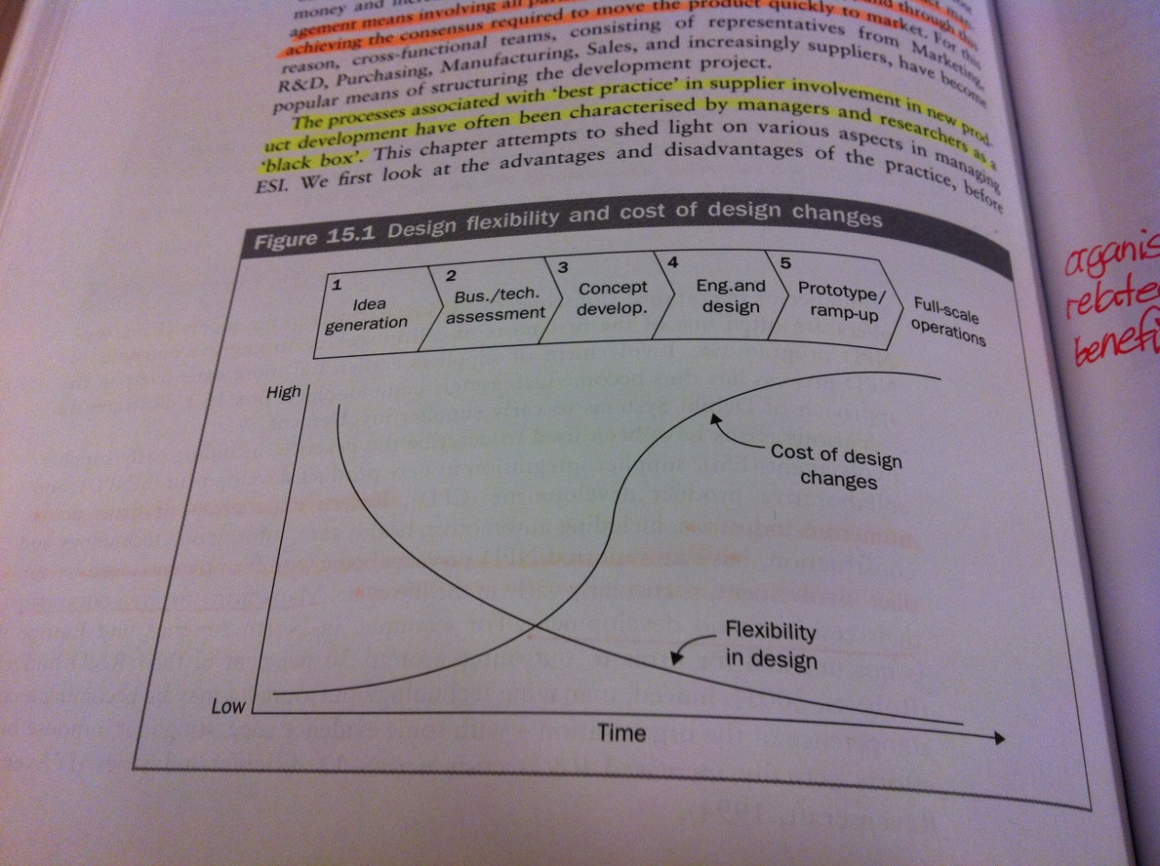

As key partners in the supply chain, suppliers are often the first involved in seeking improved results from NPD programs. Recent experiences from firms across multiple industries have all reported NPD projects being significantly enhanced by supplier involvement, particularly early in the life cycle.

Decisions made early in the development cycle have a significant impact on quality, cycle time and cost of the product (80% committed by the design phase). Procurement can add real value by adding their knowledge of the supply market, selecting the right partner and managing the relationship. However, unless you can impact sourcing early in the NPD process, you have almost no impact on the resulting design of the relationship. Effective product management means involving all parties early, resolving conflicts early, and throughout this achieve the consensus required to move the product quickly to the market.

## Advantages of ESI

### Product related

* Improved product quality
* Increased manufacturability of product
* Reduced cycle time (i.e. faster speed to markets)
* Reduced development costs
* Decreased product cost

### Organization related

* Learning effects
  + The buyer can leverage the supplier’s investments in the supplier’s core competence areas in order to gain economies of scale and scope in learning, without having to make the physical and time investments.
* Access to new capabilities
* Technology road-mapping
  + Working closely can provide access to the supplier’s technology roadmap – outlining the future directions for the supplier’s product range. This can enable the buyer to plan and incorporate the supplier’s technology more quickly into their own product architecture.
* Risk reduction
  + Spread risk of undertaking new product development.

## Disadvantages of ESI

* Early involvement is not always beneficial or appropriate
  + Not every collaborative partner must be involved in product development.
* Loss of bargaining power
* Leakage of key information
* Financial burden on manufacturing
* Locked into wrong technological trajectory

## Early supplier involvement

### 1. Selecting the right suppliers

Selecting the right supplier is critical to the success of the product and the future health of the firm. Since the supplier is typically involved in both design and volume production, the supplier selection takes on an added dimension – the supplier must not only be an effective design partner, it must also be able to ramp-up production smoothly to meet demand after product launch. The supplier selection criteria should reflect this, and at a minimum the supplier selection criteria should include assessment of:

* Design and engineering capability
* Willingness to involved in design
* Cultural compatibility with the buyer
* Ability to meet development schedule
* Willingness to co-locate design/engineering personnel
* Willingness to share cost and production information

Perhaps the key success factor in supplier selection is the technical and cultural alignment of the buyer and supplier.

### 2. Timing of supplier involvement

The general rule for supplier involvement is that if a supplier design expertise is strong and their potential impact on the final design is high, then the earlier they should be included in the process. Conversely, the simpler, less critical or standard the component, the more likely it is to involve suppliers late in the process.

### 3. Extent of supplier involvement

Typically the earlier involvement, the more extensively the firm will rely on its supplier for development of a given component.

|  |  |  |
| --- | --- | --- |
| **Degree of involvement** | **Description** | **Where to use** |
| **No supplier involvement** | A traditional approach to tendering, with the buyer providing set specification to the supplier | Routine, standard items |
| **White box involvement** | The least complex, suppliers involved in an ad hoc manner with the buyer consulting he supplier on their design | Components where some customization of parts is required |
| **Grey box involvement** | The most interesting and difficult approach. A formal integration of the supplier into the NPD team involving joint design, prototype manufacturing and testing. Requires high levels of trust, co-location of staff, intensive knowledge transfer and richer interpersonal communication. |  |
| **Black box involvement** | Highly effective when used effectively. The buyer has little involvement in the supplier activities. The design directive is base in desired functionality and performance specifications – the supplier decides how to meet the objectives. Requires a high level of trust. |  |

Table 13 – Classification of degrees of supplier involvement

### 4. Managing the involvement

Some successful practices identified by research include:

1. **Supplier selection procedures**
2. **Degree of responsibility for design**

More supplier responsibility generally means more effectively meeting the goals of the design project.

1. **Communication between buyer/supplier**

Effective communication is critical for knowledge transfer

1. **IP agreements**

Must be spelled out prior to commencement of the project

1. **Alignment of buyer/supplier technology**

A technology roadmap help determine the future working potential

1. **Project team structures**

Cross-functional teams have proven effective across numerous settings

1. **Supplier membership on project teams**
   1. The single biggest determinant of ESI success is supplier membership on project teams

# Week 19 – Public procurement

## Relevance

* Big business – influence many aspects of everyday life (roads, health care)
* Transformation of utilities (telephone, health, gas, electricity, water, rail, bus) from public to private ownership
* Outsourcing of activities in all sorts of public sector organizations
* Many private sector firms to business with public organizations
* Public and private procurement can learn from each other
  + Public: Strategic approach, professional organization, techniques and systems
  + Private: Transparency, ethics, environment and societal concerns
* Opening up of public procurement within EU’s internal market
  + Increased cross-border competition, improved prices paid by public authorities – however there is still significant potential for further competition in procurement markets

## Public vs. private procurement

The fact that the money is public makes a huge difference to all aspects of the ways in which it is spent and accounted for, and the **public scrutiny** over sourcing decisions, the need to provide services to **an insatiable client base** (can public health care ever be satisfactory?) and **the lack of a competitive market** in which to operate separate the public procurement nature from private procurement.

For private firms, the competitive pressures are translated and transmitted to its purchasing and supply activities as demands for cost reductions, timeliness and innovative solutions to next-customer requirements. There is no equivalent pressure in public procurement, but **regulations – stipulated performance requirements – put pressure onto the operating unit to be effective.** The regulations may take form as:

* Pricing policies
  + e.g. in the case of privatized utility firms who have monopolistic or oligopolistic positions
* Budgetary constraints
  + typically used in central funding to local governments
* Stipulated procedures to be followed
  + typically used in pursuit of efficient supply markets

**Public sector procurement is driven by the need for:**

* Value for money/best value
* Public scrutiny
* National and regional regulation and legislation
* Political expediency (*necessity to achieve something, though not always right or fair)*

## European Commission Directives

There are two basic purposes behind the procurement directives:

1. **Exploration of the whole EU market**

To ensure that those spending significant amount of public funds explore the whole of the single EU market and this have the best chance of getting value for money.

1. **Open markets for bidders from across the EU**

To ensure that firms in member states throughout the EU get the chance of bidding for business throughout the whole markets

The directives apply only to contracts above a certain threshold (set in € and translated to local currencies). However, there are **treaty principles applying to all purchases by the public sector:**

* No discrimination on the grounds of nationality
* Equal treatment of potential bidders
* Proportionality
* Mutual recognition
* Transparency

The original directives developed to guide public procurers in three separate types of contracts (supplies, services and works) were during reviews found to have had little impact, with few contracts being awarded to non-national entities. To answer this, two new public procurement directives where introduced in 2004: One for the public sector and one for utilities. The special case for utility firms represent their special context, as privatized public firms had to compete with established private companies they should be less constrained in their procurement than government organizations (already implemented in a previous directive called ‘the excluded sectors’). **The essential elements of these regulations require those spending public money to:**

* **Invoke competition for purchases over a threshold**
  + by requiring the purchaser to place an advert in the OJEU (*Official Journal of the European Union*)
* **Allow specified time periods to tendering**
  + for contractors throughout the EU to tender of they wish to bid for the contract
* **Ensure an open, fair and transparent tender evaluation**
* **Provide an opportunity to challenge award decision**
  + through an accelerated debriefing process, allowing all bidders to challenge an award decision before the award is made
* **Publicize details of awarded contract**
  + through the OJEU

### The thresholds

The thresholds apply to ‘one-off’ purchases as well as to a series of contracts with similar characteristics[3]. This eliminates the possibility of breaking up the contract into smaller parts underneath the threshold. Nevertheless, there is some flexibility allowing small lots below specified values to be let outside the scope of the directives providing the total value of these lots does not exceed 20 per cent of the total value. The directives also allow an organization not to aggregate where it can show that the separate parts of the organization are ‘discrete operating units’, meaning that they buy goods for their own purposes, have devolved authority to purchase those goods and takes decisions independently.

An important point here is that the burden of proof lies with the purchaser; if the eventual value of a contract is above the threshold, it is assumed that the purchaser should have foreseen this and followed the procedures.

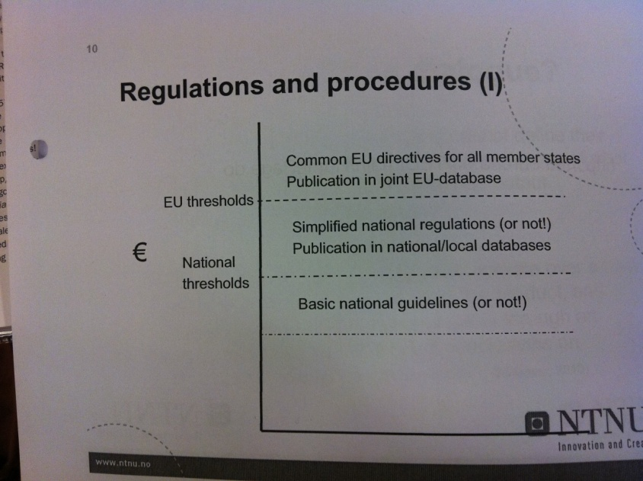

### The procedures

|  |  |  |  |
| --- | --- | --- | --- |
| **Procedure** | **Characteristics** | **Advantage** | **Disadvantage** |
| **Open procedure** | 1. Submit invitation to tender in OJEU 2. Receive tenders (up to 52 days) – clarification of ITT before receiving bids allowed, as is clarification of bids (but not changes after closing date) 3. Award contract 4. Publish award in OJEU (up to 48 days) | Shorter contracting time scales than for the other procedures | All applicants that meet the purchaser’s minimum standards must be invited to bid, this can be expensive for both purchaser and suppliers. It is therefore unsuitable if costs of bidding and assessments are high (unless there are only a few suppliers. |
| **Restricted procedure** | 1. Submit invitation to participate in OJEU – indicating nature and scope of contract, and specific expectations and requirements of suppliers 2. Receive requests (37 days) 3. Send full ITT directly to selected bidders. Debrief unsuccessful applicants. 4. Receive tenders (40 days) 5. Award contract 6. Publish award in OJEU (48 days) | Allows purchaser to short-list contractors (min. 5) that they deem competent and invite them to tender. Attractive for purchasers unwilling to waste time dealing with incompetent contractors. Often used for complex purchases. | The reasons for refusing permission to tender must be ‘water-tight’, not interpretable as favoring of local contractors.  Not suitable of purchasers are unable to express specifications, or are unaware of the solutions offered by the market. |
| **Competitive dialogue** | 1. Contract notice issued in OJEU, applicants requested to provide qualifying information requested by purchaser. 2. Purchaser may short-list (min. 3) applicants to go forward to the bidding stage. 3. Dialogue phase – initial proposals/solutions put forward based on outputs specified. Dialogue with individual bidders to agree on solutions that meet required outputs (confidential, no discrimination, equal treatment). The number of bidders can be reduced according to pre-specified criteria. 4. Final bid stage – several solutions are agreed and they may now be clarified and fine-tuned without significant changes made. 5. Selection of preferred bidder – again possibility for fine-tuning. 6. Publish award in OJEU (48 days) | Can be used when unable to define requirements in detailed terms, or if unaware of what the market can offer in terms of output performance.  Can be used when the producer and customer cooperate over a long gestation period to improve upon the product, and arrange to share both risk and gains through an incentive contract the standards conclusions on competitive bidding no longer holds. | Not available for the utility sector (p. 240). |
| **Negotiated procedure w/ call for competition** | 1. Submit invitation to tender in OJEU – may indicate that a contractor is already found 2. Receive tenders (37 days). Select a minimum of 3 suppliers for the award stage. 3. Award contract 4. Publish award in OJEU (48 days) | May be used when already advertised under the open and restricted procedures and received only non-compliant/unacceptable bids.  May be used when unable to define requirements to a level allowing to award contract under the rules applicable to the open and restricted procedures. |  |
| **Negotiated procedure w/o call for competition** |  | Can be used in situations of urgency that is due to reasons outside the control of the purchaser (flood, major fire).  Can be used when advertising has been done under open/restrictive procedures and no responses has been received, or there is only one supplier available, or the requirements are additions to contracts where change of suppliers would result in major technical problems. |  |
| **Dynamic purchasing system** | 1. Set up list of suppliers who have responded to an open procedure notice (seeking suppliers to go on the list). Qualifying procedure laid down and all suppliers that comply must be included on list. List open for new suppliers. 2. Second notice in OJEU giving other suppliers possibility to qualify. 3. Electronic bidding. | Most suitable for purchase of standard products. |  |

Table 14 – Procedure characteristics, advantages and disadvantages

### Procedure description from slides (Gjønnes, 2007)

|  |  |
| --- | --- |
| Procedure | Characteristics |
| Open procedure | - Single round  - Either lowest price or economically most favorable  - Strict time windows for publication and processing |
| Closed procedure | - Two rounds; supplier qualification (open), then selection of best received bid (closed) |
| Negotiation procedure |  |
| Various other (new) arrangement | Dialogue, dynamic purchasing systems, frame agreements, contests, E-auctions |

### Critique

* The stipulation of strict procedures would in some way compromise the ‘professional’ autonomy, skills and style of the purchasers
* The processes in the procedures would be cumbersome, time consuming and costly (especially for standard products and services)
* The directives do not help SMEs as the thresholds are set at levels that exceed typical contract sized for many SMEs
* A tendency for large organizations to set up operations in countries to bid for local contracts, rather the firms in each of the EU countries bidding for contracts.

1. Alternatively, and probably preferred, stock holding could be differentiated by holding ’A’ items as close as possible to the customer and the ’B’ and ’C’ items further up the supply chain
2. Large, powerful assemblers, centrally positioned in relatively high-volume, low-variety supply networks (Harland et al., 2001)
3. Similar products or services, for a single or recurring need, available from the same or similar suppliers, bought in the same period and perhaps capable of being bought on the same contract